1. You have an Azure Active Directory (Azure AD) tenant named Adatum and an Azure Subscription named Subscription1. Adatum contains a group named Developers. Subscription1 contains a resource group named Dev. You need to provide the Developers group with the ability to create Azure logic apps in the Dev resource group.

Solution: On Dev, you assign the Contributor role to the Developers group.

Does this meet the goal?

**Answer:** *A. Yes*

1. You have an Azure Active Directory (Azure AD) tenant named Adatum and an Azure Subscription named Subscription1. Adatum contains a group named Developers. Subscription1 contains a resource group named Dev. You need to provide the Developers group with the ability to create Azure logic apps in the Dev resource group.

Solution: On Subscription1, you assign the Logic App Operator role to the Developers group.

Does this meet the goal?

**Answer:** *B. No*

1. You have an Azure Active Directory (Azure AD) tenant named Adatum and an Azure Subscription named Subscription1. Adatum contains a group named Developers. Subscription1 contains a resource group named Dev. You need to provide the Developers group with the ability to create Azure logic apps in the Dev resource group.

Solution: On Dev, you assign the Logic App Contributor role to the Developers group.

Does this meet the goal?

**Answer:** *A. Yes*

1. You have an Azure subscription named Subscription1 that contains an Azure Log Analytics workspace named Workspace1.

You need to view the error events from a table named Event.

Which query should you run in Workspace1?

**Answer:** *D. search in (Event) “error”*

1. You have an Azure subscription named Subscription1. Subscription1 contains the resource groups in the following table.

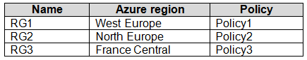

RG1 has a web app named WebApp1. WebApp1 is located in West Europe.

You move WebApp1 to RG2.

What is the effect of the move?

**Answer:** *B. The App Service plan for WebApp1 remains in West Europe. Policy2 applies to WebApp1.*

1. You have an Azure subscription that contains a resource group named RG1. RG1 contains 100 virtual machines.

Your company has three cost centers named Manufacturing, Sales, and Finance.

You need to associate each virtual machine to a specific cost center.

What should you do?

**Answer:** *Assign tags to the virtual machines*

1. You have an Azure subscription named Subscription1. Subscription1 contains a resource group named RG1. RG1 contains resources that were deployed by using templates.  
   You need to view the date and time when the resources were created in RG1.  
   Solution: From the Subscriptions blade, you select the subscription, and then click Programmatic deployment.  
   Does this meet the goal?

**Answer:** *No*

1. You have an Azure subscription named Subscription1. Subscription1 contains a resource group named RG1. RG1 contains resources that were deployed by using templates.  
   You need to view the date and time when the resources were created in RG1.  
   Solution: From the Subscriptions blade, you select the subscription, and then click Resource providers.  
   Does this meet the goal?

**Answer**: No

1. You have an Azure subscription named Subscription1. Subscription1 contains a resource group named RG1. RG1 contains resources that were deployed by using templates.

You need to view the date and time when the resources were created in RG1.

Solution: From the RG1 blade, you click Automation script.

Does this meet the goal?

**Answer**: No

1. You have an Azure subscription.

You plan to use Azure Resource Manager templates to deploy 50 Azure virtual machines that will be part of the same availability set.

You need to ensure that as many virtual machines as possible are available if the fabric fails or during servicing.

How should you configure the template? To answer, select the appropriate options in the answer area.

NOTE: Each correct selection is worth one point.

Hot Area:

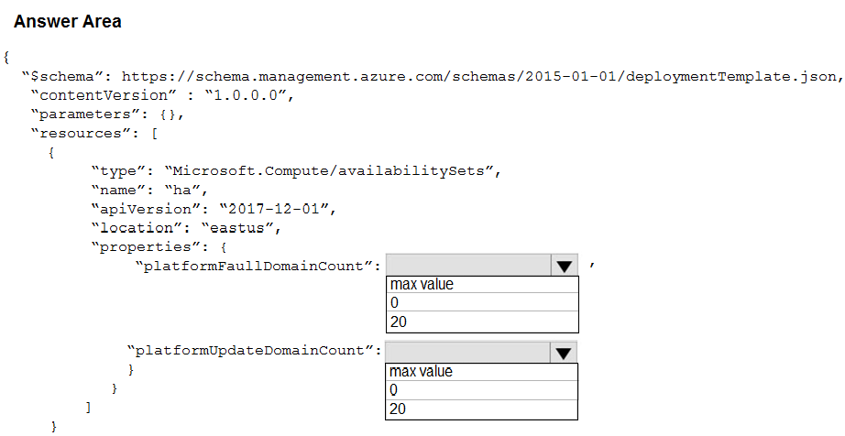

**Answer**: Use two fault domains: “max value” (2 or 3 depending on region) + “20” (platformUpdateDomainCount)

1. You have an Azure subscription named Subscription1 that has a subscription ID of c276fc76-9cd4-44c9-99a7-4fd71546436e.

You need to create a custom RBAC role named CR1 that meets the following requirements:

✑ Can be assigned only to the resource groups in Subscription1

✑ Prevents the management of the access permissions for the resource groups

✑ Allows the viewing, creating, modifying, and deleting of resource within the resource groups

What should you specify in the assignable scopes and the permission elements of the definition of CR1? To answer, select the appropriate options in the answer area.

NOTE: Each correct selection is worth one point.

Hot Area:

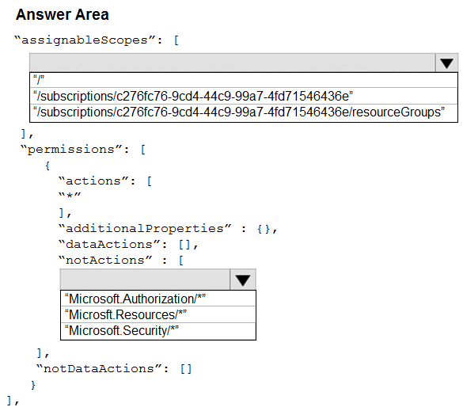

**Answer**: “/subscriptions/(…)” + “Microsoft.Authorization/”

1. You have an Azure Active Directory (Azure AD) tenant that contains three global administrators named Admin1, Admin2, and Admin3.

The tenant is associated to an Azure subscription. Access control for the subscription is configured as shown in the Access control exhibit. (Click the Exhibit tab.)

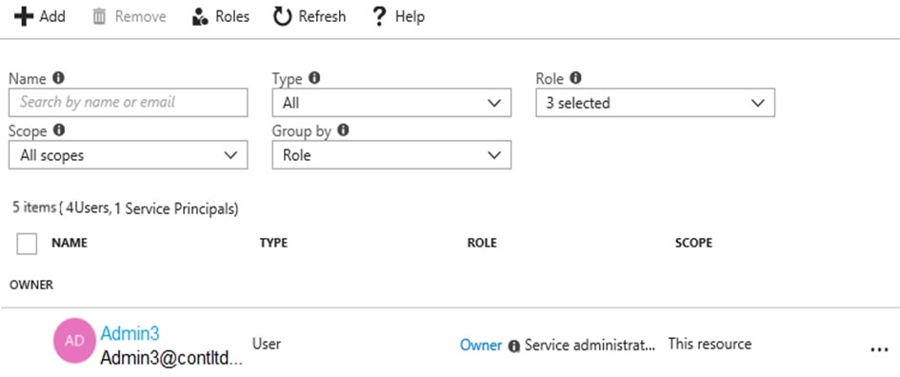

You sign in to the Azure portal as Admin1 and configure the tenant as shown in the Tenant exhibit. (Click the Exhibit tab.)

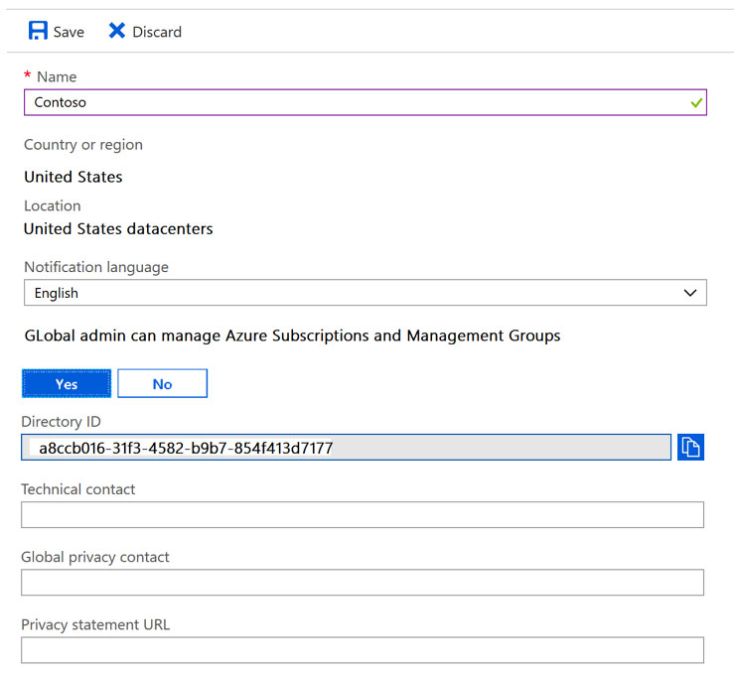

For each of the following statements, select Yes if the statement is true. Otherwise, select No.

NOTE: Each correct selection is worth one point.

Hot Area:

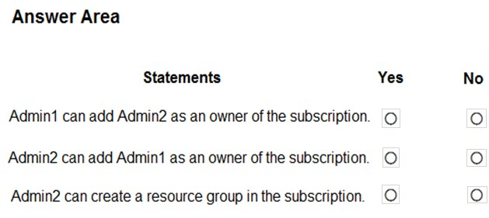

**Answer**: Yes, Yes, No

You have an Azure policy as shown in the following exhibit.

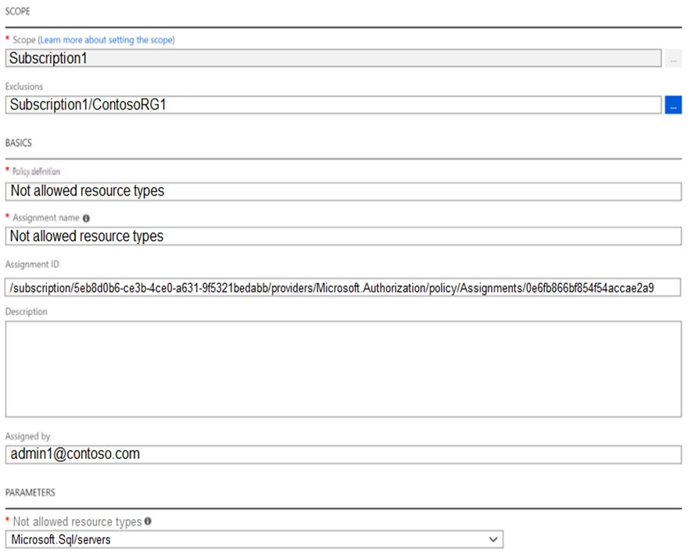

What is the effect of the policy?

**Answer**: B. You can create Azure SQL servers in ContosoRG1 only.

1. You have an Azure Active Directory (Azure AD) tenant named Adatum and an Azure Subscription named Subscription1. Adatum contains a group named

Developers. Subscription1 contains a resource group named Dev.

You need to provide the Developers group with the ability to create Azure logic apps in the Dev resource group.

Solution: On Subscription1, you assign the DevTest Labs User role to the Developers group.

Does this meet the goal?

**Answer**: No

1. You have an Azure Active Directory (Azure AD) tenant that contains 5,000 user accounts.

You create a new user account named AdminUser1.

You need to assign the User administrator administrative role to AdminUser1.

What should you do from the user account properties?

**Answer**: A. From the Directory role blade, modify the directory role.

1. You have an Azure subscription named Subscription1.

You plan to deploy an Ubuntu Server virtual machine named VM1 to Subscription1.

You need to perform a custom deployment of the virtual machine. A specific trusted root certification authority (CA) must be added during the deployment.

What should you do? To answer, select the appropriate options in the answer area.

NOTE: Each correct selection is worth one point.

Hot Area:

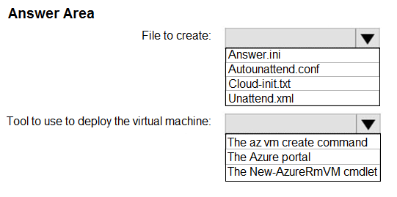

**Answer**: “Cloud-init.txt” + “The az vm create command”

1. You have an Azure subscription named Subscription1.

In Subscription1, you create an alert rule named Alert1.

The Alert1 action group is configured as shown in the following exhibit.

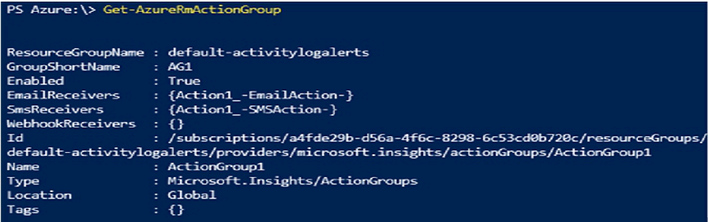

Alert1 alert criteria is triggered every minute.

Use the drop-down menus to select the answer choice that completes each statement based on the information presented in the graphic.

NOTE: Each correct selection is worth one point.

Hot Area:

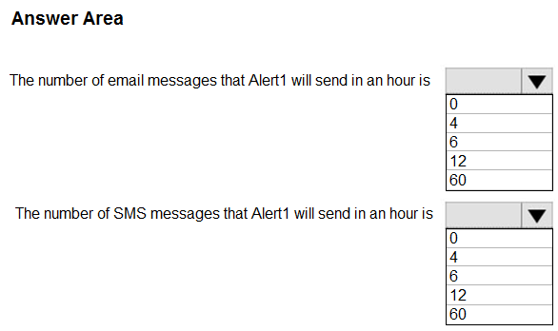

**Answer**: 60 + 12

1. You have an Azure subscription.

You have an on-premises virtual machine named VM1. The settings for VM1 are shown in the exhibit. (Click the Exhibit tab.)

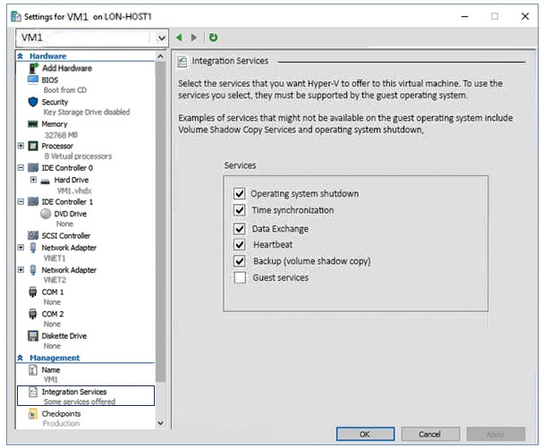

You need to ensure that you can use the disks attached to VM1 as a template for Azure virtual machines.

What should you modify on VM1?

**Answer**: A. the hard drive

1. You have an Azure subscription that is used by four departments in your company. The subscription contains 10 resource groups. Each department uses resources in several resource groups.

You need to send a report to the finance department. The report must detail the costs for each department.

Which three actions should you perform in sequence? To answer, move the appropriate actions from the list of actions to the answer area and arrange them in the correct order.

Select and Place:

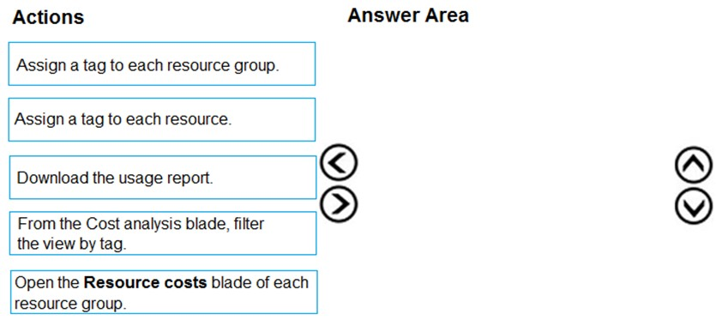

**Answer**: “Assign a tag to each resource” + “From the Cost analysis blade, filter the view by tag” + “Download the usage report”

1. Your company has an Azure subscription named Subscription1.

The company also has two on-premises servers named Server1 and Server2 that run Windows Server 2016. Server1 is configured as a DNS server that has a primary DNS zone named adatum.com. Adatum.com contains 1,000 DNS records.

You manage Server1 and Subscription1 from Server2. Server2 has the following tools installed:

✑ The DNS Manager console

✑ Azure PowerShell

✑ Azure CLI 2.0

You need to move the adatum.com zone to Subscription1. The solution must minimize administrative effort.

What should you use?

**Answer**: D. Azure CLI

1. You have a resource group named RG1. RG1 contains an Azure Storage account named storageaccount1 and a virtual machine named VM1 that runs Windows

Server 2016. Storageaccount1 contains the disk files for VM1.

You apply a ReadOnly lock to RG1.

What can you do from the Azure portal?

**Answer**: A. Generate an automation script for RG1.

1. You have an Azure subscription named Subscription1 that contains the following resource group:

✑ Name: RG1

✑ Region: West US

✑ Tag: "tag1": "value1"

You assign an Azure policy named Policy1 to Subscription1 by using the following configurations:

✑ Exclusions: None

✑ Policy definition: Append tag and its default value

✑ Assignment name: Policy1

✑ Parameters:

- Tag name: Tag2

- Tag value: Value2

After Policy1 is assigned, you create a storage account that has the following configurations:

✑ Name: storage1

✑ Location: West US

✑ Resource group: RG1

✑ Tags: "tag3": "value3"

You need to identify which tags are assigned to each resource.

What should you identify? To answer, select the appropriate options in the answer area.

NOTE: Each correct selection is worth one point.

Hot Area:

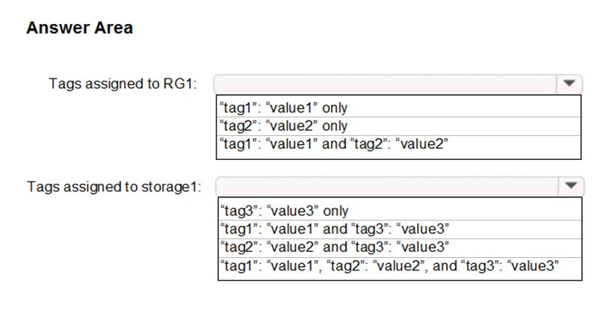

**Answer**: “tag1”:”value1” only + “tag2”:”value2” and “tag3”:”value3”

1. You have an Azure Active Directory (Azure AD) tenant named contoso.onmicrosoft.com that contains 100 user accounts.

You purchase 10 Azure AD Premium P2 licenses for the tenant.

You need to ensure that 10 users can use all the Azure AD Premium features.

What should you do?

**Answer**: D. From the Licenses blade of Azure AD, assign a license.

1. You have an Azure subscription.

You have 100 Azure virtual machines.

You need to quickly identify underutilized virtual machines that can have their service tier changed to a less expensive offering.

Which blade should you use?

**Answer**: D. Advisor

1. You have an Azure subscription named Subscription1. Subscription1 contains a resource group named RG1. RG1 contains resources that were deployed by using templates.

You need to view the date and time when the resources were created in RG1.

Solution: From the RG1 blade, you click Deployments.

Does this meet the goal?

**Answer**: Yes

1. You have an Azure subscription.

Users access the resources in the subscription from either home or from customer sites. From home, users must establish a point-to-site VPN to access the Azure resources. The users on the customer sites access the Azure resources by using site-to-site VPNs.

You have a line-of-business app named App1 that runs on several Azure virtual machine. The virtual machines run Windows Server 2016.

You need to ensure that the connections to App1 are spread across all the virtual machines.

What are two possible Azure services that you can use? Each correct answer presents a complete solution.

NOTE: Each correct selection is worth one point.

**Answer**: B + D (B. an Azure Application Gateway + D. an internal load balancer)

1. You have an Azure subscription.

You need to implement a custom policy that meets the following requirements:

✑ Ensures that each new resource group in the subscription has a tag named organization set to a value of Contoso

✑ Ensures that resource groups can be created from the Azure portal

✑ Ensures that compliance reports in the Azure portal are accruable

How should you complete the policy? To answer, select the appropriate options in the answer area.

NOTE: Each correct selection is worth one point.

Hot Area:

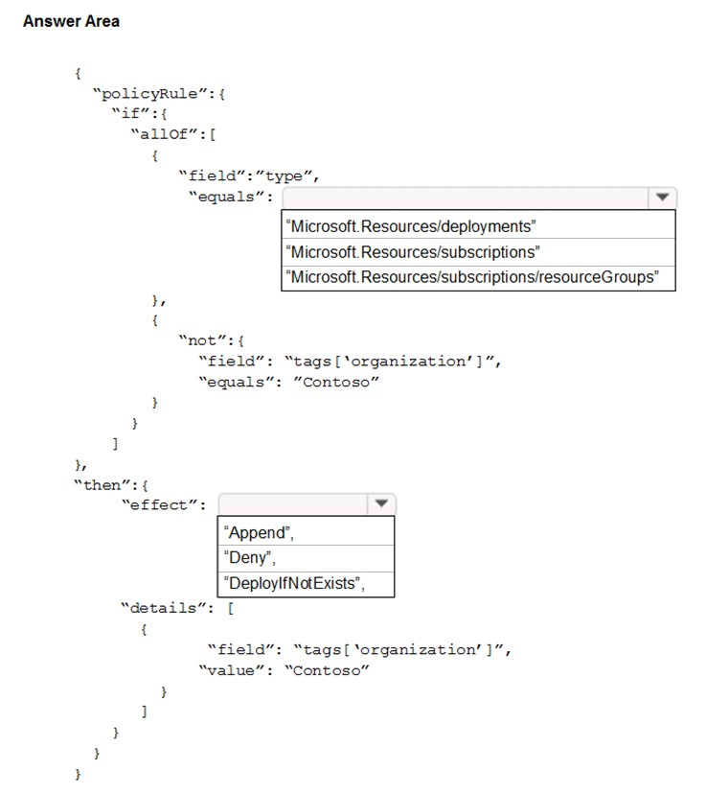

**Answer**: “Microsoft.Resources/subscriptions/resourceGroups” + “Append”

1. You have an Azure subscription that contains the resources in the following table.

You install the Web Server server role (IIS) on VM1 and VM2, and then add VM1 and VM2 to LB1.

LB1 is configured as shown in the LB1 exhibit. (Click the Exhibit tab.)

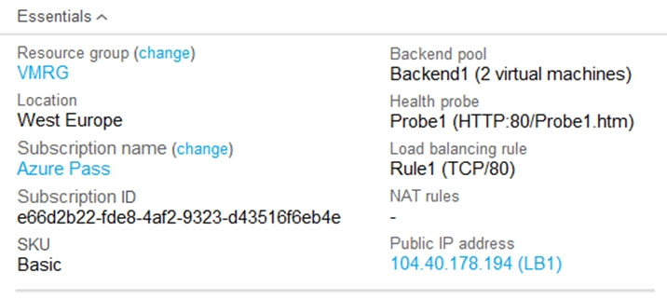

Rule1 is configured as shown in the Rule1 exhibit. (Click the Exhibit tab.)

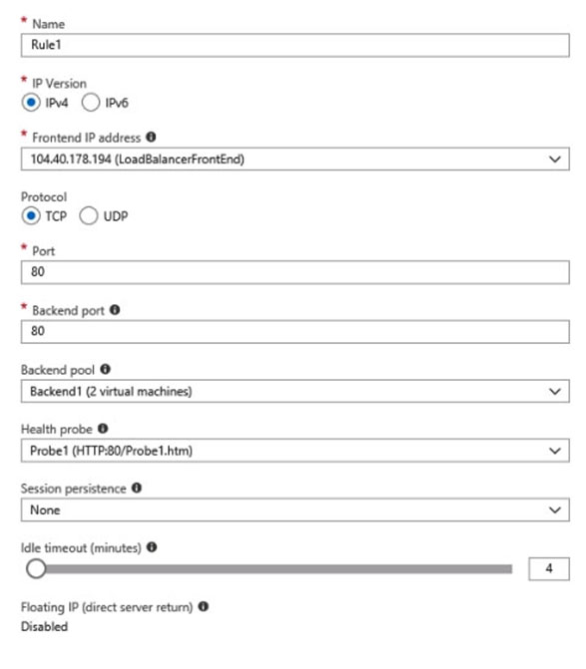

For each of the following statements, select Yes if the statement is true. Otherwise, select No.

NOTE: Each correct selection is worth one point.

Hot Area:

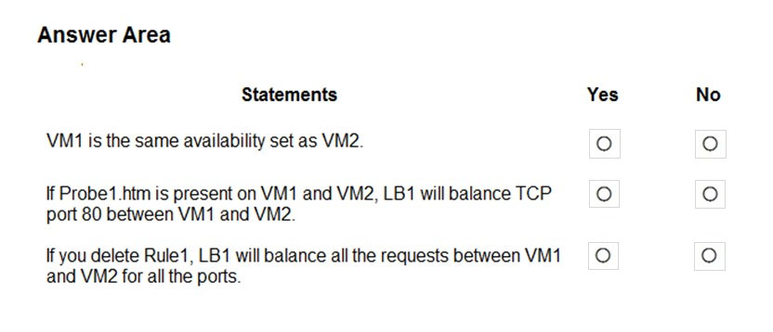

**Answer**: Yes, Yes, No

1. You have an Azure subscription named Subscription1 that is associated to an Azure Active Directory (Azure AD) tenant named AAD1.

Subscription1 contains the objects in the following table.

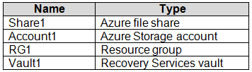

You plan to create a single backup policy for Vault1.

To answer, select the appropriate options in the answer area.

NOTE: Each correct selection is worth one point.

Hot Area:

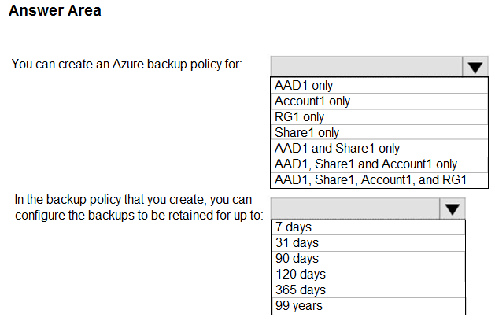

**Answer**: Share1 only + 365 days

1. You have an Azure subscription named Subscription1.

In Subscription1, you create an Azure file share named share1.

You create a shared access signature (SAS) named SAS1 as shown in the following exhibit.

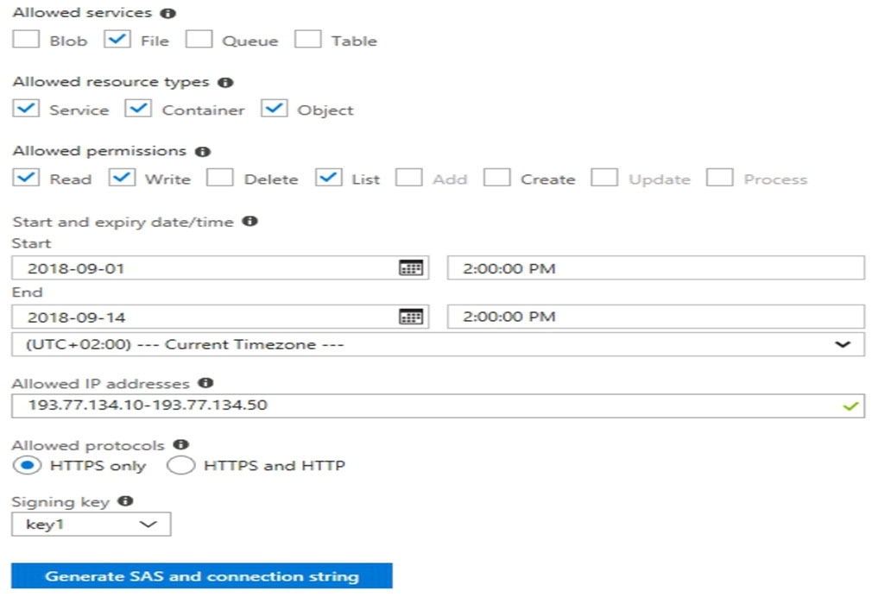

To answer, select the appropriate options in the answer area.

NOTE: Each correct selection is worth one point.

Hot Area:

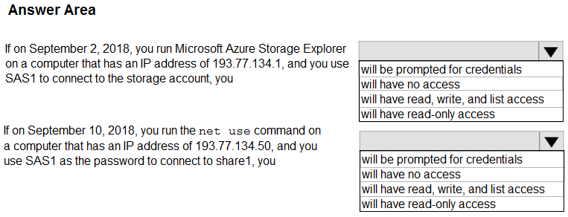

**Answer**: “will have no access” + “will have read, write and list access”

1. You have Azure Storage accounts as shown in the following exhibit.

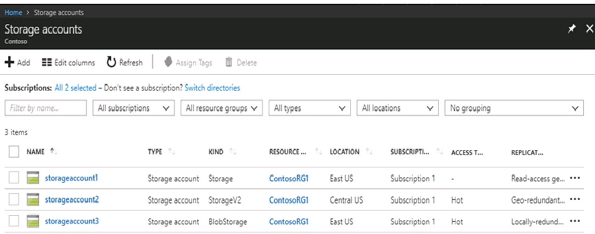

Use the drop-down menus to select the answer choice that completes each statement based on the information presented in the graphic.

NOTE: Each correct selection is worth one point.

Hot Area:

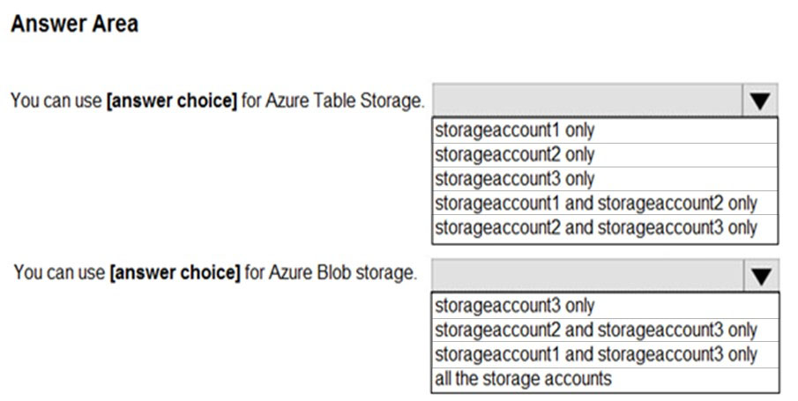

**Answer**: “storageaccount1 and storageaccount2 only” + “all the storage accounts”

1. LAB: You plan to prevent users from accidentally deleting blob data from Azure.

You need to ensure that administrators can recover any blob data that is deleted accidentally from the storagelod9272261 storage account for 14 days after the deletion occurred.

What should you do from the Azure portal?

**Answer**:

Go to storage account – Scroll down to Data Protection – Enable blob soft delete – set blob retention period to 14 days under Retention Policies: <https://www.sqlshack.com/how-to-recover-accidental-deletes-in-azure-blob-storage/>

1. LAB: Your company plans to store several documents on a public website.

You need to create a container named bios that will host the documents in the storagelod9272261 storage account. The solution must ensure anonymous access and must ensure that users can browse folders in the container.

What should you do from the Azure portal?

**Answer**:

Azure portal create public container  
To create a container in the Azure portal, follow these steps:  
Step 1: Navigate to your new storage account in the Azure portal.  
Step 2: In the left menu for the storage account, scroll to the blob service section, then select Blobs.  
Select the + Container button.  
Type a name for your new container: bios  
Set the level of public access to the container: Container (anonymous read access for containers and blobs)  
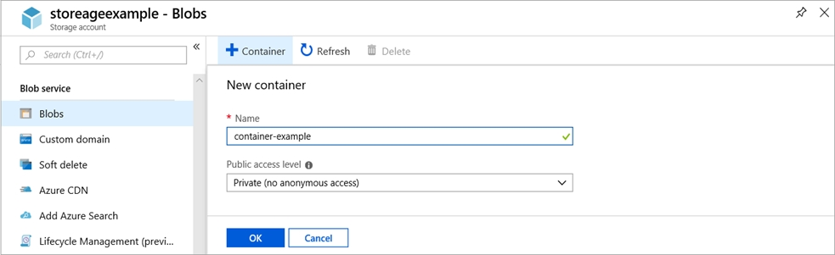  
Step 3: Select OK to create the container.

1. Your company plans to host in Azure the source files of several line-of-business applications.

You need to create an Azure file share named corpsoftware in the storagelod9272261 storage account. The solution must ensure that corpsoftware can store only up to 250 GB of data.

What should you do from the Azure portal?

**Answer**:

Step 1: Go to the Storage Account blade on the Azure portal:  
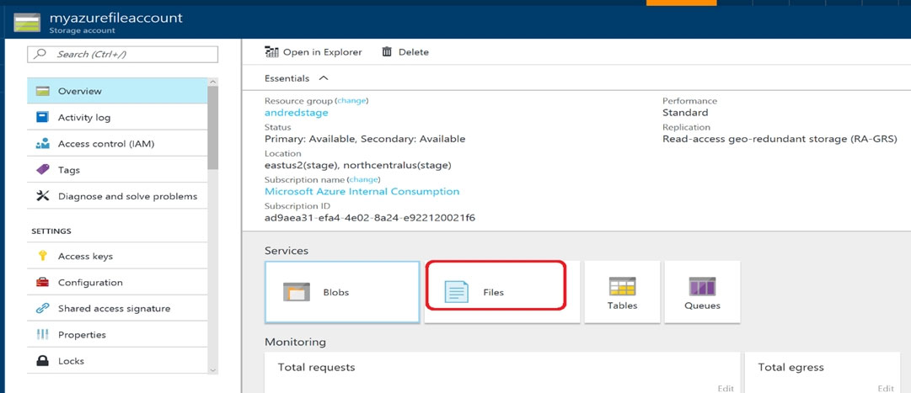  
Step 2: Click on add File Share button:  
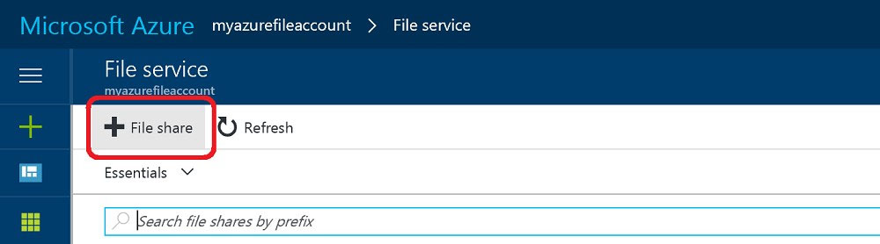  
Step 3: Provide Name (corpsoftware) and Quota (250 GB).  
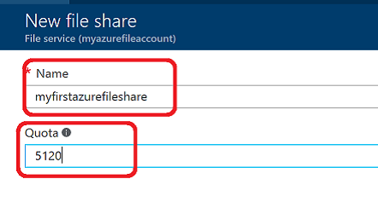

1. You recently created a virtual machine named Web01.

You need to attach a new 80GB (128 GiB) standard SSD data disk named Web01-Disk1 to Web01.

What should you do from the Azure portal?

**Answer**:

Add a data disk -  
Step 1: In the Azure portal, from the menu on the left, select Virtual machines.  
Step 2: Select the Web01 virtual machine from the list.  
Step 3: On the Virtual machine page, in Settings, select Disks.  
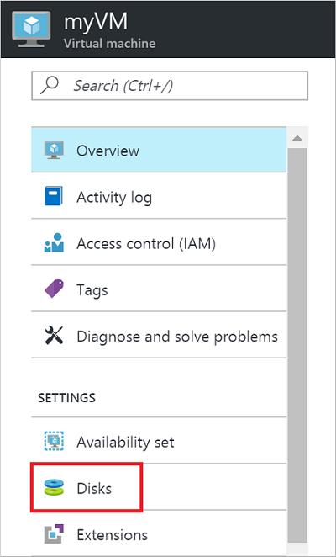  
Step 4: On the Disks page, select the Web01-Disk1 from the list of existing disks (if doesn’t exist, create).  
Step 5: In the Disks pane, click + Add data disk.  
Step 6: Click the drop-down menu for Name to view a list of existing managed disks accessible to your Azure subscription. Select the managed disk Web01-Disk1 to attach:  
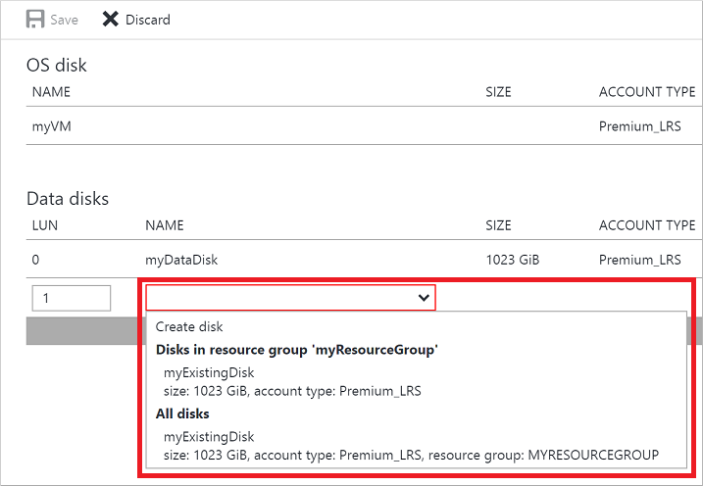

1. You plan to use the Azure Import/Export service to copy files to a storage account.

Which two files should you create before you prepare the drives for the import job? Each correct answer presents part of the solution.

NOTE: Each correct selection is worth one point.

**Answer**: A + E (A. a driveset CSV file + E. a dataset CSV file)

1. You have an on-premises file server named Server1 that runs Windows Server 2016.

You have an Azure subscription that contains an Azure file share.

You deploy an Azure File Sync Storage Sync Service, and you create a sync group.

You need to synchronize files from Server1 to Azure.

Which three actions should you perform in sequence? To answer, move the appropriate actions from the list of actions to the answer area and arrange them in the correct order.

Select and Place:

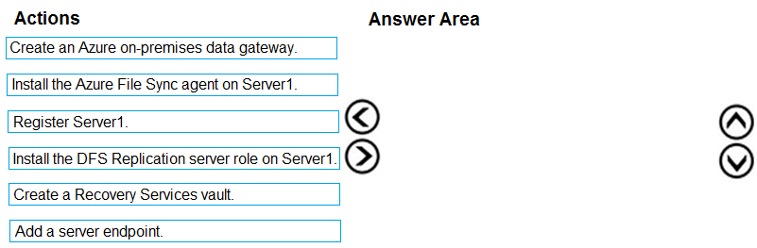

**Answer**: Install the Azure File Sync agent on Server1, Register Server1, Add a server endpoint.

1. You create an Azure Storage account named contosostorage.

You plan to create a file share named data.

Users need to map a drive to the data file share from home computers that run Windows 10.

Which outbound port should you open between the home computers and the data file share?

**Answer**: 445

1. You have several Azure virtual machines on a virtual network named VNet1.  
   You configure an Azure Storage account as shown in the following exhibit.  
   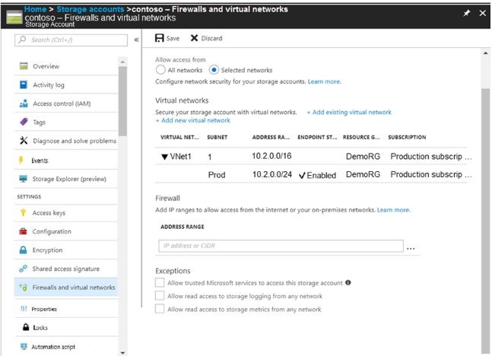  
   Use the drop-down menus to select the answer choice that completes each statement based on the information presented in the graphic.  
   NOTE: Each correct selection is worth one point.  
   Hot Area:  
   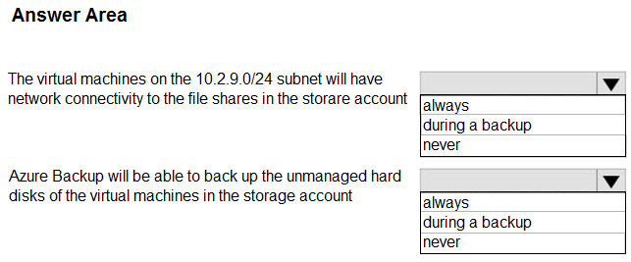

**Answer**: “never” (unless typo and supposed to be “10.2.0.0/24”, then it would be “always”) + “never”

1. You have two Azure virtual machines named VM1 and VM2. You have two Recovery Services vaults named RSV1 and RSV2.

VM2 is protected by RSV1.

You need to use RSV2 to protect VM2.

What should you do first?

**Answer**: A. From the VM2 blade, click Disaster recovery, click Replication settings, and then select RSV2 as the Recovery Services vault.

1. You plan to deploy 20 Azure virtual machines by using an Azure Resource Manager template. The virtual machines will run the latest version of Windows Server  
   2016 Datacenter by using an Azure Marketplace image.  
   You need to complete the storageProfile section of the template.  
   How should you complete the storageProfile section? To answer, select the appropriate options in the answer area.  
   NOTE: Each correct selection is worth one point.  
   Hot Area:  
   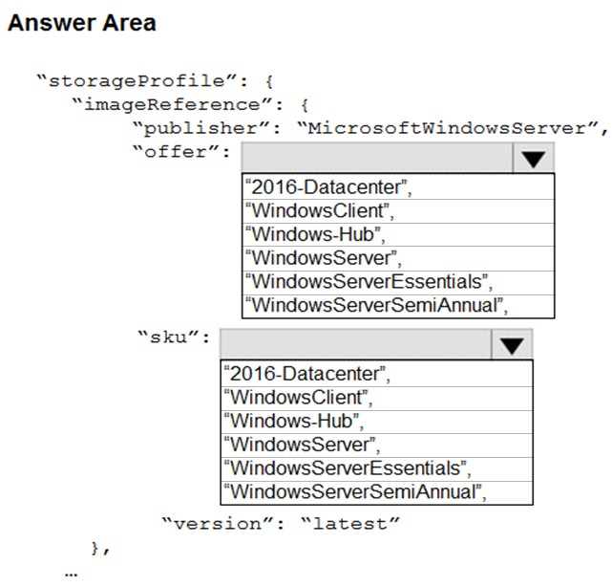

**Answer**: “WindowsServer” + “2016-Datacenter”

1. You need to create an Azure Storage account that meets the following requirements:  
   ✑ Minimize costs  
   ✑ Supports hot, cool, and archive blob tiers  
   ✑ Provides fault tolerance if a disaster affects the Azure region where the account resides  
   How should you complete the command? To answer, select the appropriate options in the answer area.  
   NOTE: Each correct selection is worth one point.  
   Hot Area:  
   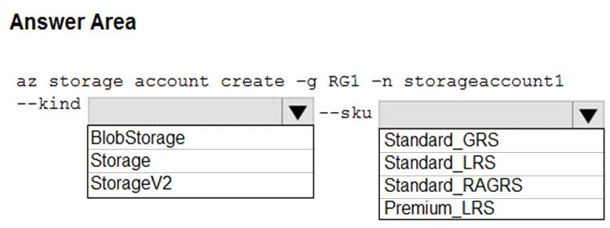

**Answer**: “StorageV2” + “Standard_GRS”

1. You have a Recovery Service vault that you use to test backups. The test backups contain two protected virtual machines.

You need to delete the Recovery Services vault.

What should you do first?

**Answer**: C. From the Recovery Service vault, stop the backup of each backup item.

1. You have an Azure subscription that contains a storage account named account1.

You plan to upload the disk files of a virtual machine to account1 from your on-premises network. The on-premises network uses a public IP address space of

131.107.1.0/24.

You plan to use the disk files to provision an Azure virtual machine named VM1. VM1 will be attached to a virtual network named VNet1. VNet1 uses an IP address space of 192.168.0.0/24.

You need to configure account1 to meet the following requirements:

✑ Ensure that you can upload the disk files to account1.

✑ Ensure that you can attach the disks to VM1.

✑ Prevent all other access to account1.

Which two actions should you perform? Each correct answer presents part of the solution.

NOTE: Each correct selection is worth one point.

**Answer**: D +C (D. From the Firewalls and virtual networks blade of account1, select Selected networks + C. From the Firewalls and virtual networks blade of account1, add the 131.107.1.0/24 IP address range)

1. You have an Azure subscription that contains several virtual machines and an Azure Log Analytics workspace named Workspace1.  
   You create a log search query as shown in the following exhibit.  
   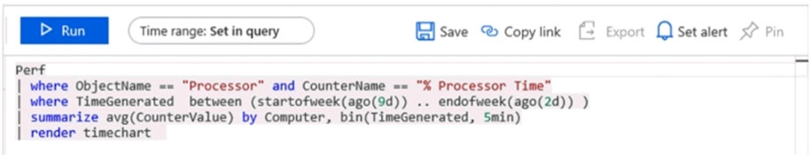  
   Use the drop-down menus to select the answer choice that completes each statement based on the information presented in the graphic.  
   NOTE: Each correct selection is worth one point.  
   Hot Area:  
   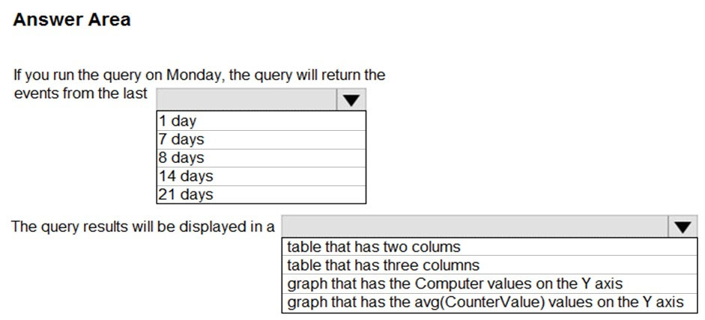

**Answer**: 14 days + graph that has the avg(CounterValue) values on the Y axis

1. You have an Azure subscription named Subscription1 that contains the resources shown in the following table.  
   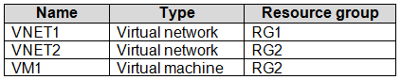

The status of VM1 is Running.  
You assign an Azure policy as shown in the exhibit. (Click the Exhibit tab.)  
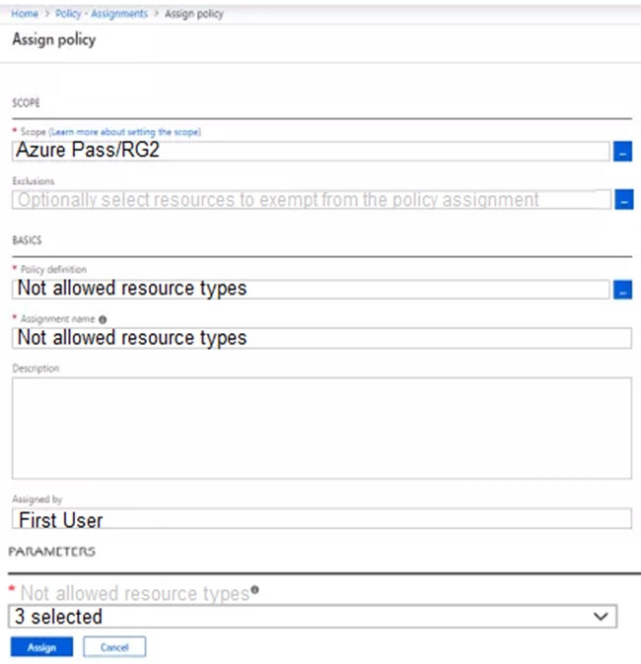  
You assign the policy by using the following parameters:  
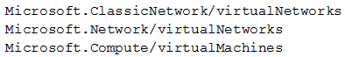  
For each of the following statements, select Yes if the statement is true. Otherwise, select No.  
NOTE: Each correct selection is worth one point.  
Hot Area:  
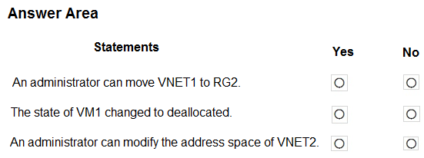

**Answer**: Yes, No, No

1. LAB: You plan to store media files in the rg1lod9172796 storage account.

You need to configure the storage account to store the media files. The solution must ensure that only users who have access keys can download the media files and that the files are accessible only over HTTPS.

What should you do from the Azure portal?

**Answer**:

We should create an Azure file share.  
Step 1: In the Azure portal, select All services. In the list of resources, type Storage Accounts. As you begin typing, the list filters based on your input. Select  
Storage Accounts.  
On the Storage Accounts window that appears.  
Step 2: Locate the rg1lod9172796 storage account.  
Step 3: On the storage account page, in the Configuration section.



1. You have an Azure subscription named Subscription1.

You have 5 TB of data that you need to transfer to Subscription1.

You plan to use an Azure Import/Export job.

What can you use as the destination of the imported data?

**Answer**: B. Azure File Storage

1. You plan to migrate a large amount of corporate data to Azure Storage and to back up files stored on old hardware to Azure Storage.

You need to create a storage account named corpdata9172795n1 in the corpdatalod9172795 resource group. The solution must meet the following requirements:

✑ Corpdata9172795n1 must be able to host the virtual disk files for Azure virtual machines.

✑ The cost of accessing the files must be minimized.

✑ Replication costs must be minimized.

What should you do from the Azure portal?

**Answer**:

Step 1: In the Azure portal, click All services. In the list of resources, type Storage Accounts. As you begin typing, the list filters based on your input. Select  
Storage Accounts.  
Step 2: On the Storage Accounts window that appears, choose Add.  
Step 3: Select the subscription in which to create the storage account.  
Step 4: Under the Resource group field, select corpdatalod9172795.  
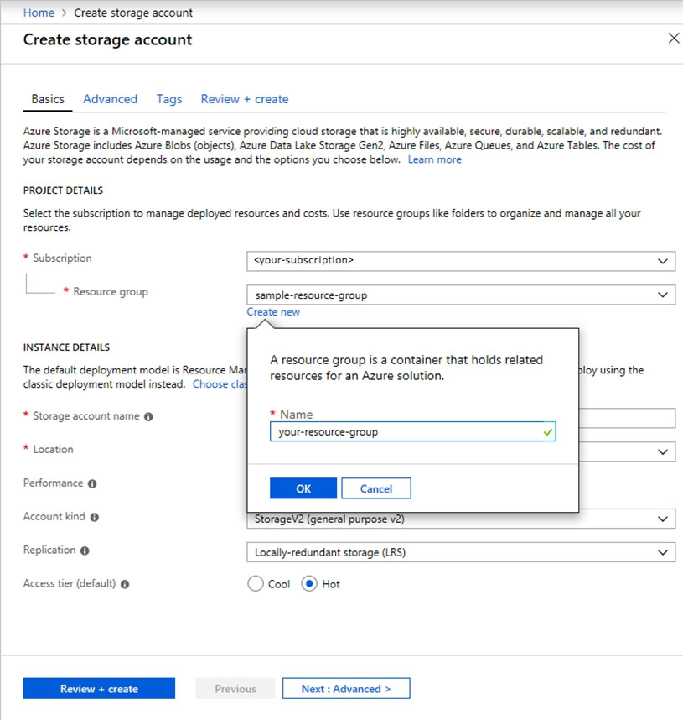  
Step 5: Enter a name for your storage account: corpdata9172795n1, performance: standard, account kind: storagev2, access tier: hot, replication: LRS.

1. You plan to move backup files and documents from an on-premises Windows file server to Azure Storage. The backup files will be stored as blobs.

You need to create a storage account named corpdata9172795n2. The solution must meet the following requirements:

✑ Ensure that the documents are accessible via drive mappings from Azure virtual machines that run Windows Server 2016.

✑ Provide the highest possible redundancy for the documents.

✑ Minimize storage access costs.

What should you do from the Azure portal?

**Answer**:

Step 1: In the Azure portal, click All services. In the list of resources, type Storage Accounts. As you begin typing, the list filters based on your input. Select  
Storage Accounts.  
Step 2: On the Storage Accounts window that appears, choose Add.  
Step 3: Select the subscription in which to create the storage account.  
Step 4: Under the Resource group field, select Create New. Create a new Resource  
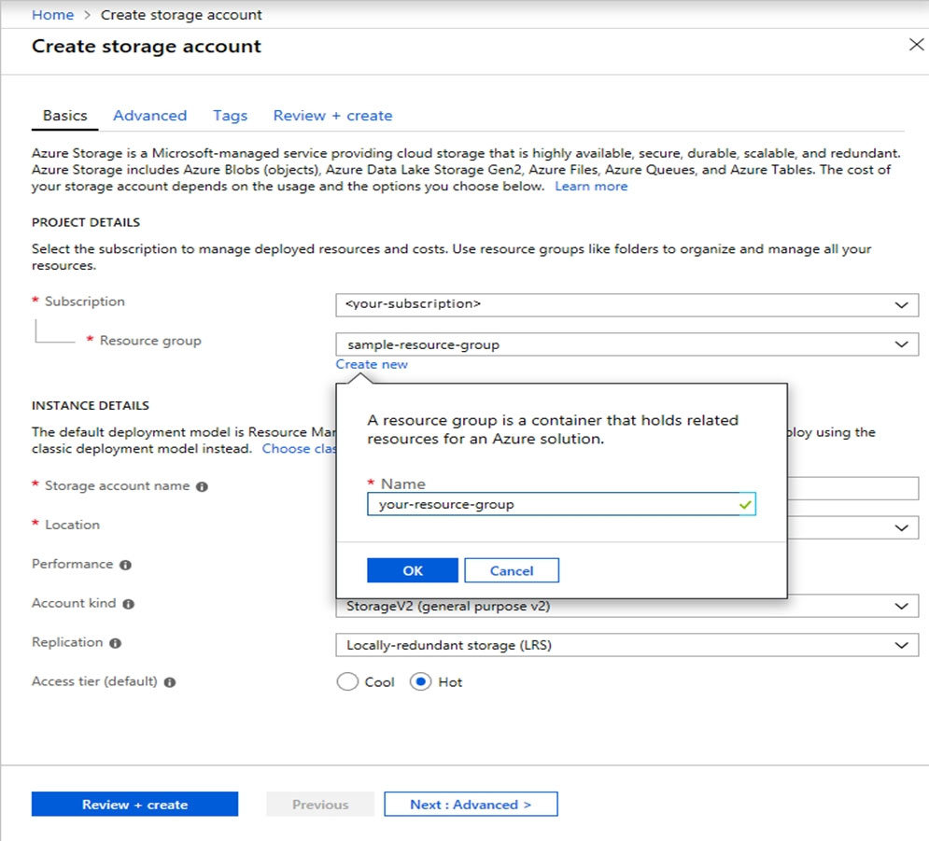  
Step 5: Enter a name for your storage account: corpdata9172795n2  
Step 6: For Account kind select: General-purpose v2 accounts (recommended for most scenarios)  
Step 7: For replication select: Read-access geo-redundant storage (RA-GRS) + Access tier: Hot

1. You have an Azure subscription that contains the resources in the following table.

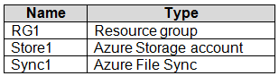

Store1 contains a file share named Data. Data contains 5,000 files.

You need to synchronize the files in the file share named Data to an on-premises server named Server1.

Which three actions should you perform? Each correct answer presents part of the solution.

NOTE: Each correct selection is worth one point.

**Answer**: E+B+C (B. Register Server1 + C. Create a sync group + E. Install the Azure File Sync agent on Server1)

1. You have an Azure subscription named Subscription1.  
   You create an Azure Storage account named contosostorage, and then you create a file share named data.  
   Which UNC path should you include in a script that references files from the data file share? To answer, drag the appropriate values to the correct targets. Each value may be used once, more than once, or not at all. You may need to drag the split bar between panes or scroll to view content.  
   NOTE: Each correct selection is worth one point.  
   Select and Place:  
   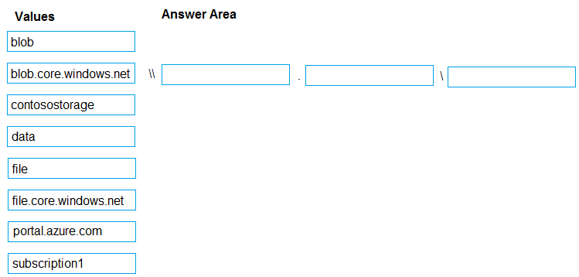

**Answer**: “contosostorage” + “file.core.windows.net” + “data”

1. You have an Azure subscription that contains a storage account.  
   You have an on-premises server named Server1 that runs Windows Server 2016. Server1 has 2 TB of data.  
   You need to transfer the data to the storage account by using the Azure Import/Export service.  
   In which order should you perform the actions? To answer, move all actions from the list of actions to the answer area and arrange them in the correct order.  
   NOTE: More than one order of answer choices is correct. You will receive credit for any of the correct orders you select.  
   Select and Place:  
   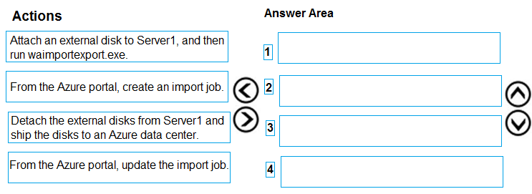

**Answer**:

Step 1: Attach an external disk to Server1 and then run waimportexport.exe

Step 2: From the Azure portal, create an import job.

Step 3: Detach the external disks from Server1 and ship the disks to an Azure data center.

Step 4: From the Azure portal, update the import job

1. You have the Azure virtual machines shown in the following table.  
   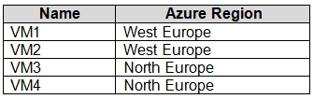  
   You have a Recovery Services vault that protects VM1 and VM2.  
   You need to protect VM3 and VM4 by using Recovery Services.  
   What should you do first?

**Answer**: D. Create a new Recovery Services vault.

1. You have an Azure subscription named Subscription1.

You have 5 TB of data that you need to transfer to Subscription1.

You plan to use an Azure Import/Export job.

What can you use as the destination of the imported data?

**Answer**: D. Azure Blob storage (OR Azure File Storage)

1. You have an Azure subscription that contains an Azure file share.  
   You have an on-premises server named Server1 that runs Windows Server 2016.  
   You plan to set up Azure File Sync between Server1 and the Azure file share.  
   You need to prepare the subscription for the planned Azure File Sync.  
   Which two actions should you perform in the Azure subscription? To answer, drag the appropriate actions to the correct targets. Each action may be used once, more than once, or not at all. You may need to drag the split bar between panes or scroll to view content.  
   NOTE: Each correct selection is worth one point.  
   Select and Place:  
   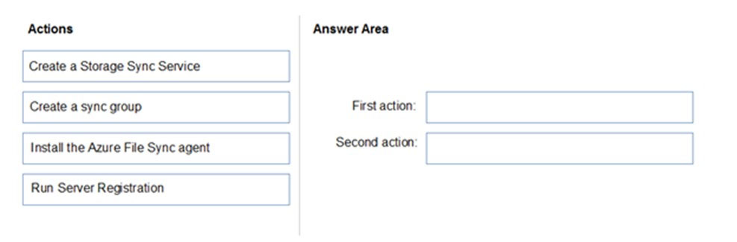

**Answer**: Create a Storage Sync Service + Create a sync group.

1. You plan to create an Azure Storage account in the Azure region of East US 2.  
   You need to create a storage account that meets the following requirements:  
   ✑ Replicates synchronously.  
   ✑ Remains available if a single data center in the region fails.  
   How should you configure the storage account? To answer, select the appropriate options in the answer area.  
   NOTE: Each correct selection is worth one point.  
   Hot Area:  
   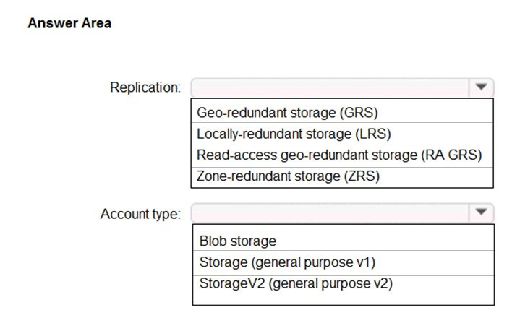

**Answer**: Zone-redundant storage (ZRS) + StorageV2 (general purpose v2)

1. You purchase a new Azure subscription named Subscription1.  
   You create a virtual machine named VM1 in Subscription1. VM1 is not protected by Azure Backup.  
   You need to protect VM1 by using Azure Backup. Backups must be created at 01:00 and stored for 30 days.  
   What should you do? To answer, select the appropriate options in the answer area,  
   NOTE: Each correct selection is worth one point.  
   Hot Area:  
   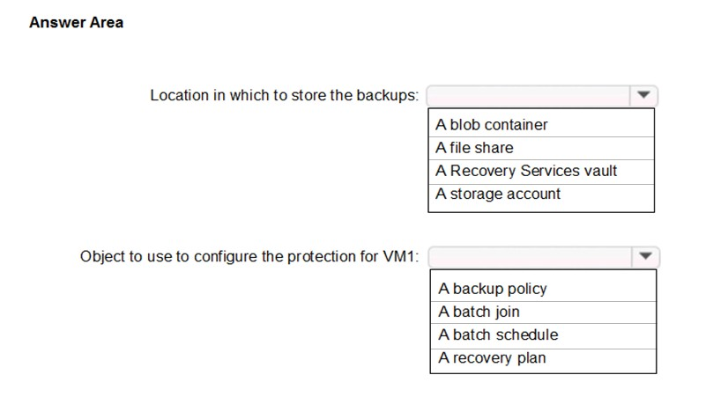

**Answer**: A Recovery Services vault + A backup policy

1. You have an Azure subscription named Subscription1. Subscription1 contains a virtual machine named VM1.  
   You install and configure a web server and a DNS server on VM1.  
   VM1 has the effective network security rules shown in the following exhibit.  
   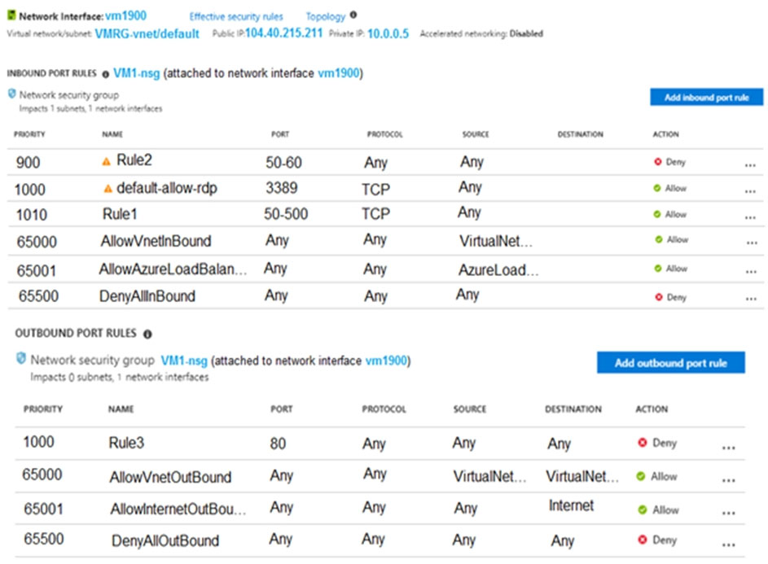  
   Use the drop-down menus to select the answer choice that completes each statement based on the information presented.  
   NOTE: Each correct selection is worth one point.  
   Hot Area:  
   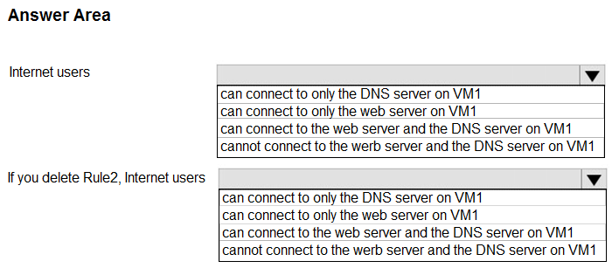

**Answer**: “can connect to only the web server on VM1” + “can connect to the web server and the DNS server on VM1”

1. You have an Azure Linux virtual machine that is protected by Azure Backup.  
   One week ago, two files were deleted from the virtual machine.  
   You need to restore the deleted files to an on-premises computer as quickly as possible.  
   Which four actions should you perform in sequence? To answer, move the appropriate actions from the list of actions to the answer area and arrange them in the correct order.  
   Select and Place:  
   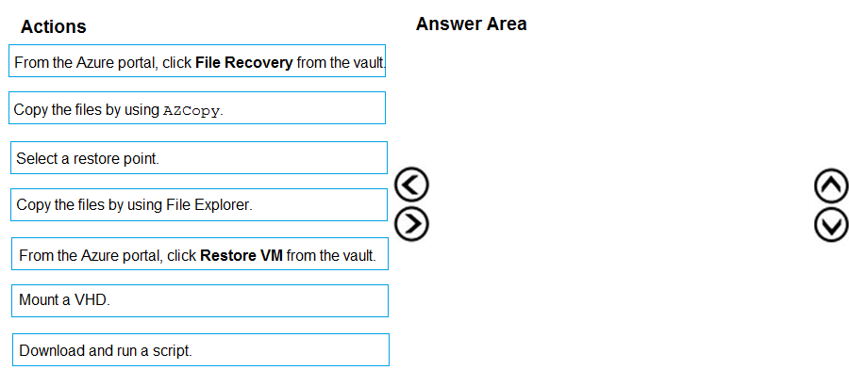

**Answer**:

Step 1. From the Azure portal, click File Recovery from the vault.

Step 2. Select a restore point.

Step 3. Download and run a script.

Step 4. Copy the files by using AzCopy. (if Windows, it’s File Explorer)

1. You plan to protect on-premises virtual machines and Azure virtual machines by using Azure Backup.

You need to prepare the backup infrastructure in Azure. The solution must minimize the cost of storing the backups in Azure.

What should you do from the Azure portal?

**Answer**:

First, create Recovery Services vault.  
Step 1: On the left-hand menu, select All services and in the services list, type Recovery Services. As you type, the list of resources filters. When you see  
Recovery Services vaults in the list, select it to open the Recovery Services vaults menu.  
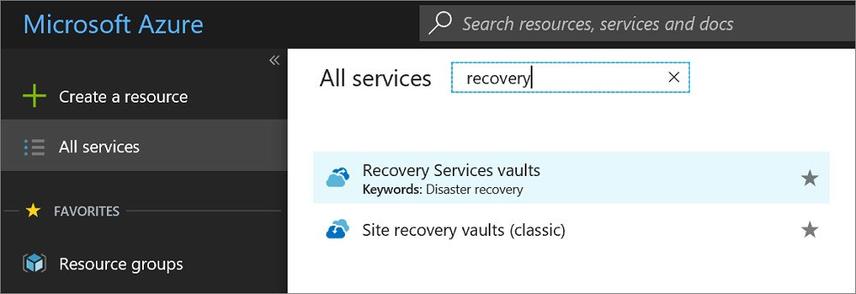  
Step 2: In the Recovery Services vaults menu, click Add to open the Recovery Services vault menu.  
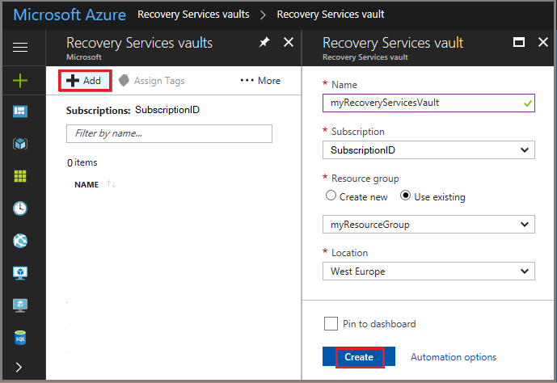  
Step 3: In the Recovery Services vault menu, for example,  
Type myRecoveryServicesVault in Name.  
The current subscription ID appears in Subscription. If you have additional subscriptions, you could choose another subscription for the new vault.  
For Resource group select Use existing and choose myResourceGroup. If myResourceGroup does not exist, select Create new and type myResourceGroup.  
From the Location drop-down menu, choose West Europe.  
Click Create to create your Recovery Services vault, then go to “Properties”, “Backup configuration update” and change Storage Replication type to Locally-Redundant.

1. You need to deploy two Azure virtual machines named VM1003a and VM1003b based on an Ubuntu Server image. The deployment must meet the following requirements:

✑ Provide a Service Level Agreement (SLA) of 99.95 percent availability.

✑ Use managed disks.

What should you do from the Azure portal?

Step 1: Open the Azure portal.

Step 1b: Create availability set.

Step 2: On the left menu, select All resources. You can sort the resources by Type to easily find your images.

Step 3: Select the image you want to use from the list. The image Overview page opens.

Step 4: Select Create VM from the menu.

Step 5: Enter the virtual machine information.

Select VM1003a as the name for the first Virtual machine.

The username and password entered here will be used to log in to the virtual machine. When complete, select OK. You can create the new VM in an existing resource group or choose Create new to create a new resource group to store the VM.

Step 6: Select a size for the VM. To see more sizes, select View all or change the Supported disk type filter.

Step 7: Under Settings, make changes as necessary and select OK.

Step 8: On the summary page, you should see your image name listed as a Private image. Select Ok to start the virtual machine deployment.

Repeat the procedure for the second VM and name it VM1003b, then associate both to availability set.

You need to deploy an Azure virtual machine named VM1004a based on an Ubuntu Server image, and then configure VM1004a to meet the following requirements:

✑ The virtual machine must contain data disks that can store at least 15 TB of data.

✑ The data disks must be able to provide at least 2.000 IOPS.

✑ Storage costs must be minimized.

What should you do from the Azure portal?

**Answer**:

Step 1: Open the Azure portal.

Step 2: On the left menu, select All resources. You can sort the resources by Type to easily find your images.

Step 3: Select the image you want to use from the list. The image Overview page opens.

Step 4: Select Create VM from the menu.

Step 5: Enter the virtual machine information.

Select VM1004a as the name for the first Virtual machine.

The username and password entered here will be used to log in to the virtual machine. When complete, select OK. You can create the new VM in an existing resource group or choose Create new to create a new resource group to store the VM.

Step 6: Select a size for the VM. To see more sizes, select View all or change the Supported disk type filter.

To meet the requirements, select Standard SSD E70.

Step 7: Under Settings, make changes as necessary and select OK.

Step 8: On the summary page, you should see your image name listed as a Private image. Select Ok to start the virtual machine deployment.

1. You have an Azure subscription that contains a virtual machine named VM1. VM1 hosts a line-of-business application that is available 24 hours a day. VM1 has one network interface and one managed disk. VM1 uses the D4s v3 size.

You plan to make the following changes to VM1:

✑ Change the size to D8s v3.

✑ Add a 500-GB managed disk.

✑ Add the Puppet Agent extension.

✑ Attach an additional network interface.

Which change will cause downtime for VM1?

**Answer**: B. Change the size to D8s v3.

1. You have an Azure virtual machine named VM1 that you use for testing. VM1 is protected by Azure Backup.

You delete VM1.

You need to remove the backup data stored for VM1.

What should you do first?

**Answer**: C. Stop the backup.

1. You have an Azure subscription named Subscription1.

You deploy a Linux virtual machine named VM1 to Subscription1.

You need to monitor the metrics and the logs of VM1.

What should you use?

**Answer**: C. Linux Diagnostic Extension (LAD) 3.0

1. You have an Azure subscription that contains 100 virtual machines.

You regularly create and delete virtual machines.

You need to identify unattached disks that can be deleted.

What should you do?

**Answer**: A. From Microsoft Azure Storage Explorer, view the Account Management properties.

1. You have an Azure virtual machine named VM1.

Azure collects events from VM1.

You are creating an alert rule in Azure Monitor to notify an administrator when an error is logged in the System event log of VM1.

You need to specify which resource type to monitor.

What should you specify?

**Answer**: C. Virtual machine.

1. You have an availability set named AS1 that contains three virtual machines named VM1, VM2, and VM3.  
   You attempt to reconfigure VM1 to use a larger size. The operation fails and you receive an allocation failure message.  
   You need to ensure that the resize operation succeeds.  
   Which three actions should you perform in sequence? To answer, move the appropriate actions from the list of actions to the answer area and arrange them in the correct order.  
   Select and Place:  
   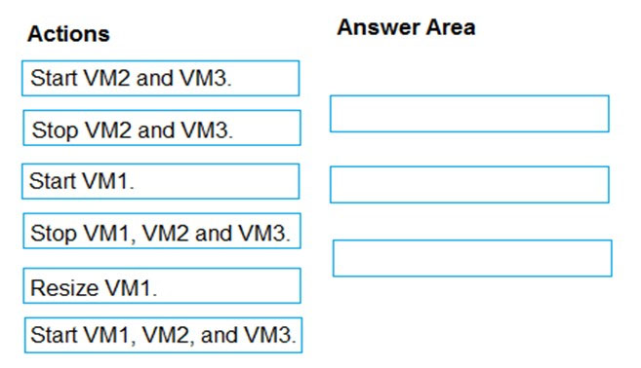

**Answer**: “Stop VM1, VM2 and VM3” + “Resize VM1” + “Start VM1, VM2 and VM3”

1. You plan to back up an Azure virtual machine named VM1.

You discover that the Backup Pre-Check status displays a status of Warning.

What is a possible cause of the Warning status?

**Answer**: B. VM1 does not have the latest version of WaAppAgent.exe installed.

1. You have an Azure subscription named Subscription1 that is used by several departments at your company. Subscription1 contains the resources in the following table.  
   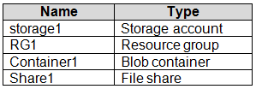  
   Another administrator deploys a virtual machine named VM1 and an Azure Storage account named Storage2 by using a single Azure Resource Manager template.  
   You need to view the template used for the deployment.  
   From which blade can you view the template that was used for the deployment?

**Answer**: B. RG1

1. You have an Azure subscription that contains the resources shown in the following table.  
   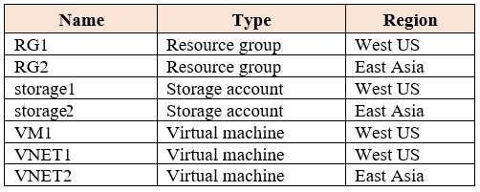  
   VM1 connects to VNET1.  
   You need to connect VM1 to VNET2.  
   Solution: You create a new network interface, and then you add the network interface to VM1.  
   Does this meet the goal?

**Answer**: No

1. You have an Azure subscription that contains the resources shown in the following table.  
   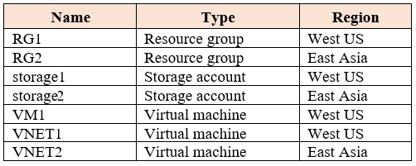  
   VM1 connects to VNET1.  
   You need to connect VM1 to VNET2.  
   Solution: You turn off VM1, and then you add a new network interface to VM1.  
   Does this meet the goal?

**Answer**: No

1. You have an Azure subscription that contains the resources shown in the following table.  
     
   VM1 connects to VNET1.  
   You need to connect VM1 to VNET2.  
   Solution: You delete VM1. You recreate VM1, and then you create a new network interface for VM1.  
   Does this meet the goal?

**Answer**: Yes

1. You have an Azure virtual machine named VM1. VM1 was deployed by using a custom Azure Resource Manager template named ARM1.json.

You receive a notification that VM1 will be affected by maintenance.

You need to move VM1 to a different host immediately.

Solution: From the Overview blade, you move the virtual machine to a different subscription.

Does this meet the goal?

**Answer**: No

1. You have an Azure virtual machine named VM1. VM1 was deployed by using a custom Azure Resource Manager template named ARM1.json.

You receive a notification that VM1 will be affected by maintenance.

You need to move VM1 to a different host immediately.

Solution: From the Redeploy blade, you click Redeploy.

Does this meet the goal?

**Answer**: Yes

1. You have an Azure virtual machine named VM1. VM1 was deployed by using a custom Azure Resource Manager template named ARM1.json.

You receive a notification that VM1 will be affected by maintenance.

You need to move VM1 to a different host immediately.

Solution: From the Update management blade, you click Enable.

Does this meet the goal?

**Answer**: No

1. You have an Azure subscription named Subscription1. Subscription1 contains two Azure virtual machines named VM1 and VM2. VM1 and VM2 run Windows  
   Server 2016.  
   VM1 is backed up daily by Azure Backup without using the Azure Backup agent.  
   VM1 is affected by ransomware that encrypts data.  
   You need to restore the latest backup of VM1.  
   To which location can you restore the backup? To answer, select the appropriate options in the answer area.  
   NOTE: Each correct selection is worth one point.  
   Hot Area:  
   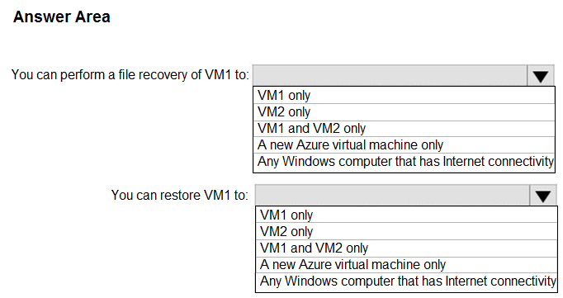

**Answer**: “VM2 only” + “VM1 and a new Azure virtual machine only”

1. You download an Azure Resource Manager template based on an existing virtual machine. The template will be used to deploy 100 virtual machines.

You need to modify the template to reference an administrative password. You must prevent the password from being stored in plain text.

What should you create to store the password?

**Answer**: A. an Azure Key Vault and an access policy

1. You create a virtual machine scale set named Scale1. Scale1 is configured as shown in the following exhibit.  
   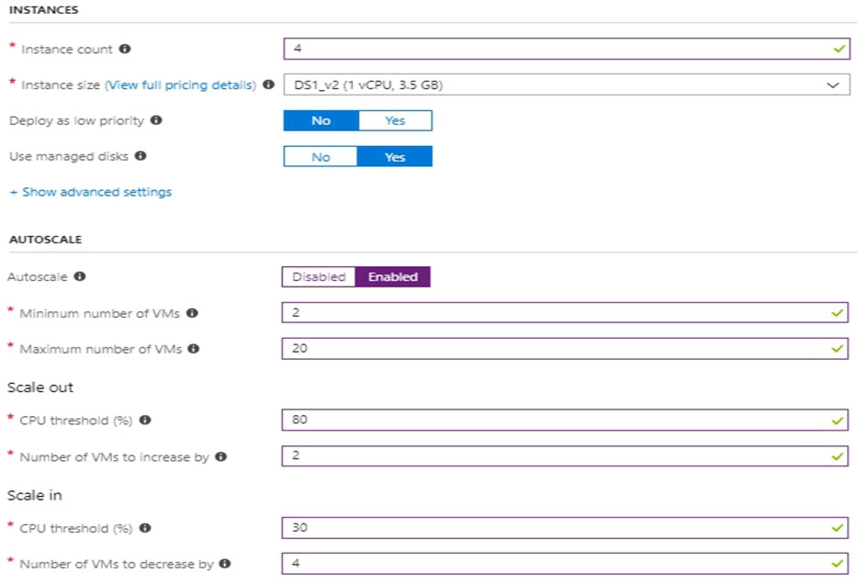  
   Use the drop-down menus to select the answer choice that completes each statement based on the information presented in the graphic.  
   NOTE: Each correct selection is worth one point.  
   Hot Area:  
   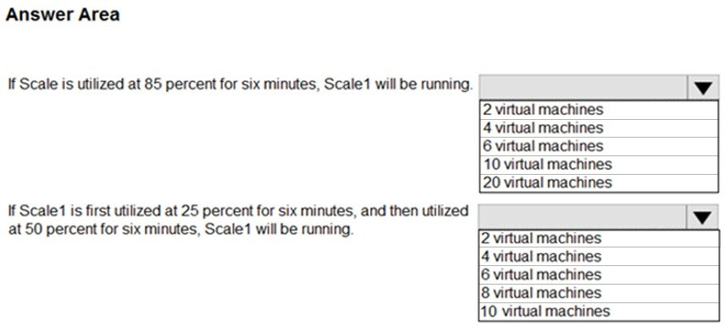

**Answer**: “6 virtual machines” + “2 virtual machines” (if does not specify timing, thus using default time, then answers would be 4 + 4)

1. LAB: You plan to back up all the Azure virtual machines in your Azure subscription at 02:00 Coordinated Universal Time (UTC) daily.

You need to prepare the Azure environment to ensure that any new virtual machines can be configured quickly for backup. The solution must ensure that all the daily backups performed at 02:00 UTC are stored for only 90 days.

What should you do from your Recovery Services vault on the Azure portal?

**Answer**:

Task A: Create a Recovery Services vault (if a vault already exists skip this task, go to Task B below)  
1. Create backup policy with correct retention and set it to the resource you want to protect (for ex., RG).

1. LAB: You plan to connect several virtual machines to the VNET01-USEA2 virtual network.

In the Web-RGlod9272261 resource group, you need to create a virtual machine that uses the Standard_B2ms size named Web01 that runs Windows Server

2016. Web01 must be added to an availability set.

What should you do from the Azure portal?

**Answer**:

Step 1: Choose Create a resource in the upper left-hand corner of the Azure portal.  
Step 2: In the Basics tab, under Project details, make sure the correct subscription is selected and then choose Web-RGlod9272261 resource group  
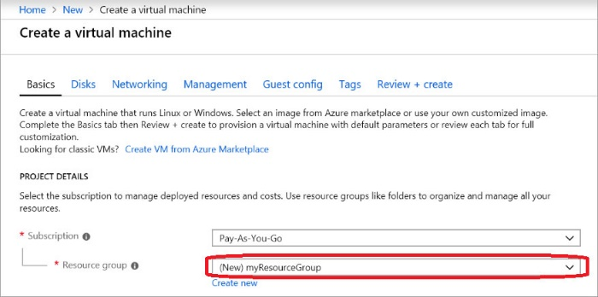  
Step 3: Under Instance details type/select:  
Virtual machine name: Web01 -  
Image: Windows Server 2016 -  
Size: Standard_B2ms size –

ALSO CREATE AN AVAILABILITY SET EITHER BEFORE OR DURING!  
Leave the other defaults.  
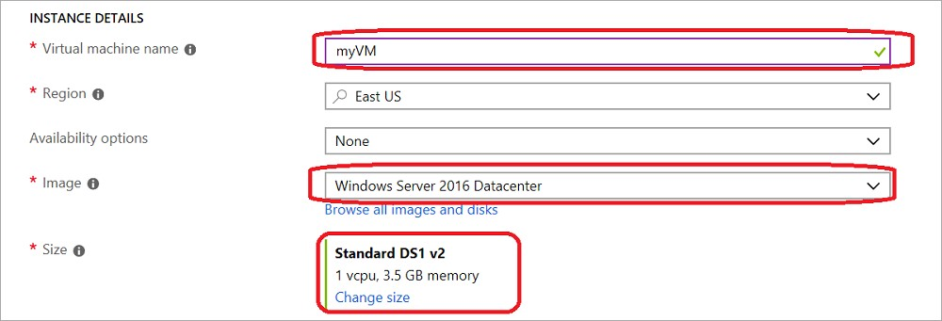  
Step 4: Finish the Wizard.

1. You plan to automate the deployment of a virtual machine scale set that uses the Windows Server 2016 Datacenter image.

You need to ensure that when the scale set virtual machines are provisioned, they have web server components installed.

Which two actions should you perform? Each correct answer presents part of the solution.

NOTE: Each correct selection is worth one point.

**Answer**: A+D (A. Modify the extensionProfile section of the Azure Resource Manager template + D. Create a new virtual machine scale set in the Azure portal)

1. You have two Azure virtual machines named VM1 and VM2. VM1 has a single data disk named Disk1.  
   You need to attach Disk1 to VM2. The solution must minimize downtime for both virtual machines.  
   Which four actions should you perform in sequence? To answer, move the appropriate actions from the list of actions to the answer area and arrange them in the correct order.  
   Select and Place:  
   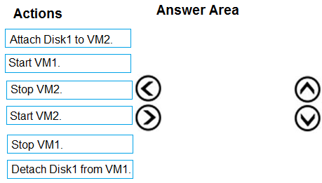

**Answer**: “Stop VM1” + “Detach Disk1 from VM1” + “Start VM1”

+ “Attach Disk1 to VM2”

1. You have an Azure subscription named Subscription1. Subscription1 contains the resources in the following table.  
   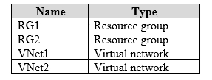  
   VNet1 is in RG1. VNet2 is in RG2. There is no connectivity between VNet1 and VNet2.  
   An administrator named Admin1 creates an Azure virtual machine named VM1 in RG1. VM1 uses a disk named Disk1 and connects to VNet1. Admin1 then installs a custom application in VM1.  
   You need to move the custom application to VNet2. The solution must minimize administrative effort.  
   Which two actions should you perform? To answer, select the appropriate options in the answer area.  
   NOTE: Each correct selection is worth one point.  
   Hot Area:  
   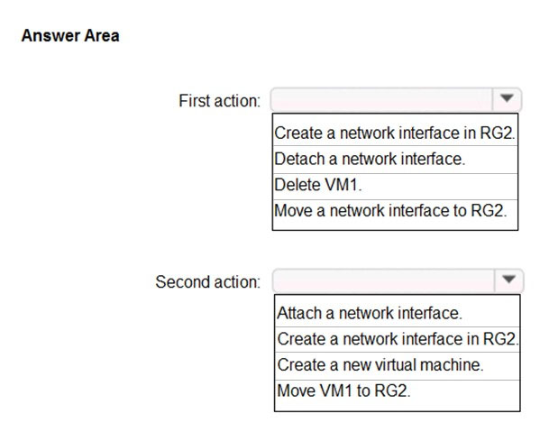

**Answer**: “Delete VM1” + “Create a new virtual machine”

1. You are creating an Azure load balancer.  
   You need to add an IPv6 load balancing rule to the load balancer.  
   How should you complete the Azure PowerShell script? To answer, select the appropriate options in the answer area.  
   NOTE: Each correct selection is worth one point.  
   Hot Area:  
   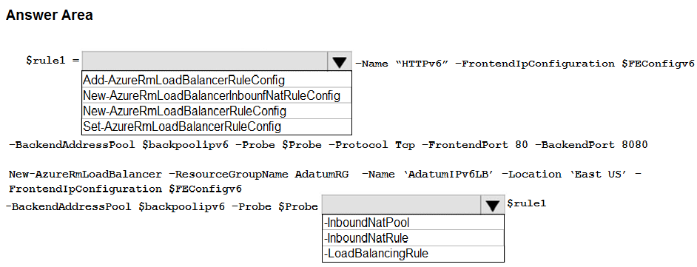

**Answer**: “New-AzureRmLoadBalancerRuleConfig” + “-LoadBalancingRule”

1. You have an Azure subscription named Subscription1 that contains a resource group named RG1.  
   In RG1, you create an internal load balancer named LB1 and a public load balancer named LB2.  
   You need to ensure that an administrator named Admin1 can manage LB1 and LB2. The solution must follow the principle of least privilege.  
   Which role should you assign to Admin1 for each task? To answer, select the appropriate options in the answer area.  
   NOTE: Each correct selection is worth one point.  
   Hot Area:  
   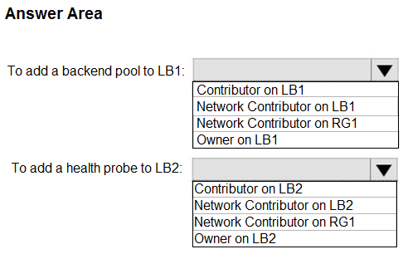

**Answer**: “Network Contributor on RG1” + “Network Contributor on LB2”

1. LAB: You plan to allow connections between the VNET01-USEA2 and VNET01-USWE2 virtual networks.

You need to ensure that virtual machines can communicate across both virtual networks by using their private IP address. The solution must NOT require any virtual network gateways.

What should you do from the Azure portal?

**Answer**:

Peer virtual networks -  
Step 1. In the Search box at the top of the Azure portal, begin typing VNET01-USEA2. When VNET01-USEA2 appears in the search results, select it.  
Step 2. Select Peerings, under SETTINGS, and then select + Add, as shown in the following picture:  
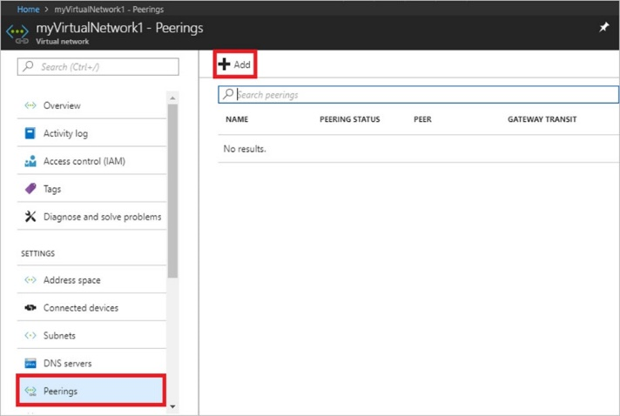  
Step 3. Enter, or select, the following information, accept the defaults for the remaining settings, and then select OK.  
Name: myVirtualNetwork1-myVirtualNetwork2 (for example)  
Subscription: elect your subscription.  
Virtual network: VNET01-USWE2 - To select the VNET01-USWE2 virtual network, select Virtual network, then select VNET01-USWE2. You can select a virtual network in the same region or in a different region.  
Now we need to repeat steps 1-3 for the other network VNET01-USWE2:  
Step 4. In the Search box at the top of the Azure portal, begin typing VNET01- USEA2. When VNET01- USEA2 appears in the search results, select it.  
(CAN CREATE BOTH ENDS OF THE PEERING IN THE SAME BLADE)

1. LAB: You plan to host several secured websites on Web01.

You need to allow HTTPS over TCP port 443 to Web01 and to prevent HTTP over TCP port 80 to Web01.

What should you do from the Azure portal?

**Answer**:  
Step A: Once created a VM, go to NSG, and create an inbound security rule to allows HTTPS over TCP port 443  
a1. Select your new network security group.  
a2. Select Inbound security rules, then select Add.  
a3. Add inbound rule -  
a4. Select Advanced.  
From the drop-down menu, select HTTPS.  
You can also verify by clicking Custom and selecting TCP port, and 443.  
a5. Select Add to create the rule.  
Repeat step a2-a5 to deny TCP port 80  
Step B: Associate your network security group with a subnet  
Your final step is to associate your network security group with a subnet or a specific network interface.  
b1. In the Search resources, services, and docs box at the top of the portal, begin typing Web01. When the Web01 VM appears in the search results, select it.  
b2. Under SETTINGS, select Networking. Select Configure the application security groups, select the Security Group you created in Step A, and then select Save, as shown in the following picture:  
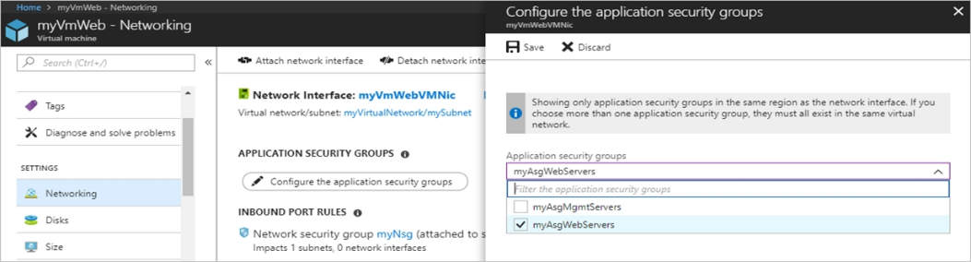

1. Your company registers a domain name of contoso.com.

You create an Azure DNS zone named contoso.com, and then you add an A record to the zone for a host named www that has an IP address of 131.107.1.10.

You discover that Internet hosts are unable to resolve www.contoso.com to the 131.107.1.10 IP address.

You need to resolve the name resolution issue.

Solution: You create a PTR record for www in the contoso.com zone.

Does this meet the goal?

**Answer**: No

1. You have five Azure virtual machines that run Windows Server 2016. The virtual machines are configured as web servers.

You have an Azure load balancer named LB1 that provides load balancing services for the virtual machines.

You need to ensure that visitors are serviced by the same web server for each request.

What should you configure?

**Answer**: D. Session persistence to Client IP and protocol

1. You have a public load balancer that balances ports 80 and 443 across three virtual machines.

You need to direct all the Remote Desktop Protocol (RDP) connections to VM3 only.

What should you configure?

**Answer**: A. an inbound NAT rule

1. You have an Azure subscription that contains three virtual networks named VNet1, VNet2, and VNet3. VNet2 contains a virtual appliance named VM2 that operates as a router.

You are configuring the virtual networks in a hub and spoke topology that uses VNet2 as the hub network.

You plan to configure peering between VNet1 and Vnet2 and between VNet2 and VNet3.

You need to provide connectivity between VNet1 and VNet3 through VNet2.

Which two configurations should you perform? Each correct answer presents part of the solution.

**Answer**: B + D (B. On the peering connections, allow forwarded traffic + D. Create route tables and assign the table to subnets)

1. You have an Azure subscription named Subscription1 that contains an Azure virtual network named VNet1. VNet1 connects to your on-premises network by using

Azure ExpressRoute.

You need to connect VNet1 to the on-premises network by using a site-to-site VPN. The solution must minimize cost.

Which three actions should you perform? Each correct answer presents part of the solution.

NOTE: Each correct selection is worth one point.

**Answer**: C+D+E (C. Create a connection + D. Create a local site VPN gateway + E. Create a VPN gateway that uses the VpnGw1 SKU)

1. Your company registers a domain name of contoso.com.

You create an Azure DNS zone named contoso.com, and then you add an A record to the zone for a host named www that has an IP address of 131.107.1.10.

You discover that Internet hosts are unable to resolve www.contoso.com to the 131.107.1.10 IP address.

You need to resolve the name resolution issue.

Solution: You modify the name servers at the domain registrar.

Does this meet the goal?

**Answer**: Yes

1. Your company registers a domain name of contoso.com.

You create an Azure DNS zone named contoso.com, and then you add an A record to the zone for a host named www that has an IP address of 131.107.1.10.

You discover that Internet hosts are unable to resolve www.contoso.com to the 131.107.1.10 IP address.

You need to resolve the name resolution issue.

Solution: You modify the SOA record in the contoso.com zone.

Does this meet the goal?

**Answer**: No

1. Your company registers a domain name of contoso.com.

You create an Azure DNS zone named contoso.com, and then you add an A record to the zone for a host named www that has an IP address of 131.107.1.10.

You discover that Internet hosts are unable to resolve www.contoso.com to the 131.107.1.10 IP address.

You need to resolve the name resolution issue.

Solution: You add an NS record to the contoso.com Azure DNS zone.

Does this meet the goal?

**Answer**: No

1. You are troubleshooting a performance issue for an Azure Application Gateway.

You need to compare the total requests to the failed requests during the past six hours.

What should you use?

**Answer**: B. Metrics in Application Gateway

1. You have two subscriptions named Subscription1 and Subscription2. Each subscription is associated to a different Azure AD tenant.

Subscription1 contains a virtual network named VNet1. VNet1 contains an Azure virtual machine named VM1 and has an IP address space of 10.0.0.0/16.

Subscription2 contains a virtual network named VNet2. VNet2 contains an Azure virtual machine named VM2 and has an IP address space of 10.10.0.0/24.

You need to connect VNet1 to VNet2.

What should you do first?

**Answer**: C. Provision virtual network gateways

1. You have an Azure subscription that contains two virtual networks named VNet1 and VNet2. Virtual machines connect to the virtual networks.  
   The virtual networks have the address spaces and the subnets configured as shown in the following table.  
   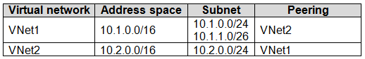  
   You need to add the address space of 10.33.0.0/16 to VNet1. The solution must ensure that the hosts on VNet1 and VNet2 can communicate.  
   Which three actions should you perform in sequence? To answer, move the appropriate actions from the list of actions to the answer area and arrange them in the correct order.  
   Select and Place:  
   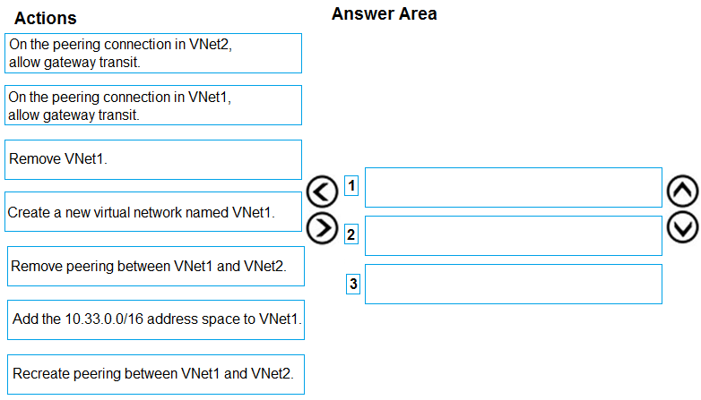

**Answer**: “Remove peering between VNet1 and VNet2” + “Add the 10.33.0.0/16 address space to VNet1” + “Recreate peering between VNet1 and VNet2”

1. You have an Azure subscription that contains the resources in the following table.  
   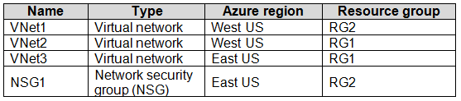  
   To which subnets can you apply NSG1?

**Answer**: E. the subnets on VNet3 only

1. You have an Azure virtual machine named VM1 that connects to a virtual network named VNet1. VM1 has the following configurations:  
   ✑ Subnet 10.0.0.0/24  
   ✑ Availability set: AVSet  
   ✑ Network security group (NSG): None  
   Private IP address: 10.0.0.4 (dynamic)  
   ✑ Public IP address: 40.90.219.6 (dynamic)  
   You deploy a standard, Internet-facing load balancer named slb1.  
   You need to configure slb1 to allow connectivity to VM1.  
   Which changes should you apply to VM1 as you configure slb1? To answer, select the appropriate options in the answer area.  
   NOTE: Each correct selection is worth one point.  
   Hot Area:  
   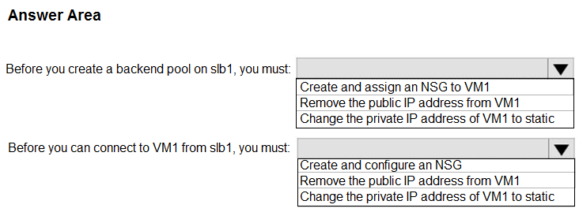

**Answer**: “Remove the public IP address from VM1” + “Create and configure a NSG”

1. You have five Azure virtual machines that run Windows Server 2016. The virtual machines are configured as web servers.

You have an Azure load balancer named LB1 that provides load balancing services for the virtual machines.

You need to ensure that visitors are serviced by the same web server for each request.

What should you configure?

**Answer**: C. Session persistence to Client IP

1. You have the Azure virtual networks shown in the following table.  
   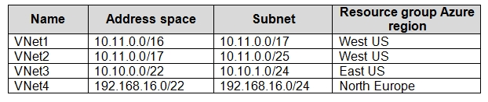  
   To which virtual networks can you establish a peering connection from VNet1?

**Answer**: C. VNet3, and VNet4 only.

1. You have an Azure subscription that contains a policy-based virtual network gateway named GW1 and a virtual network named VNet1.

You need to ensure that you can configure a point-to-site connection from VNet1 to an on-premises computer.

Which two actions should you perform? Each correct answer presents part of the solution.

NOTE: Each correct selection is worth one point.

**Answer**: B+C (B. Create a route-based virtual network gateway + C. Delete GW1)

1. You have an Azure subscription named Subscription1. Subscription1 contains the virtual networks in the following table.  
   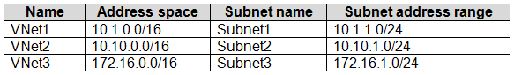  
   Subscription1 contains the virtual machines in the following table.  
   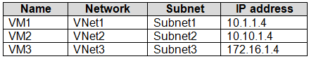  
   The firewalls on all the virtual machines are configured to allow all ICMP traffic.  
   You add the peerings in the following table.  
   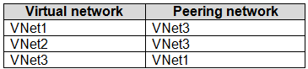  
   For each of the following statements, select Yes if the statement is true. Otherwise, select No.  
   NOTE: Each correct selection is worth one point.  
   Hot Area:  
   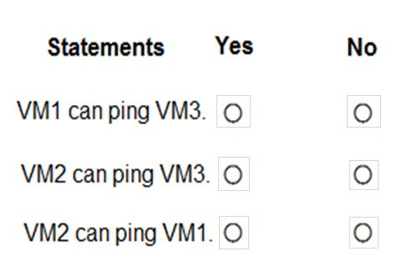

**Answer**: Yes, No + No

1. You have an Azure subscription that contains 10 virtual networks. The virtual networks are hosted in separate resource groups.

Another administrator plans to create several network security groups (NSGs) in the subscription.

You need to ensure that when an NSG is created, it automatically blocks TCP port 8080 between the virtual networks.

Solution: You create a resource lock, and then you assign the lock to the subscription.

Does this meet the goal?

**Answer**: No

1. You have an Azure subscription that contains 10 virtual networks. The virtual networks are hosted in separate resource groups.

Another administrator plans to create several network security groups (NSGs) in the subscription.

You need to ensure that when an NSG is created, it automatically blocks TCP port 8080 between the virtual networks.

Solution: You configure a custom policy definition, and then you assign the policy to the subscription.

Does this meet the goal?

**Answer**: Yes

1. You have an Azure subscription that contains 10 virtual networks. The virtual networks are hosted in separate resource groups.

Another administrator plans to create several network security groups (NSGs) in the subscription.

You need to ensure that when an NSG is created, it automatically blocks TCP port 8080 between the virtual networks.

Solution: From the Resource providers blade, you unregister the Microsoft.ClassicNetwork provider.

Does this meet the goal?

**Answer**: No

1. You have an Azure subscription named Subscription1. Subscription1 contains a virtual machine named VM1.  
   You have a computer named Computer1 that runs Windows 10. Computer1 is connected to the Internet.  
   You add a network interface named Interface1 to VM1 as shown in the exhibit. (Click the Exhibit tab.)  
   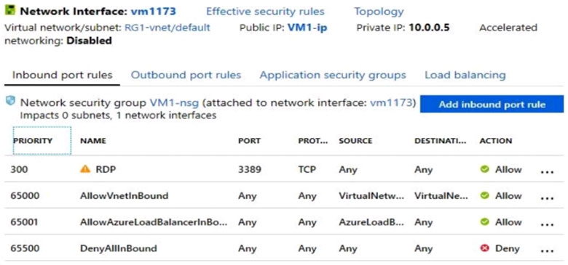  
   From Computer1, you attempt to connect to VM1 by using Remote Desktop, but the connection fails.  
   You need to establish a Remote Desktop connection to VM1.  
   What should you do first?

**Answer**: D. Start VM1

1. You plan to use Azure Network Watcher to perform the following tasks:  
   ✑ Task1: Identify a security rule that prevents a network packet from reaching an Azure virtual machine.  
   ✑ Task2: Validate outbound connectivity from an Azure virtual machine to an external host.  
   Which feature should you use for each task? To answer, select the appropriate options in the answer area.  
   NOTE: Each correct selection is worth one point.  
   Hot Area:  
   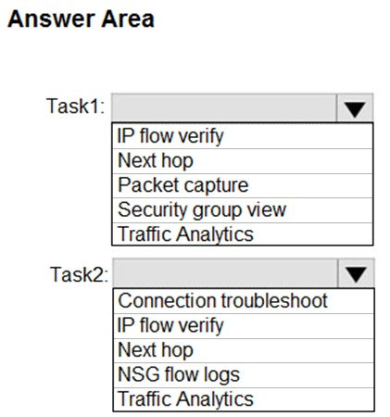

**Answer**: “IP flow verify” + “Connection troubleshoot”

1. You have an Azure subscription named Subscription1. Subscription1 contains the resources in the following table.  
   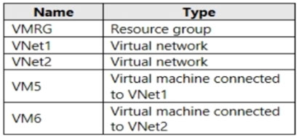  
   In Azure, you create a private DNS zone named adatum.com. You set the registration virtual networks to VNet2. The adatum.com zone is configured as shown in the following exhibit.  
   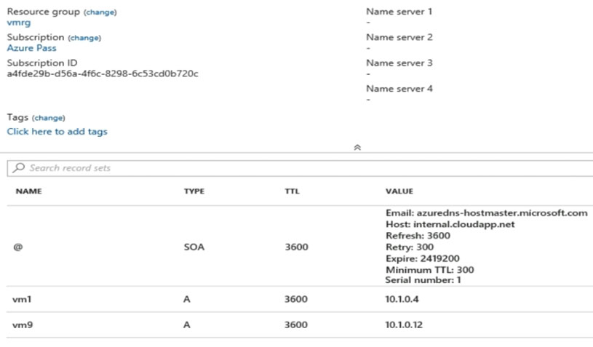  
   For each of the following statements, select Yes if the statement is true. Otherwise, select No.  
   NOTE: Each correct selection is worth one point.  
   Hot Area:  
   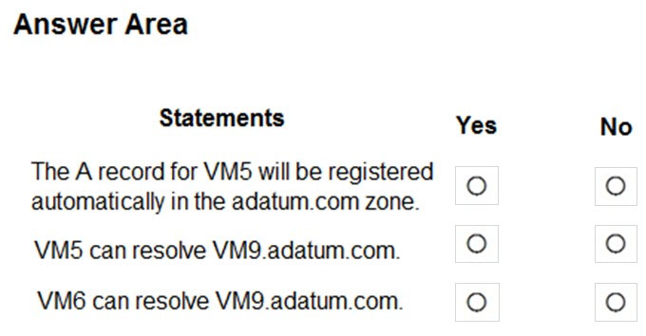

**Answer**: No, No + Yes

1. You have an Azure virtual machine named VM1.  
   The network interface for VM1 is configured as shown in the exhibit. (Click the Exhibit tab.)  
   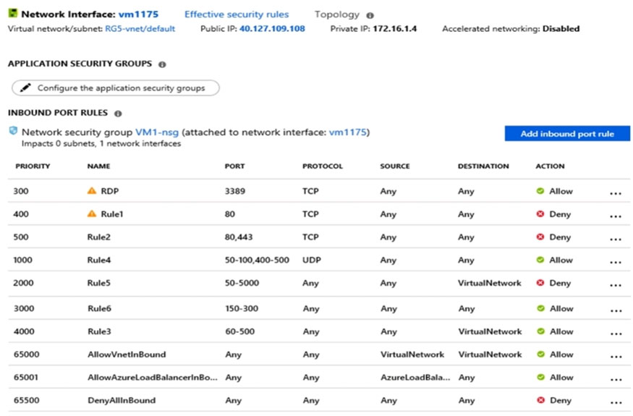  
   You deploy a web server on VM1, and then create a secure website that is accessible by using the HTTPS protocol. VM1 is used as a web server only.  
   You need to ensure that users can connect to the website from the internet.  
   What should you do?

**Answer**: B. For Rule5, change the Action to Allow and change the priority to 401

1. You have peering configured as shown in the following exhibit.  
   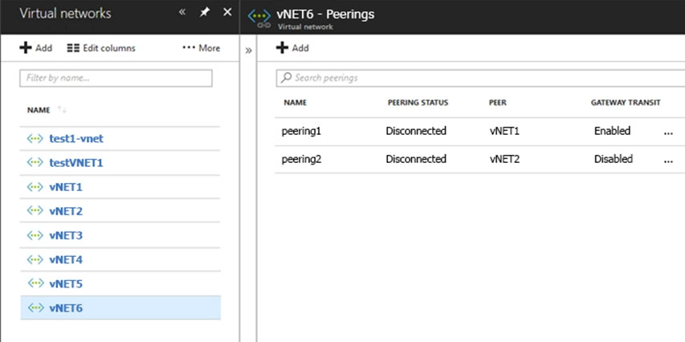  
   Use the drop-down menus to select the answer choice that completes each statement based on the information presented in the graphic.  
   NOTE: Each correct selection is worth one point.  
   Hot Area:  
   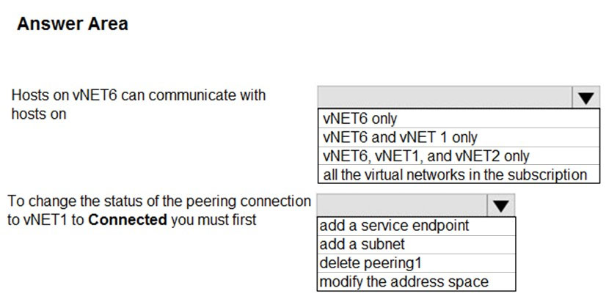

**Answer**: “Vnet6 only” + “delete peering1”

1. You plan to deploy five virtual machines to a virtual network subnet.  
   Each virtual machine will have a public IP address and a private IP address.  
   Each virtual machine requires the same inbound and outbound security rules.  
   What is the minimum number of network interfaces and network security groups that you require? To answer, select the appropriate options in the answer area.  
   NOTE: Each correct selection is worth one point.  
   Hot Area:  
   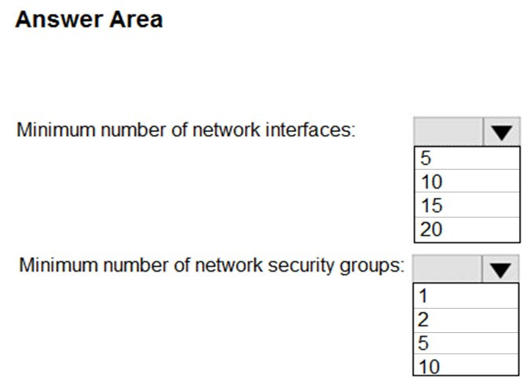

**Answer**: 5 + 1

1. You have an Azure subscription named Subscription1 that contains the resource groups shown in the following table.  
   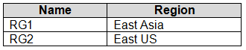  
   In RG1, you create a virtual machine named VM1 in the East Asia location.  
   You plan to create a virtual network named VNET1.  
   You need to create VNET1, and then connect VM1 to VNET1.  
   What are two possible ways to achieve this goal? Each correct answer presents a complete solution.  
   NOTE: Each correct selection is worth one point.

**Answer**: A+E (A. Create VNET1 in RG2, and then set East Asia as the location + E. Create VNET1 in RG1, and then set East Asia as the location)

1. You have an Azure subscription that contains a virtual network named VNet1. VNet1 contains four subnets named Gateway, Perimeter, NVA, and Production.

The NVA subnet contains two network virtual appliances (NVAs) that will perform network traffic inspection between the Perimeter subnet and the Production subnet.

You need to implement an Azure load balancer for the NVAs. The solution must meet the following requirements:

✑ The NVAs must run in an active-active configuration that uses automatic failover.

✑ The NVAs must load balance traffic to two services on the Production subnet. The services have different IP addresses.

Which three actions should you perform? Each correct answer presents part of the solution.

NOTE: Each correct selection is worth one point.

**Answer**: BCD (B. Add a frontend IP configuration, two backend pools, and a health probe + C. Add two load balancing rules that have HA Ports and Floating IP enabled + D. Deploy a standard load balancer)

1. LAB: Your on-premises network uses an IP address range of 131.107.2.0 to 131.107.2.255.

You need to ensure that only device from the on-premises network can connect to the rg1lod9172796n1 storage account.

What should you do from the Azure portal?

**Answer**:

Step 1: Navigate to the rg1lod9172796n1 storage account.

Step 2: Click on the settings menu called Firewalls and virtual networks.

Step 3: Ensure that you have elected to allow access from 'Selected networks'.

Step 4: Just provide 131.107.2.0/24 as CIDR.

1. LAB: Another administrator attempts to establish connectivity between two virtual networks named VNET1 and VNET2.

The administrator reports that connections across the virtual networks fail.

You need to ensure that network connections can be established successfully between VNET1 and VNET2 as quickly as possible.

What should you do from the Azure portal?

**Answer**:

You can connect one VNet to another VNet using either a Virtual network peering, or an Azure VPN Gateway.  
To create a virtual network gateway  
Step 1: In the portal, on the left side, click +Create a resource and type 'virtual network gateway' in search. Locate Virtual network gateway in the search return and click the entry. On the Virtual network gateway page, click Create at the bottom of the page to open the Create virtual network gateway page.  
Step 2: On the Create virtual network gateway page, fill in the values for your virtual network gateway.  
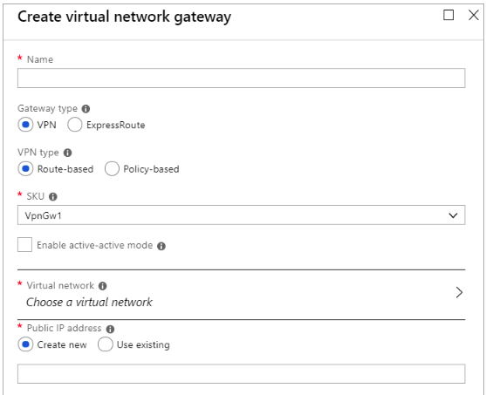  
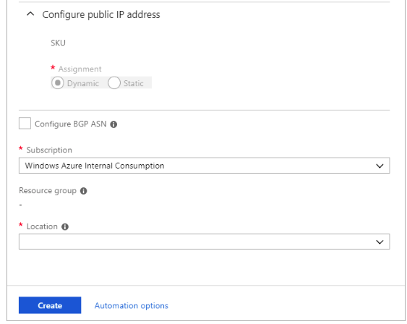  
Name: Name your gateway. This is not the same as naming a gateway subnet. It's the name of the gateway object you are creating.  
Gateway type: Select VPN. VPN gateways use the virtual network gateway type VPN.  
Virtual network: Choose the virtual network to which you want to add this gateway. Click Virtual network to open the 'Choose a virtual network' page. Select the  
VNet. If you don't see your VNet, make sure the Location field is pointing to the region in which your virtual network is located.  
Gateway subnet address range: You will only see this setting if you did not previously create a gateway subnet for your virtual network. If you previously created a valid gateway subnet, this setting will not appear.  
Step 4: Select Create New to create a Gateway subnet.  
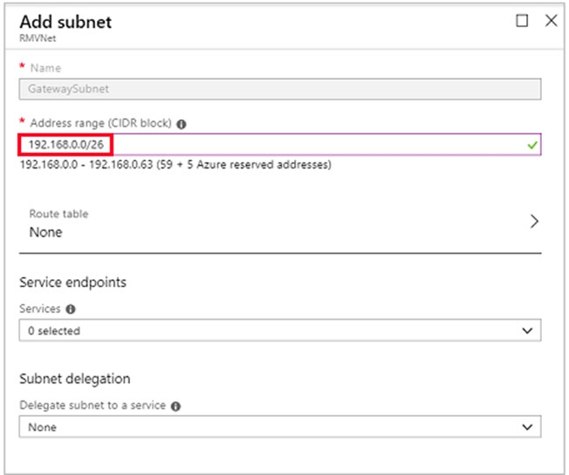  
Step 5: Click Create to begin creating the VPN gateway. The settings are validated and you'll see the "Deploying Virtual network gateway" tile on the dashboard.  
Creating a gateway can take up to 45 minutes. You may need to refresh your portal page to see the completed status.

1. LAB: You plan to configure VM1 to be accessible from the Internet.

You need to add a public IP address to the network interface used by VM1.

What should you do from the Azure portal?

**Answer**:

You can add private and public IP addresses to an Azure network interface by completing the steps that follow.  
Step 1: In Azure portal, click More services > type virtual machines in the filter box, and then click Virtual machines.  
Step 2: In the Virtual machines pane, click the VM you want to add IP addresses to. Click Network interfaces in the virtual machine pane that appears, and then select the network interface you want to add the IP addresses to. In the example shown in the following picture, the NIC named myNIC from the VM named myVM is selected:  
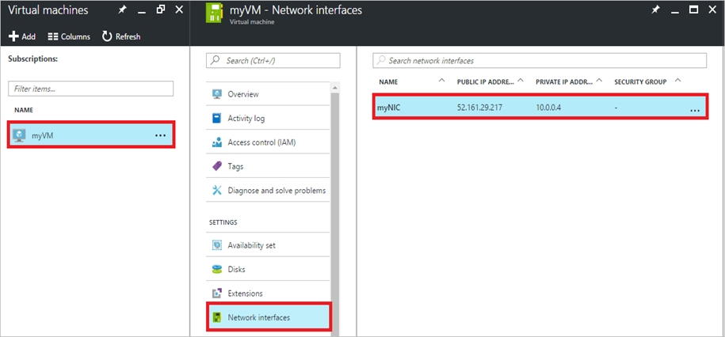  
Step 3: In the pane that appears for the NIC you selected, click IP configurations.  
Step 4: Click Create public IP address (OR Add).  
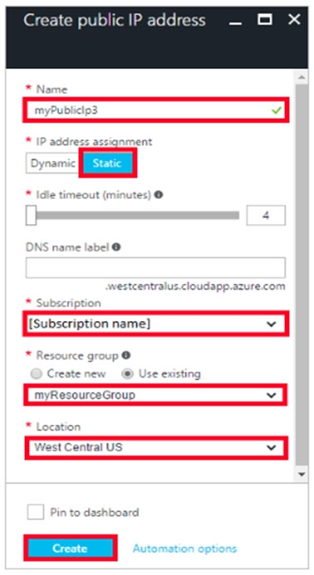  
Step 5: In the Create public IP address pane that appears, enter a Name, select an IP address assignment type, a Subscription, a Resource group, and a  
Location, then click Create.

Step 6: Also must update the NSG to allow port 80.

1. LAB: You need to allow RDP connections over TCP port 3389 to VM1 from the Internet. The solution must prevent connections from the Internet over all other TCP ports.

What should you do from the Azure portal?

**Answer**:

Step 1: Create a new network security group  
Step 2: Select your new network security group.  
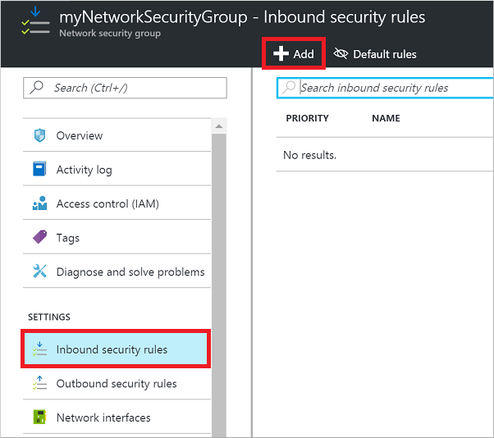  
Step 3: Select Inbound security rules. Under Add inbound security rule, enter the following  
Destination: Select Network security group, and then select the security group you created previously.  
Destination port ranges: 3389 -  
Protocol: Select TCP -  
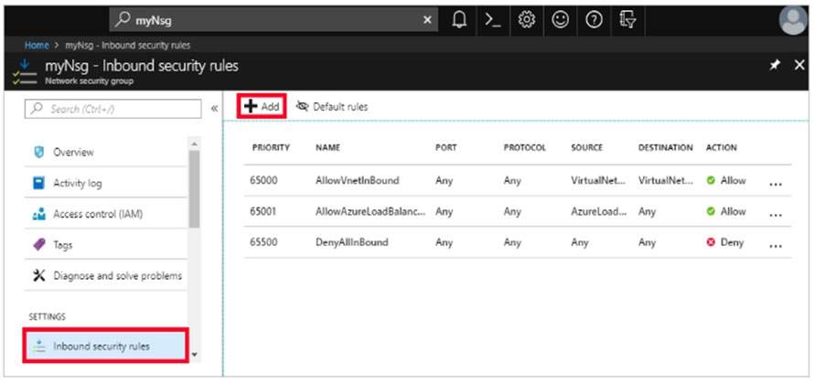

DON’T FORGET TO ASSOCIATE SUBNET.

<https://docs.microsoft.com/en-us/azure/virtual-machines/troubleshooting/troubleshoot-rdp-nsg-problem#solution>

1. You have an Azure subscription that contains a virtual network named VNET1. VNET1 contains the subnets shown in the following table.  
   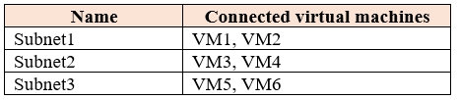  
   Each virtual machine uses a static IP address.  
   You need to create network security groups (NSGs) to meet following requirements:  
   ✑ Allow web requests from the internet to VM3, VM4, VM5, and VM6.  
   ✑ Allow all connections between VM1 and VM2.  
   ✑ Allow Remote Desktop connections to VM1.  
   Prevent all other network traffic to VNET1.  
     
   What is the minimum number of NSGs you should create?

**Answer**: 1

You have a computer named Computer1 that has a point-to-site VPN connection to an Azure virtual network named VNet1. The point-to-site connection uses a self-signed certificate.

From Azure, you download and install the VPN client configuration package on a computer named Computer2.

You need to ensure that you can establish a point-to-site VPN connection to VNet1 from Computer2.

Solution: You export the client certificate from Computer1 and install the certificate on Computer2.

Does this meet the goal?

**Answer**: Yes

1. You have a computer named Computer1 that has a point-to-site VPN connection to an Azure virtual network named VNet1. The point-to-site connection uses a self-signed certificate.

From Azure, you download and install the VPN client configuration package on a computer named Computer2.

You need to ensure that you can establish a point-to-site VPN connection to VNet1 from Computer2.

Solution: On Computer2, you set the Startup type for the IPSec Policy Agent service to Automatic.

Does this meet the goal?

**Answer**: No

1. You have an Azure subscription named Subscription1 that contains an Azure virtual network named VM1. VM1 is in a resource group named RG1.

VM1 runs services that will be used to deploy resources to RG1.

You need to ensure that a service running on VM1 can manage the resources in RG1 by using the identity of VM1.

What should you do first?

**Answer**: D. From the Azure portal, modify the value of the Managed Service Identity option for VM1.

1. LAB: You plan to create 100 Azure virtual machines on each of the following three virtual networks:

✑ VNET1005a

✑ VNET1005b

✑ VNET1005c

All the network traffic between the three virtual networks will be routed through VNET1005a.

You need to create the virtual networks, and then to ensure that all the Azure virtual machines can connect to other virtual machines by using their private IP address. The solution must NOT require any virtual network gateways and must minimize the number of peerings.

What should you do from the Azure portal before you configure IP routing?  
**Answer**:

Step 1: Click Create a resource in the portal.

Step 2: Enter Virtual network in the Search the Marketplace box at the top of the New pane that appears. Click Virtual network when it appears in the search results.

Step 3: Select Classic in the Select a deployment model box in the Virtual Network pane that appears, then click Create.

Step 4: Enter the following values on the Create virtual network (classic) pane and then click Create:

Name: VNET1005a -

Address space: 10.0.0.0/16 -

Subnet name: subnet0 -

Resource group: Create new -

Subnet address range: 10.0.0.0/24

Subscription and location: Select your subscription and location.

Step 5: Repeat steps 3-5 for VNET1005b (10.1.0.0/16, 10.1.0.0/24), and for VNET1005c 10.2.0.0/16, 10.2.0.0/24).

Step 6: Configure peerings

- VNET1005a to VNET1005b

- VNET1005a to VNET1005c

- Configure forwarded traffic settings:

Allow forwarded traffic from remote virtual network to VNET1005a: Enabled

Allow forwarded traffic from VNET1005a to remote virtual network: Enabled

1. LAB: You plan to create several virtual machines in different availability zones, and then to configure the virtual machines for load balanced connections from the

Internet.

You need to create an IP address resource named ip1006 to support the planned load balancing solution. The solution must minimize costs.

What should you do from the Azure portal?

**Answer**:

We should create a public IP address.

Step 1: At the top, left corner of the portal, select + Create a resource.

Step 2: Enter public ip address in the Search the Marketplace box. When Public IP address appears in the search results, select it.

Step 3: Under Public IP address, select Create.

Step 4: Enter, or select values for the following settings, under Create public IP address, then select Create:

Name: ip1006 -

SKU: Standard SKU -

IP Version: IPv4 -

IP address assignment: Static -

Subscription: Select appropriate

Resource group: Select appropriate

1. LAB: You need to create a virtual network named VNET1008 that contains three subnets named subnet0, subnet1, and subnet2. The solution must meet the following requirements:

✑ Connections from any of the subnets to the Internet must be blocked.

✑ Connections from the Internet to any of the subnets must be blocked.

✑ The number of network security groups (NSGs) and NSG rules must be minimized.

What should you do from the Azure portal?

**Answer**:

Step 1: Click Create a resource in the portal.

Step 2: Enter Virtual network in the Search the Marketplace box at the top of the New pane that appears. Click Virtual network when it appears in the search results.

Step 3: Select Classic in the Select a deployment model box in the Virtual Network pane that appears, then click Create.

Step 4: Enter the following values on the Create virtual network (classic) pane and then click Create:

Name: VNET1008 -

Address space: 10.0.0.0/16 -

Subnet name: subnet0 -

Resource group: Create new -

Subnet address range: 10.0.0.0/24

Subscription and location: Select your subscription and location.

Step 5: In the portal, you can create only one subnet when you create a virtual network. Click Subnets (in the SETTINGS section) on the Create virtual network

(classic) pane that appears.

Click +Add on the VNET1008 - Subnets pane that appears.

Step 6: Enter subnet1 for Name on the Add subnet pane. Enter 10.0.1.0/24 for Address range. Click OK.

Step 7: Create the third subnet: Click +Add on the VNET1008 - Subnets pane that appears. Enter subnet2 for Name on the Add subnet pane. Enter 10.0.2.0/24 for

Address range. Click OK.

Step 8: Create NSG with one inbound and one outbound rule and associate NSG to the subnets.

1. You manage a virtual network named VNet1 that is hosted in the West US Azure region.

VNet1 hosts two virtual machines named VM1 and VM2 that run Windows Server.

You need to inspect all the network traffic from VM1 to VM2 for a period of three hours.

Solution: From Azure Network Watcher, you create a connection monitor.

Does this meet the goal?

**Answer**: No

1. You manage a virtual network named VNet1 that is hosted in the West US Azure region.

VNet1 hosts two virtual machines named VM1 and VM2 that run Windows Server.

You need to inspect all the network traffic from VM1 to VM2 for a period of three hours.

Solution: From Azure Network Watcher, you create a packet capture.

Does this meet the goal?

**Answer**: Yes

1. You have an Azure subscription named Subscription1 that contains the virtual networks in the following table.  
   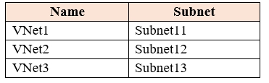  
   Subscription1 contains the virtual machines in the following table.  
   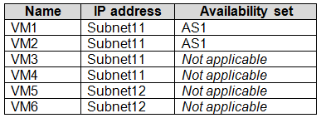  
   In Subscription1, you create a load balancer that has the following configurations:  
   ✑ Name: LB1  
   ✑ SKU: Basic  
   ✑ Type: Internal  
   ✑ Subnet: Subnet12  
   ✑ Virtual network: VNET1  
   For each of the following statements, select Yes if the statement is true. Otherwise, select No.  
   NOTE: Each correct selection is worth one point.  
   Hot Area:  
   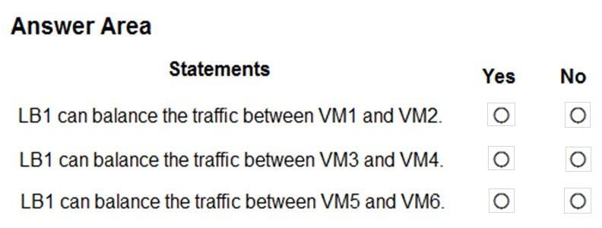

**Answer**: (AQUI HÁ TYPO: If Subnet 11 - Yes, No + No, if Subnet 12 – No, No, No)

1. You have an Azure subscription named Subscription1 that contains two Azure virtual networks named VNet1 and VNet2. VNet1 contains a VPN gateway named

VPNGW1 that uses static routing. There is a site-to-site VPN connection between your on-premises network and VNet1.

On a computer named Client1 that runs Windows 10, you configure a point-to-site VPN connection to VNet1.

You configure virtual network peering between VNet1 and VNet2. You verify that you can connect to VNet2 from the on-premises network. Client1 is unable to connect to VNet2.

You need to ensure that you can connect Client1 to VNet2.

What should you do?

**Answer**: D. Download and re-install the VPN client configuration package on Client1.

1. You manage a virtual network named VNet1 that is hosted in the West US Azure region.

VNet1 hosts two virtual machines named VM1 and VM2 that run Windows Server.

You need to inspect all the network traffic from VM1 to VM2 for a period of three hours.

Solution: From Performance Monitor, you create a Data Collector Set (DCS).

Does this meet the goal?

**Answer**: No

1. You have a virtual network named VNet1 that has the configuration shown in the following exhibit.  
   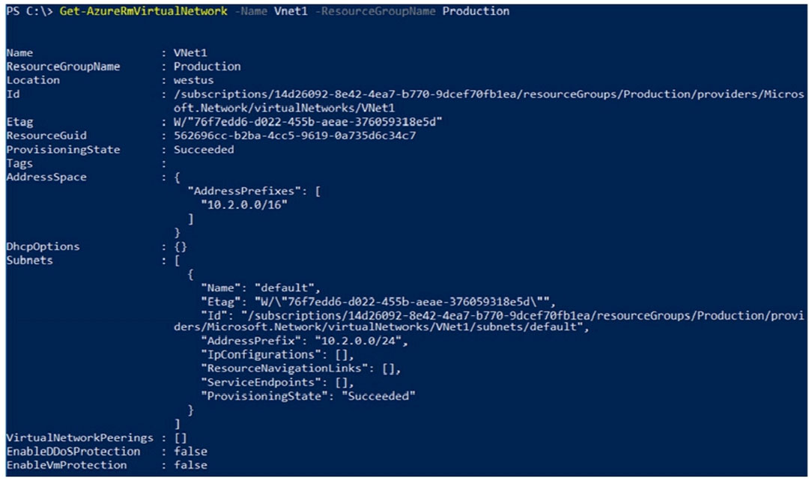  
   Use the drop-down menus to select the answer choice that completes each statement based on the information presented in the graphic.  
   NOTE: Each correct selection is worth one point.  
   Hot Area:  
   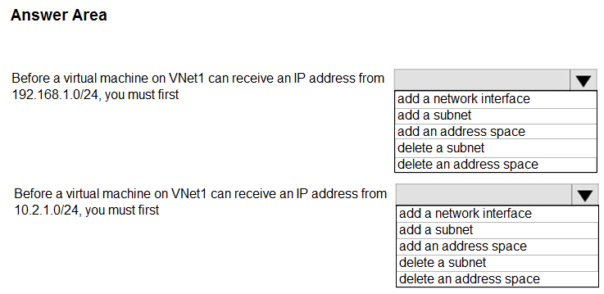

**Answer**: “add an address space” + “add a subnet”

1. You have an Azure subscription named Subscription1.  
   Subscription1 contains the virtual machines in the following table.  
   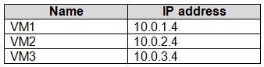  
   Subscription1 contains a virtual network named VNet1 that has the subnets in the following table.  
   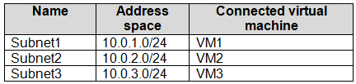  
   VM3 has multiple network adapters, including a network adapter named NIC3. IP forwarding is enabled on NIC3. Routing is enabled on VM3.  
   You create a route table named RT1 that contains the routes in the following table.  
   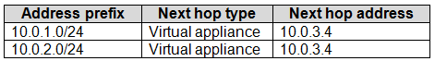  
   You apply RT1 to Subnet1 and Subnet2.  
   For each of the following statements, select Yes if the statement is true. Otherwise, select No.  
   NOTE: Each correct selection is worth one point.  
   Hot Area:  
   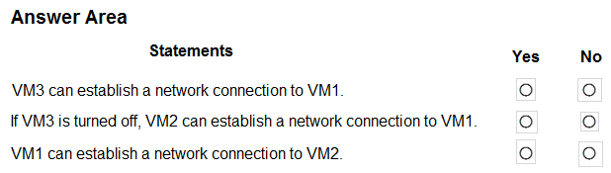

**Answer**: Yes, No, Yes

1. You have an Azure subscription that contains the resources in the following table.  
   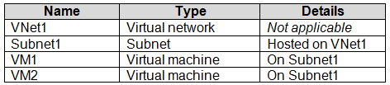  
   VM1 and VM2 are deployed from the same template and host line-of-business applications accessed by using Remote Desktop.  
   You configure the network security group (NSG) shown in the exhibit. (Click the Exhibit tab.)  
   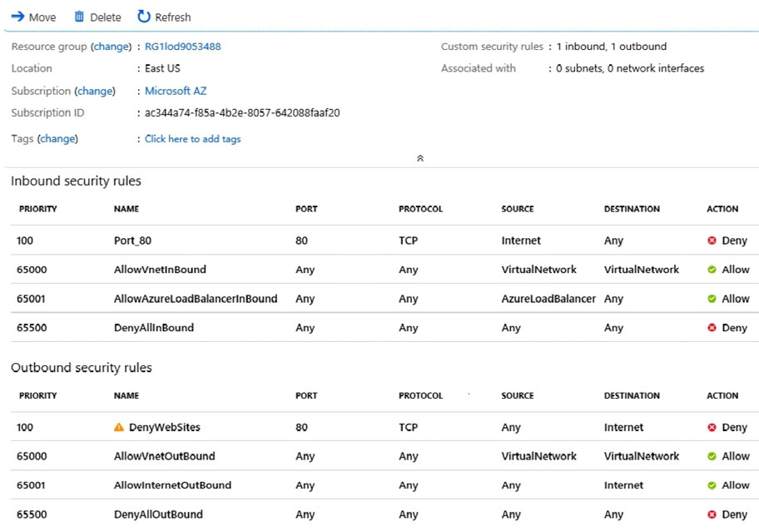  
   You need to prevent users of VM1 and VM2 from accessing websites on the Internet over TCP port 80.  
   What should you do?

**Answer**: D. Associate the NSG to Subnet1.

1. You have an on-premises data center and an Azure subscription. The data center contains two VPN devices. The subscription contains an Azure virtual network named VNet1. VNet1 contains a gateway subnet.  
   You need to create a site-to-site VPN. The solution must ensure that is a single instance of an Azure VPN gateway fails, or a single on-premises VPN device fails, the failure will not cause an interruption that is longer than two minutes.  
   What is the minimum number of public IP addresses, virtual network gateways, and local network gateways required in Azure? To answer, select the appropriate options in the answer area.  
   NOTE: Each correct selection is worth one point.  
   Hot Area:  
   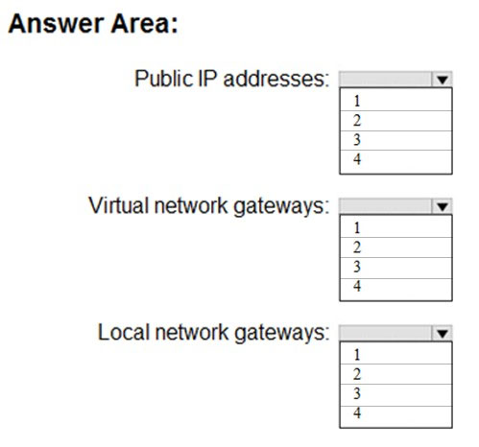

**Answer**: 4 + 2 + 2

1. You have two Azure virtual networks named VNet1 and VNet2. VNet1 contains an Azure virtual machine named VM1. VNet2 contains an Azure virtual machine named VM2.

VM1 hosts a frontend application that connects to VM2 to retrieve data.

Users report that the frontend application is slower than usual.

You need to view the average round-trip time (RTT) of the packets from VM1 to VM2.

Which Azure Network Watcher feature should you use?

**Answer**: B. Connection monitor

1. Your company has offices in New York and Los Angeles.  
   You have an Azure subscription that contains an Azure virtual network named VNet1. Each office has a site-to-site VPN connection to VNet1.  
   Each network uses the address spaces shown in the following table.  
   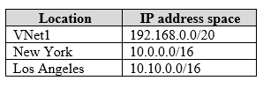  
   You need to ensure that all Internet-bound traffic from VNet1 is routed through the New York office.  
   What should you do? To answer, select the appropriate options in the answer area.  
   NOTE: Each correct selection is worth one point.  
   Hot Area:  
   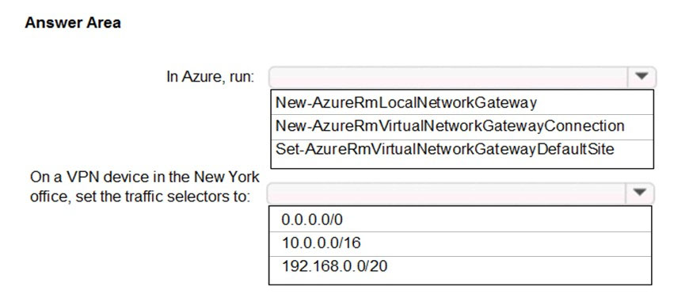

**Answer**: “Set-AzureRmVirtualNetworkGatewayDefaultSite” + “0.0.0.0/0”

1. You have an on-premises network that you plan to connect to Azure by using a site-to-site VPN.  
   In Azure, you have an Azure virtual network named VNet1 that uses an address space of 10.0.0.0/16. VNet1 contains a subnet named Subnet1 that uses an address space of 10.0.0.0/24.  
   You need to create a site-to-site VPN to Azure.  
   Which four actions should you perform in sequence? To answer, move the appropriate actions from the list of actions to the answer area and arrange them in the correct order.  
   NOTE: More than one order of answer choices is correct. You will receive credit for any of the correct orders you select.  
   Select and Place:  
   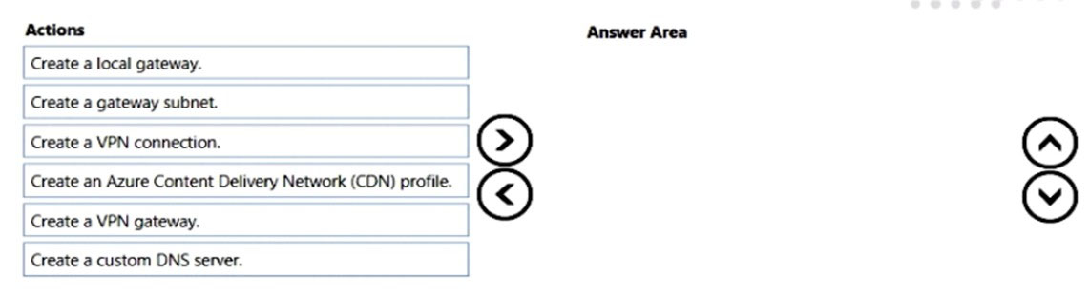

**Answer**: “Create a gateway subnet” + “Create a VPN gateway” + “Create a local gateway” + “Create a VPN connection”

1. You have an Azure subscription that contains a virtual network named VNet1. VNet1 uses an IP address space of 10.0.0.0/16 and contains the subnets in the following table.  
   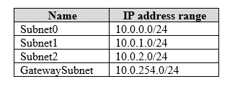  
   Subnet1 contains a virtual appliance named VM1 that operates as a router.  
   You create a routing table named RT1.  
   You need to route all inbound traffic from the VPN gateway to VNet1 through VM1.  
   How should you configure RT1? To answer, select the appropriate options in the answer area.  
   NOTE: Each correct selection is worth one point.  
   Hot Area:  
   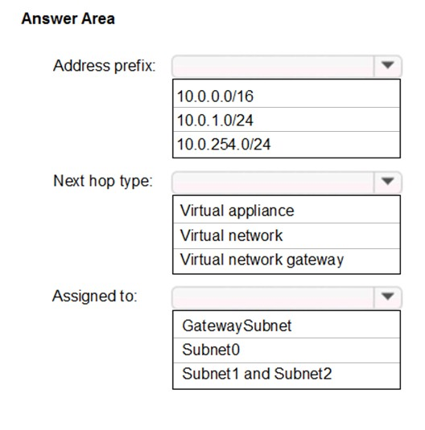

**Answer**: “10.0.0.0/16” + “Virtual appliance” + “GatewaySubnet”

1. You have a virtual network named VNet1 as shown in the exhibit. (Click the Exhibit tab.)  
   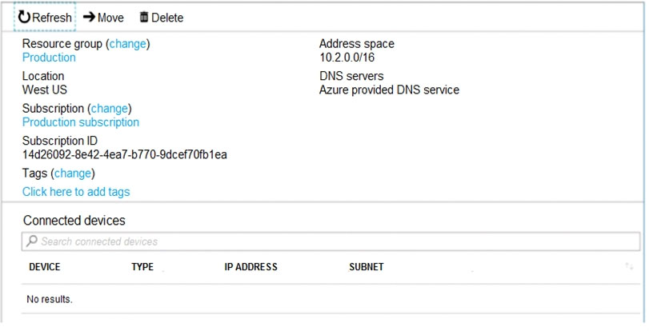  
   No devices are connected to VNet1.  
   You plan to peer VNet1 to another virtual network named VNet2 in the same region. VNet2 has an address space of 10.2.0.0/16.  
   You need to create the peering.  
   What should you do first?

**Answer**: C. Modify the address space of VNet1.

1. You have an Azure subscription that contains the resources shown in the following table.  
   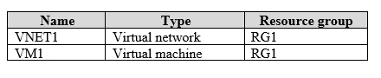  
   The Not allowed resource types Azure policy is assigned to RG1 and uses the following parameters:  
   Microsoft.Network/virtualNetworks  
   Microsoft.Compute/virtualMachines  
   In RG1, you need to create a new virtual machine named VM2, and then connect VM2 to VNET1.  
   What should you do first?

**Answer**: C. Remove Microsoft.Compute/virtualMachines from the policy.

1. You have an Azure virtual network named VNet1 that connects to your on-premises network by using a site-to-site VPN. VNet1 contains one subnet named  
   Subnet1.  
   Subnet1 is associated to a network security group (NSG) named NSG1. Subnet1 contains a basic internal load balancer named ILB1. ILB1 has three Azure virtual machines in the backend pool.  
   You need to collect data about the IP addresses that connects to ILB1. You must be able to run interactive queries from the Azure portal against the collected data.  
   What should you do? To answer, select the appropriate options in the answer area.  
   NOTE: Each correct selection is worth one point.  
   Hot Area:  
   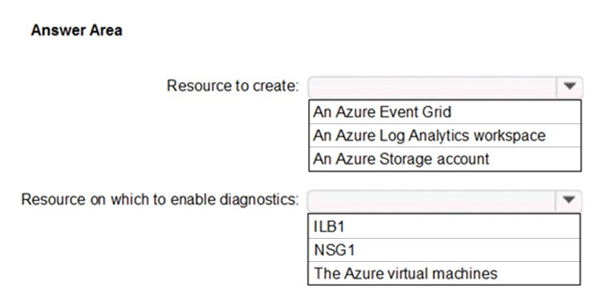

**Answer**: “An Azure Log Analytics workspace” + “ILB1”

1. You have two Azure Active Directory (Azure AD) tenants named contoso.com and fabrikam.com.

You have a Microsoft account that you use to sign into both tenants.

You need to configure the default sign-in tenant for the Azure portal.

What should you do?

**Answer**: D. From the Azure portal, change the directory.

1. You have an Azure Active Directory (Azure AD) tenant.

All administrators must enter a verification code to access the Azure portal.

You need to ensure that the administrators can access the Azure portal only from your on-premises network.

What should you configure?

**Answer**: B. the multi-factor authentication service settings.

1. You have an Active Directory forest named contoso.com.

You install and configure Azure AD Connect to use password hash synchronization as the single sign-on (SSO) method. Staging mode is enabled.

You review the synchronization results and discover that the Synchronization Service Manager does not display any sync jobs.

You need to ensure that the synchronization completes successfully.

What should you do?

**Answer**: D. Run Azure AD Connect and disable staging mode.

1. You have an Azure Active Directory (Azure AD) tenant named contosocloud.onmicrosoft.com.

Your company has a public DNS zone for contoso.com.

You add contoso.com as a custom domain name to Azure AD.

You need to ensure that Azure can verify the domain name.

Which type of DNS record should you create?

**Answer**: D. TXT

1. You sign up for Azure Active Directory (Azure AD) Premium.

You need to add a user named admin1@contoso.com as an administrator on all the computers that will be joined to the Azure AD domain.

What should you configure in Azure AD?

**Answer**: B. Device settings from the Devices blade

1. Your network contains an Active Directory domain named adatum.com and an Azure Active Directory (Azure AD) tenant named adatum.onmicorosft.com.  
   Adatum.com contains the user accounts in the following table.  
   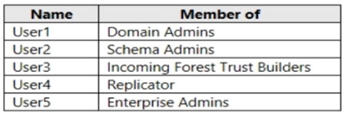  
   Adatum.onmicrosoft.com contains the user accounts in the following table.  
   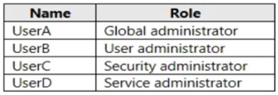  
   You need to implement Azure AD Connect. The solution must follow the principle of least privilege.  
   Which user accounts should you use? To answer, select the appropriate options in the answer area.  
   NOTE: Each correct selection is worth one point.  
   Hot Area:  
   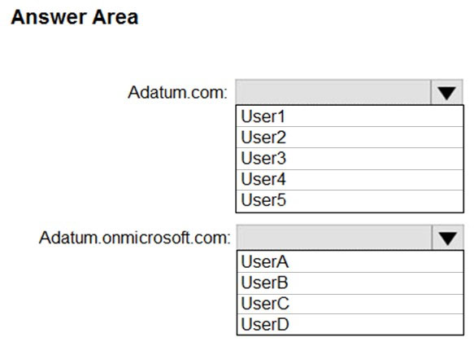

**Answer**: “User5” + “UserA”

1. You have an Azure Active Directory (Azure AD) tenant.  
   You need to create a conditional access policy that requires all users to use multi-factor authentication when they access the Azure portal.  
   Which three settings should you configure? To answer, select the appropriate settings in the answer area.  
   NOTE: Each correct selection is worth one point.  
   Hot Area:  
   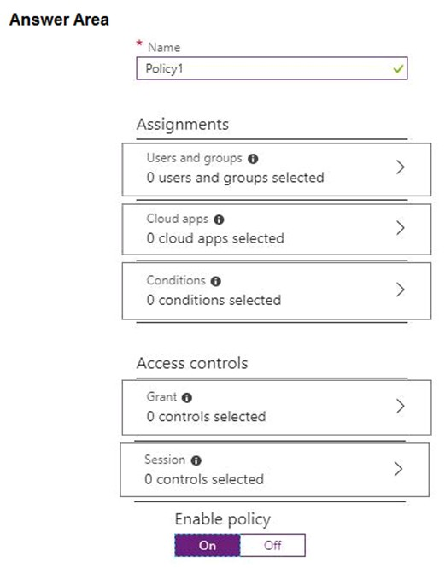

**Answer**: “Users and groups” + “Cloud apps” + “Grant”

1. You have an Azure Active Directory (Azure AD) tenant.

You have an existing Azure AD conditional access policy named Policy1. Policy1 enforces the use of Azure AD-joined devices when members of the Global

Administrators group authenticate to Azure AD from untrusted locations.

You need to ensure that members of the Global Administrators group will also be forced to use multi-factor authentication when authenticating from untrusted locations.

What should you do?

**Answer**: C. From the Azure portal, modify grant control of Policy1.

1. From the MFA Server blade, you open the Block/unblock users blade as shown in the exhibit.  
   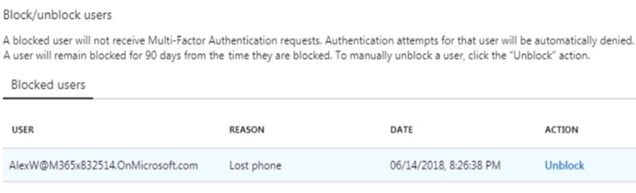  
   What caused AlexW to be blocked?

**Answer**: C. An administrator manually blocked the user.

1. Your network contains an Active Directory domain named contoso.com that is synced to an Azure Active Directory (Azure AD) tenant named contoso.onmicrosoft.com. The tenant contains only default domain names.  
   The domain contains the users shown in the following table.  
   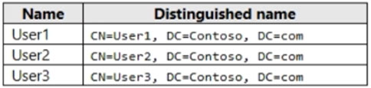  
   The users have value sets for their user account as shown in the following table.  
   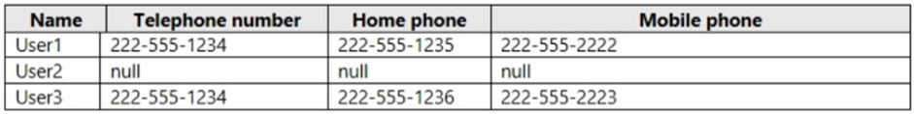  
   You plan to enable Azure Multi-Factor Authentication (MFA) by using the following bulk update file named File1.  
   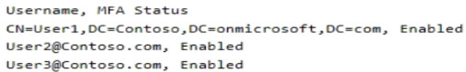  
   For each of the following statements, select Yes if the statement is true. Otherwise, select No.  
   NOTE: Each correct selection is worth one point.  
   Hot Area:  
   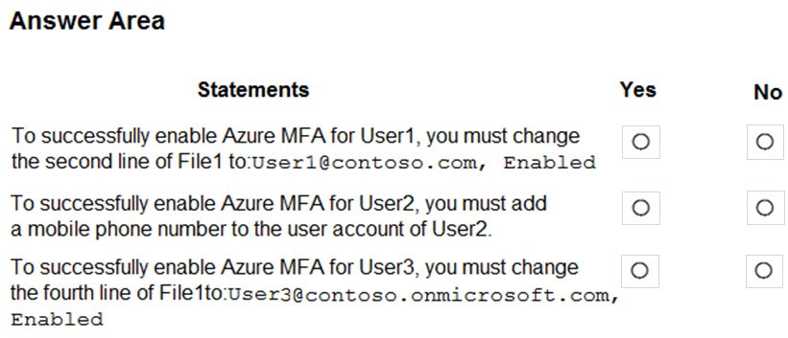

**Answer**: Yes, Yes, No

1. You have an Azure Active Directory (Azure AD) tenant named contoso.onmicrosoft.com.

You hire a temporary vendor. The vendor uses a Microsoft account that has a sign-in of user1@outlook.com.

You need to ensure that the vendor can authenticate to the tenant by using user1@outlook.com.

What should you do?

**Answer**: C. From the Azure portal, add a new guest user, and then specify user1@outlook.com as the email address.

1. You have an Azure Active Directory (Azure AD) tenant named contosocloud.onmicrosoft.com.

Your company has a public DNS zone for contoso.com.

You add contoso.com as a custom domain name to Azure AD.

You need to ensure that Azure can verify the domain name.

Which type of DNS record should you create?

**Answer**: A. MX (não está cá o TXT mas se sair, está mais adequada TXT)

1. You set the multi-factor authentication status for a user named admin1@contoso.com to Enabled.

Admin1 accesses the Azure portal by using a web browser.

Which additional security verifications can Admin1 use when accessing the Azure portal?

**Answer**: A. a phone call, a text message that contains a verification code, and a notification or a verification code sent from the Microsoft Authenticator app

1. You have an Azure Active Directory (Azure AD) tenant that has the initial domain name.  
   You have a domain name of contoso.com registered at a third-party registrar.  
   You need to ensure that you can create Azure AD users that have names containing a suffix of @contoso.com.  
   Which three actions should you perform in sequence? To answer, move the appropriate cmdlets from the list of cmdlets to the answer area and arrange them in the correct order.  
   Select and Place:  
   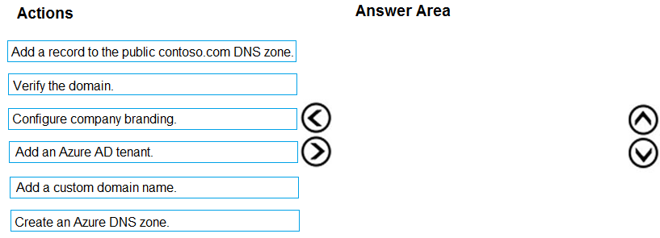

**Answer**: “Add a custom domain name” + “Add a record to the public contoso.com DNS zone” + “Verify the domain”

1. Your company has a main office in London that contains 100 client computers.

Three years ago, you migrated to Azure Active Directory (Azure AD).

The company's security policy states that all personal devices and corporate-owned devices must be registered or joined to Azure AD.

A remote user named User1 is unable to join a personal device to Azure AD from a home network.

You verify that other users can join their devices to Azure AD.

You need to ensure that User1 can join the device to Azure AD.

What should you do?

**Answer**: B. From the Device settings blade, modify the Maximum number of devices per user setting.

1. You have an Azure DNS zone named adatum.com.

You need to delegate a subdomain named research.adatum.com to a different DNS server in Azure.

What should you do?

**Answer**: D. Create an NS record named research in the adatum.com zone.

1. You plan to deploy several Azure virtual machines and to connect them to a virtual network named VNET1007.

You need to ensure that future virtual machines on VNET1007 can register their name in an internal DNS zone named corp9172795.com. The zone must NOT be hosted on a virtual machine.

What should you do from Azure Cloud Shell?

To complete this task, start Azure Cloud Shell and select PowerShell (Linux). Click Show Advanced Settings, and then enter corp9172795n1 in the

Storage account text box and File1 in the File share text box. Click Create storage, and then complete the task.

**Answer**:

Step 1: New-AzureRMResourceGroup

Step 2: New-AzVirtualNetwork

Step 3: New-AzPrivateDnsZone

Step 4: New-AzPrivateDnsVirtualNetworkLink

Step 5: New-AzVM

1. You have an Azure Active Directory (Azure AD) tenant named adatum.com. Adatum.com contains the groups in the following table:  
   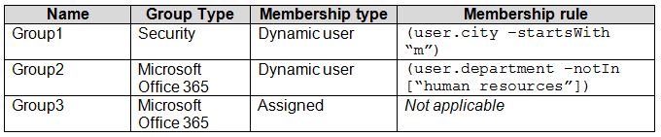  
   You create two user accounts that are configured as shown in the following table.  
     
   To which groups do User1 and User2 belong? To answer, select the appropriate options in the answer area.  
   NOTE: Each correct selection is worth one point.  
   Hot Area:  
   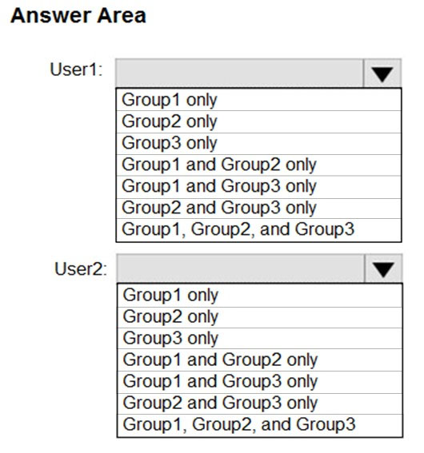

**Answer**: “Group1 only” + “Group1 and Group2 only”

1. You have an Azure Active Directory (Azure AD) tenant named contoso.onmicrosoft.com.

The User administrator role is assigned to a user named Admin1.

An external partner has a Microsoft account that uses the user1@outlook.com sign in.

Admin1 attempts to invite the external partner to sign into the Azure AD tenant and receives the following error message: "Unable to invite user user1@outlook.com "" Generic authorization exception."

You need to ensure that Admin1 can invite the external partner to sign in to the Azure AD tenant.

What should you do?

**Answer**: D. From the Users blade, modify the External collaboration settings.

1. Your company has an Azure Active Directory (Azure AD) tenant named contoso.com that is configured for hybrid coexistence with the on-premises Active  
   Directory domain. The tenant contains the users shown in the following table.  
   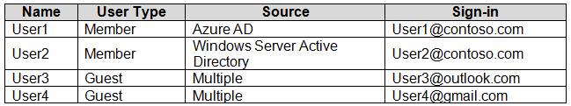  
   Whenever possible, you need to enable Azure Multi-Factor Authentication (MFA) for the users in contoso.com.  
   Which users should you enable for Azure MFA?

**Answer**: D. User1, User2, User3, and User4

1. You configure Azure AD Connect for Azure Active Directory Seamless Single Sign-On (Azure AD Seamless SSO) for an on-premises network.

Users report that when they attempt to access myapps.microsoft.com, they are prompted multiple times to sign in and are forced to use an account name that ends with onmicrosoft.com.

You discover that there is a UPN mismatch between Azure AD and the on-premises Active Directory.

You need to ensure that the users can use single-sign-on (SSO) to access Azure resources.

What should you do first?

**Answer**: B. From the on-premises network, deploy Active Directory Federation Services (AD FS).

1. You have an Azure subscription named Subscription1 that contains a virtual network named VNet1.  
   You add the users in the following table.  
   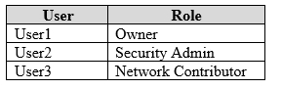  
   Which user can perform each configuration? To answer, select the appropriate options in the answer area.  
   NOTE: Each correct selection is worth one point.  
   Hot Area:  
   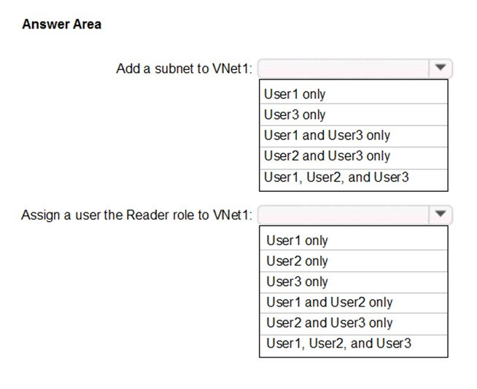

**Answer**: “User1 and User3 only” + “User1 and User2 only”

1. You have an Azure subscription named Subscription1 and two Azure Active Directory (Azure AD) tenants named Tenant1 and Tenant2.

Subscription1 is associated to Tenant1. Multi-factor authentication (MFA) is enabled for all the users in Tenant1.

You need to enable MFA for the users in Tenant2. The solution must maintain MFA for Tenant1.

What should you do first?

**Answer**: C. Create and link a subscription to Tenant2.

1. You have an Azure Active Directory (Azure AD) tenant named contoso.onmicrosoft.com that contains the users shown in the following table.  
   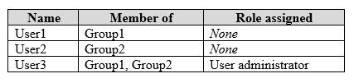  
   You enable password reset for contoso.onmicrosoft.com as shown in the Password Reset exhibit. (Click the Password Reset tab.)  
   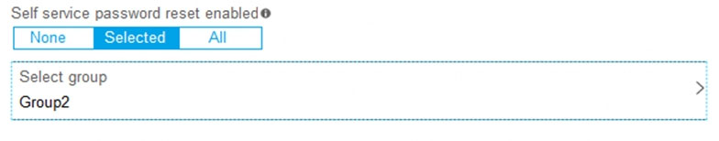  
   You configure the authentication methods for password reset as shown in the Authentication Methods exhibit. (Click the Authentication Methods tab.)  
   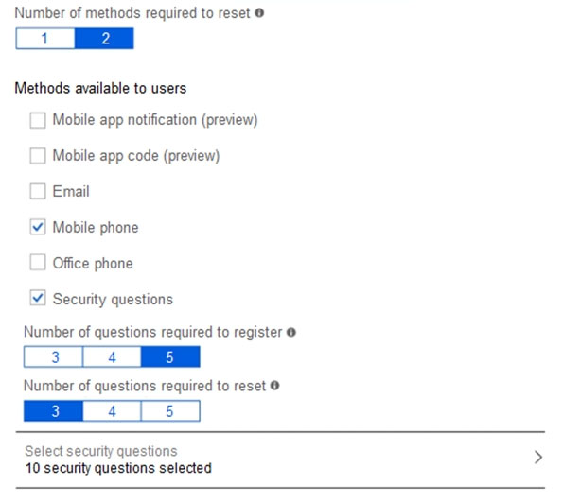  
   For each of the following statements, select Yes if the statement is true. Otherwise, select No.  
   NOTE: Each correct selection is worth one point.  
   Hot Area:  
   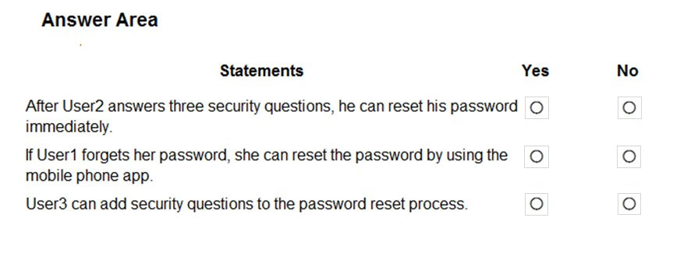

**Answer**: No, No, Yes

1. You have an Azure Active Directory (Azure AD) tenant.

All administrators must enter a verification code to access the Azure portal.

You need to ensure that the administrators can access the Azure portal without entering a verification code when they are connecting from your on-premises network.

What should you configure?

**Answer**: B. the multi-factor authentication service settings.

1. CASE STUDY:

Humongous Insurance is an insurance company that has three offices in Miami, Tokyo and Bangkok. Each office has 5,000 users.

Existing Environment:

* Active Directory Environment - Humongous Insurance has a single-domain Active Directory forest named humongousinsurance.com. The functional level of the forest is Windows Server 2012. You recently provisioned an Azure Active Directory (Azure AD) tenant.
* Network Infrastructure - Each office has a local data center that contains all the servers for that office. Each office has a dedicated connection to the Internet. Each office has several link load balancers that provide access to the servers.
* Active Directory Issue - Several users in humongousinsurance.com have UPNs that contain special characters. You suspect that some of the characters are unsupported in Azure AD.
* Licensing Issue - You attempt to assign a license in Azure to several users and receive the following error message: "Licenses not assigned. License assignment failed for one user." You verify that the Azure subscription has the available licenses.

Requirements:

* Planned Changes - Humongous Insurance plans to open a new office in Paris. The Paris office will contain 1,000 users who will be hired during the next 12 months. All the resources used by the Paris office users will be hosted in Azure.
* Planned Azure AD Infrastructure - The on-premises Active Directory domain will be synchronized to Azure AD. All client computers in the Paris office will be joined to an Azure AD domain.
* Planned Azure Networking Infrastructure

You plan to create the following networking resources in a resource group named All_Resources:

* Default Azure system routes that will be the only routes used to route traffic
* A virtual network named Paris-VNet that will contain two subnets named Subnet1 and Subnet2
* A virtual network named ClientResources-VNet that will contain one subnet named ClientSubnet
* A virtual network named AllOffices-VNet that will contain two subnets named Subnet3 and Subnet4

You plan to enable peering between Paris-VNet and AllOffices-VNet. You will enable the Use remote gateways setting for the Paris-VNet peerings.

You plan to create a private DNS zone named humongousinsurance.local and set the registration network to the ClientResources-VNet virtual network.

Planned Azure Computer Infrastructure

Each subnet will contain several virtual machines that will run either Windows Server 2012 R2, Windows Server 2016, or Red Hat Linux.

* Department Requirements - Humongous Insurance identifies the following requirements for the company's departments: Web administrators will deploy Azure web apps for the marketing department. Each web app will be added to a separate resource group. The initial configuration of the web apps will be identical. The web administrators have permission to deploy web apps to resource groups. During the testing phase, auditors in the finance department must be able to review all Azure costs from the past week.
* Authentication Requirements - Users in the Miami office must use Azure Active Directory Seamless Single Sign-on (Azure AD Seamless SSO) when accessing resources in Azure.

Question:

You need to resolve the licensing issue before you attempt to assign the license again.

What should you do?

**Answer**: B. From the Profile blade, modify the usage location.

1. CASE STUDY:

Humongous Insurance is an insurance company that has three offices in Miami, Tokyo and Bangkok. Each office has 5,000 users.

Existing Environment:

* Active Directory Environment - Humongous Insurance has a single-domain Active Directory forest named humongousinsurance.com. The functional level of the forest is Windows Server 2012. You recently provisioned an Azure Active Directory (Azure AD) tenant.
* Network Infrastructure - Each office has a local data center that contains all the servers for that office. Each office has a dedicated connection to the Internet. Each office has several link load balancers that provide access to the servers.
* Active Directory Issue - Several users in humongousinsurance.com have UPNs that contain special characters. You suspect that some of the characters are unsupported in Azure AD.
* Licensing Issue - You attempt to assign a license in Azure to several users and receive the following error message: "Licenses not assigned. License assignment failed for one user." You verify that the Azure subscription has the available licenses.

Requirements:

* Planned Changes - Humongous Insurance plans to open a new office in Paris. The Paris office will contain 1,000 users who will be hired during the next 12 months. All the resources used by the Paris office users will be hosted in Azure.
* Planned Azure AD Infrastructure - The on-premises Active Directory domain will be synchronized to Azure AD.
* All client computers in the Paris office will be joined to an Azure AD domain.
* Planned Azure Networking Infrastructure

You plan to create the following networking resources in a resource group named All_Resources:

* + Default Azure system routes that will be the only routes used to route traffic
  + A virtual network named Paris-VNet that will contain two subnets named Subnet1 and Subnet2
  + A virtual network named ClientResources-VNet that will contain one subnet named ClientSubnet
  + A virtual network named AllOffices-VNet that will contain two subnets named Subnet3 and Subnet4

You plan to enable peering between Paris-VNet and AllOffices-VNet. You will enable the Use remote gateways setting for the Paris-VNet peerings.

You plan to create a private DNS zone named humongousinsurance.local and set the registration network to the ClientResources-VNet virtual network.

Planned Azure Computer Infrastructure

Each subnet will contain several virtual machines that will run either Windows Server 2012 R2, Windows Server 2016, or Red Hat Linux.

* Department Requirements - Humongous Insurance identifies the following requirements for the company's departments: Web administrators will deploy Azure web apps for the marketing department. Each web app will be added to a separate resource group. The initial configuration of the web apps will be identical. The web administrators have permission to deploy web apps to resource groups. During the testing phase, auditors in the finance department must be able to review all Azure costs from the past week.
* Authentication Requirements - Users in the Miami office must use Azure Active Directory Seamless Single Sign-on (Azure AD Seamless SSO) when accessing resources in Azure.

Question:

You need to resolve the Active Directory issue.

What should you do?

**Answer**: A. Run the IdFix tool then use the Update actions.

1. CASE STUDY:

Humongous Insurance is an insurance company that has three offices in Miami, Tokyo and Bangkok. Each office has 5,000 users.

Existing Environment:

* Active Directory Environment - Humongous Insurance has a single-domain Active Directory forest named humongousinsurance.com. The functional level of the forest is Windows Server 2012. You recently provisioned an Azure Active Directory (Azure AD) tenant.
* Network Infrastructure - Each office has a local data center that contains all the servers for that office. Each office has a dedicated connection to the Internet. Each office has several link load balancers that provide access to the servers.
* Active Directory Issue - Several users in humongousinsurance.com have UPNs that contain special characters. You suspect that some of the characters are unsupported in Azure AD.
* Licensing Issue - You attempt to assign a license in Azure to several users and receive the following error message: "Licenses not assigned. License assignment failed for one user." You verify that the Azure subscription has the available licenses.

Requirements:

* Planned Changes - Humongous Insurance plans to open a new office in Paris. The Paris office will contain 1,000 users who will be hired during the next 12 months. All the resources used by the Paris office users will be hosted in Azure.
* Planned Azure AD Infrastructure - The on-premises Active Directory domain will be synchronized to Azure AD. All client computers in the Paris office will be joined to an Azure AD domain.
* Planned Azure Networking Infrastructure

You plan to create the following networking resources in a resource group named All_Resources:

* + Default Azure system routes that will be the only routes used to route traffic
  + A virtual network named Paris-VNet that will contain two subnets named Subnet1 and Subnet2
  + A virtual network named ClientResources-VNet that will contain one subnet named ClientSubnet
  + A virtual network named AllOffices-VNet that will contain two subnets named Subnet3 and Subnet4

You plan to enable peering between Paris-VNet and AllOffices-VNet. You will enable the Use remote gateways setting for the Paris-VNet peerings.

You plan to create a private DNS zone named humongousinsurance.local and set the registration network to the ClientResources-VNet virtual network.

Planned Azure Computer Infrastructure

Each subnet will contain several virtual machines that will run either Windows Server 2012 R2, Windows Server 2016, or Red Hat Linux.

* Department Requirements - Humongous Insurance identifies the following requirements for the company's departments: Web administrators will deploy Azure web apps for the marketing department. Each web app will be added to a separate resource group. The initial configuration of the web apps will be identical. The web administrators have permission to deploy web apps to resource groups. During the testing phase, auditors in the finance department must be able to review all Azure costs from the past week.
* Authentication Requirements - Users in the Miami office must use Azure Active Directory Seamless Single Sign-on (Azure AD Seamless SSO) when accessing resources in Azure.

Question:

You need to define a custom domain name for Azure AD to support the planned infrastructure.

Which domain name should you use?

**Answer**: C. humongousinsurance.com

1. CASE STUDY:

Humongous Insurance is an insurance company that has three offices in Miami, Tokyo and Bangkok. Each office has 5,000 users.

Existing Environment:

* Active Directory Environment - Humongous Insurance has a single-domain Active Directory forest named humongousinsurance.com. The functional level of the forest is Windows Server 2012. You recently provisioned an Azure Active Directory (Azure AD) tenant.
* Network Infrastructure - Each office has a local data center that contains all the servers for that office. Each office has a dedicated connection to the Internet. Each office has several link load balancers that provide access to the servers.
* Active Directory Issue - Several users in humongousinsurance.com have UPNs that contain special characters. You suspect that some of the characters are unsupported in Azure AD.
* Licensing Issue - You attempt to assign a license in Azure to several users and receive the following error message: "Licenses not assigned. License assignment failed for one user."
* You verify that the Azure subscription has the available licenses.

Requirements:

* Planned Changes - Humongous Insurance plans to open a new office in Paris. The Paris office will contain 1,000 users who will be hired during the next 12 months. All the resources used by the Paris office users will be hosted in Azure.
* Planned Azure AD Infrastructure - The on-premises Active Directory domain will be synchronized to Azure AD. All client computers in the Paris office will be joined to an Azure AD domain.
* Planned Azure Networking Infrastructure

You plan to create the following networking resources in a resource group named All_Resources:

* + Default Azure system routes that will be the only routes used to route traffic
  + A virtual network named Paris-VNet that will contain two subnets named Subnet1 and Subnet2
  + A virtual network named ClientResources-VNet that will contain one subnet named ClientSubnet
  + A virtual network named AllOffices-VNet that will contain two subnets named Subnet3 and Subnet4

You plan to enable peering between Paris-VNet and AllOffices-VNet. You will enable the Use remote gateways setting for the Paris-VNet peerings.

You plan to create a private DNS zone named humongousinsurance.local and set the registration network to the ClientResources-VNet virtual network.

Planned Azure Computer Infrastructure

Each subnet will contain several virtual machines that will run either Windows Server 2012 R2, Windows Server 2016, or Red Hat Linux.

* Department Requirements - Humongous Insurance identifies the following requirements for the company's departments: Web administrators will deploy Azure web apps for the marketing department. Each web app will be added to a separate resource group. The initial configuration of the web apps will be identical. The web administrators have permission to deploy web apps to resource groups. During the testing phase, auditors in the finance department must be able to review all Azure costs from the past week.
* Authentication Requirements - Users in the Miami office must use Azure Active Directory Seamless Single Sign-on (Azure AD Seamless SSO) when accessing resources in Azure.

Question:

Which blade should you instruct the finance department auditors to use?

**Answer**: A. Cost analysis

1. CASE STUDY:

Humongous Insurance is an insurance company that has three offices in Miami, Tokyo and Bangkok. Each office has 5,000 users.

Existing Environment:

* Active Directory Environment - Humongous Insurance has a single-domain Active Directory forest named humongousinsurance.com. The functional level of the forest is Windows Server 2012. You recently provisioned an Azure Active Directory (Azure AD) tenant.
* Network Infrastructure - Each office has a local data center that contains all the servers for that office. Each office has a dedicated connection to the Internet. Each office has several link load balancers that provide access to the servers.
* Active Directory Issue - Several users in humongousinsurance.com have UPNs that contain special characters. You suspect that some of the characters are unsupported in Azure AD.
* Licensing Issue - You attempt to assign a license in Azure to several users and receive the following error message: "Licenses not assigned. License assignment failed for one user." You verify that the Azure subscription has the available licenses.

Requirements:

* Planned Changes - Humongous Insurance plans to open a new office in Paris. The Paris office will contain 1,000 users who will be hired during the next 12 months. All the resources used by the Paris office users will be hosted in Azure.
* Planned Azure AD Infrastructure - The on-premises Active Directory domain will be synchronized to Azure AD. All client computers in the Paris office will be joined to an Azure AD domain.
* Planned Azure Networking Infrastructure

You plan to create the following networking resources in a resource group named All_Resources:

* + Default Azure system routes that will be the only routes used to route traffic
  + A virtual network named Paris-VNet that will contain two subnets named Subnet1 and Subnet2
  + A virtual network named ClientResources-VNet that will contain one subnet named ClientSubnet
  + A virtual network named AllOffices-VNet that will contain two subnets named Subnet3 and Subnet4

You plan to enable peering between Paris-VNet and AllOffices-VNet. You will enable the Use remote gateways setting for the Paris-VNet peerings.

You plan to create a private DNS zone named humongousinsurance.local and set the registration network to the ClientResources-VNet virtual network.

* Planned Azure Computer Infrastructure - Each subnet will contain several virtual machines that will run either Windows Server 2012 R2, Windows Server 2016, or Red Hat Linux.
* Department Requirements - Humongous Insurance identifies the following requirements for the company's departments: Web administrators will deploy Azure web apps for the marketing department. Each web app will be added to a separate resource group. The initial configuration of the web apps will be identical. The web administrators have permission to deploy web apps to resource groups. During the testing phase, auditors in the finance department must be able to review all Azure costs from the past week.
* Authentication Requirements - Users in the Miami office must use Azure Active Directory Seamless Single Sign-on (Azure AD Seamless SSO) when accessing resources in Azure.

Question:

You need to prepare the environment to meet the authentication requirements.

Which two actions should you perform? Each correct answer presents part of the solution.

NOTE: Each correct selection is worth one point.

**Answer**: D+E (D. Add http://autologon.microsoftazuread-sso.com to the intranet zone of each client computer in the Miami office + E. Install Azure AD Connect on a server in the Miami office and enable Pass-through Authentication)

1. CASE STUDY:  
   Contoso, Ltd. is a manufacturing company that has offices worldwide. Contoso works with partner organizations to bring products to market.  
   Contoso products are manufactured by using blueprint files that the company authors and maintains.

Existing Environment - Currently, Contoso uses multiple types of servers for business operations, including the following: File servers, Domain controllers + Microsoft SQL Server servers

Your network contains an Active Directory forest named contoso.com. All servers and client computers are joined to Active Directory.  
You have a public-facing application named App1. App1 is comprised of the following three tiers: A SQL database, a web front end + a processing middle tier  
Each tier is comprised of five virtual machines. Users access the web front end by using HTTPS only.  
  
Requirements:  
Planned Changes - Contoso plans to implement the following changes to the infrastructure: Move all the tiers of App1 to Azure, move the existing product blueprint files to Azure Blob storage + create a hybrid directory to support an upcoming Microsoft Office 365 migration project.  
  
Technical Requirements:

* Contoso must meet the following technical requirements:
* Move all the virtual machines for App1 to Azure.
* Minimize the number of open ports between the App1 tiers.
* Ensure that all the virtual machines for App1 are protected by backups.
* Copy the blueprint files to Azure over the Internet.
* Ensure that the blueprint files are stored in the archive storage tier.
* Ensure that partner access to the blueprint files is secured and temporary.
* Prevent user passwords or hashes of passwords from being stored in Azure.
* Use unmanaged standard storage for the hard disks of the virtual machines.
* Ensure that when users join devices to Azure Active Directory (Azure AD), the users use a mobile phone to verify their identity
* Minimize administrative effort whenever possible

User Requirements:

Contoso identifies the following requirements for users:

* Ensure that only users who are part of a group named Pilot can join devices to Azure AD.
* Designate a new user named Admin1 as the service admin for the Azure subscription.
* Admin1 must receive email alerts regarding service outages.
* Ensure that a new user named User3 can create network objects for the Azure subscription.

Question:  
You need to identify the storage requirements for Contoso.  
For each of the following statements, select Yes if the statement is true. Otherwise, select No.  
NOTE: Each correct selection is worth one point.  
Hot Area:  
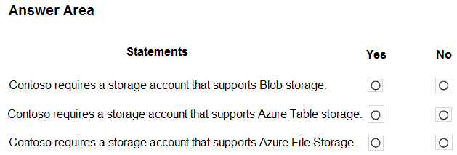

**Answer**: Yes, No, No

1. CASE STUDY:

Contoso, Ltd. is a manufacturing company that has offices worldwide. Contoso works with partner organizations to bring products to market.

Contoso products are manufactured by using blueprint files that the company authors and maintains.

Existing Environment - Currently, Contoso uses multiple types of servers for business operations, including the following:

* File servers
* Domain controllers
* Microsoft SQL Server servers

Your network contains an Active Directory forest named contoso.com. All servers and client computers are joined to Active Directory.

You have a public-facing application named App1. App1 is comprised of the following three tiers:

* A SQL database
* A web front end
* A processing middle tier

Each tier is comprised of five virtual machines. Users access the web front end by using HTTPS only.

Requirements:

Planned Changes:

* Contoso plans to implement the following changes to the infrastructure:
* Move all the tiers of App1 to Azure.
* Move the existing product blueprint files to Azure Blob storage.
* Create a hybrid directory to support an upcoming Microsoft Office 365 migration project.

Technical Requirements:

Contoso must meet the following technical requirements:

* Move all the virtual machines for App1 to Azure.
* Minimize the number of open ports between the App1 tiers.
* Ensure that all the virtual machines for App1 are protected by backups.
* Copy the blueprint files to Azure over the Internet.
* Ensure that the blueprint files are stored in the archive storage tier.
* Ensure that partner access to the blueprint files is secured and temporary.
* Prevent user passwords or hashes of passwords from being stored in Azure.
* Use unmanaged standard storage for the hard disks of the virtual machines.
* Ensure that when users join devices to Azure Active Directory (Azure AD), the users use a mobile phone to verify their identity
* Minimize administrative effort whenever possible

User Requirements:

* Contoso identifies the following requirements for users:
* Ensure that only users who are part of a group named Pilot can join devices to Azure AD.
* Designate a new user named Admin1 as the service admin for the Azure subscription.
* Admin1 must receive email alerts regarding service outages.
* Ensure that a new user named User3 can create network objects for the Azure subscription.

Question:

You need to move the blueprint files to Azure.

What should you do?

**Answer**: A. Use Azure Storage Explorer to copy the files.

1. CASE STUDY:

Contoso, Ltd. is a manufacturing company that has offices worldwide. Contoso works with partner organizations to bring products to market.

Contoso products are manufactured by using blueprint files that the company authors and maintains.

Existing Environment:

Currently, Contoso uses multiple types of servers for business operations, including the following:

* File servers
* Domain controllers
* Microsoft SQL Server servers

Your network contains an Active Directory forest named contoso.com. All servers and client computers are joined to Active Directory.

You have a public-facing application named App1. App1 is comprised of the following three tiers:

* A SQL database
* A web front end
* A processing middle tier

Each tier is comprised of five virtual machines. Users access the web front end by using HTTPS only.

Requirements:

Planned Changes:

Contoso plans to implement the following changes to the infrastructure:

* Move all the tiers of App1 to Azure.
* Move the existing product blueprint files to Azure Blob storage.
* Create a hybrid directory to support an upcoming Microsoft Office 365 migration project.

Technical Requirements:

Contoso must meet the following technical requirements:

* Move all the virtual machines for App1 to Azure.
* Minimize the number of open ports between the App1 tiers.
* Ensure that all the virtual machines for App1 are protected by backups.
* Copy the blueprint files to Azure over the Internet.
* Ensure that the blueprint files are stored in the archive storage tier.
* Ensure that partner access to the blueprint files is secured and temporary.
* Prevent user passwords or hashes of passwords from being stored in Azure.
* Use unmanaged standard storage for the hard disks of the virtual machines.
* Ensure that when users join devices to Azure Active Directory (Azure AD), the users use a mobile phone to verify their identity
* Minimize administrative effort whenever possible

User Requirements:

Contoso identifies the following requirements for users:

* Ensure that only users who are part of a group named Pilot can join devices to Azure AD.
* Designate a new user named Admin1 as the service admin for the Azure subscription.
* Admin1 must receive email alerts regarding service outages.
* Ensure that a new user named User3 can create network objects for the Azure subscription.

Question:

You need to implement a backup solution for App1 after the application is moved.

What should you create first?

**Answer**: B. a Recovery Services vault

1. CASE STUDY:

Humongous Insurance is an insurance company that has three offices in Miami, Tokyo and Bangkok. Each office has 5,000 users.

Existing Environment:

* Active Directory Environment - Humongous Insurance has a single-domain Active Directory forest named humongousinsurance.com. The functional level of the forest is Windows Server 2012. You recently provisioned an Azure Active Directory (Azure AD) tenant.
* Network Infrastructure - Each office has a local data center that contains all the servers for that office. Each office has a dedicated connection to the Internet. Each office has several link load balancers that provide access to the servers.
* Active Directory Issue - Several users in humongousinsurance.com have UPNs that contain special characters. You suspect that some of the characters are unsupported in Azure AD.
* Licensing Issue - You attempt to assign a license in Azure to several users and receive the following error message: "Licenses not assigned. License assignment failed for one user." You verify that the Azure subscription has the available licenses.

Requirements:

* Planned Changes - Humongous Insurance plans to open a new office in Paris. The Paris office will contain 1,000 users who will be hired during the next 12 months. All the resources used by the Paris office users will be hosted in Azure.
* Planned Azure AD Infrastructure - The on-premises Active Directory domain will be synchronized to Azure AD.
* All client computers in the Paris office will be joined to an Azure AD domain.
* Planned Azure Networking Infrastructure

You plan to create the following networking resources in a resource group named All_Resources:

* + Default Azure system routes that will be the only routes used to route traffic
  + A virtual network named Paris-VNet that will contain two subnets named Subnet1 and Subnet2
  + A virtual network named ClientResources-VNet that will contain one subnet named ClientSubnet
  + A virtual network named AllOffices-VNet that will contain two subnets named Subnet3 and Subnet4

You plan to enable peering between Paris-VNet and AllOffices-VNet. You will enable the Use remote gateways setting for the Paris-VNet peerings.

You plan to create a private DNS zone named humongousinsurance.local and set the registration network to the ClientResources-VNet virtual network.

* Planned Azure Computer Infrastructure - Each subnet will contain several virtual machines that will run either Windows Server 2012 R2, Windows Server 2016, or Red Hat Linux.
* Department Requirements - Humongous Insurance identifies the following requirements for the company's departments: Web administrators will deploy Azure web apps for the marketing department. Each web app will be added to a separate resource group. The initial configuration of the web apps will be identical. The web administrators have permission to deploy web apps to resource groups. During the testing phase, auditors in the finance department must be able to review all Azure costs from the past week.
* Authentication Requirements - Users in the Miami office must use Azure Active Directory Seamless Single Sign-on (Azure AD Seamless SSO) when accessing resources in Azure.

Question:

DRAG DROP -

You need to prepare the environment to ensure that the web administrators can deploy the web apps as quickly as possible.

Which three actions should you perform in sequence? To answer, move the appropriate actions from the list of actions to the answer area and arrange them in the correct order.

Select and Place:

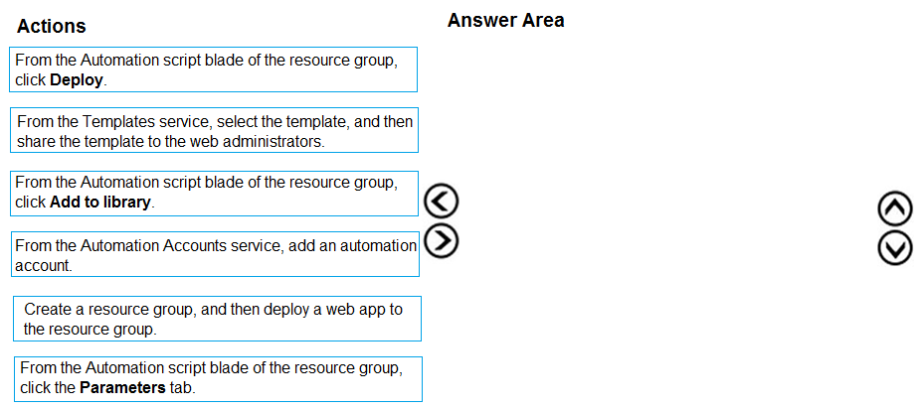

**Answer**:

1) Create a resource group, and then deploy a web app to the resource group.

2) From the Automation script blade of the RG, click "Add to Library"

3) From the Templates service, select the template, and then share the template to the web administrators.

1. CASE STUDY:

Contoso, Ltd. is a consulting company that has a main office in Montreal and two branch offices in Seattle and New York.

The Montreal office has 2,000 employees. The Seattle office has 1,000 employees. The New York office has 200 employees.

All the resources used by Contoso are hosted on-premises.

Contoso creates a new Azure subscription. The Azure Active Directory (Azure AD) tenant uses a domain named contoso.onmicrosoft.com. The tenant uses the

P1 pricing tier.

Existing Environment - The network contains an Active Directory forest named contoso.com. All domain controllers are configured as DNS servers and host the contoso.com DNS zone.

Contoso has finance, human resources, sales, research, and information technology departments. Each department has an organizational unit (OU) that contains all the accounts of that respective department. All the user accounts have the department attribute set to their respective department. New users are added frequently.

Contoso.com contains a user named User1.

All the offices connect by using private links.

Contoso has data centers in the Montreal and Seattle offices. Each data center has a firewall that can be configured as a VPN device.

All infrastructure servers are virtualized. The virtualization environment contains the servers in the following table.

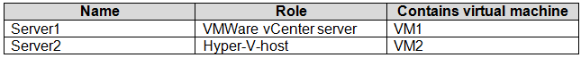

Contoso uses two web applications named App1 and App2. Each instance on each web application requires 1GB of memory.

The Azure subscription contains the resources in the following table.

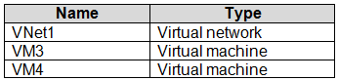

The network security team implements several network security groups (NSGs).

Planned Changes:

Contoso plans to implement the following changes:

* Deploy Azure ExpressRoute to the Montreal office.
* Migrate the virtual machines hosted on Server1 and Server2 to Azure.
* Synchronize on-premises Active Directory to Azure Active Directory (Azure AD).
* Migrate App1 and App2 to two Azure web apps named WebApp1 and WebApp2.

Technical requirements:

Contoso must meet the following technical requirements:

* Ensure that WebApp1 can adjust the number of instances automatically based on the load and can scale up to five instances.
* Ensure that VM3 can establish outbound connections over TCP port 8080 to the applications servers in the Montreal office.
* Ensure that routing information is exchanged automatically between Azure and the routers in the Montreal office.
* Ensure Azure Multi-Factor Authentication (MFA) for the users in the finance department only.
* Ensure that webapp2.azurewebsites.net can be accessed by using the name app2.contoso.com
* Connect the New York office to VNet1 over the Internet by using an encrypted connection.
* Create a workflow to send an email message when the settings of VM4 are modified.
* Create a custom Azure role named Role1 that is based on the Reader role.
* Minimize costs whenever possible.

Question:

You discover that VM3 does NOT meet the technical requirements.

You need to verify whether the issue relates to the NSGs.

What should you use?

**Answer**: E. IP flow verify in Azure Network Watcher

1. CASE STUDY:

Humongous Insurance is an insurance company that has three offices in Miami, Tokyo and Bangkok. Each office has 5,000 users.

Existing Environment:

* Active Directory Environment - Humongous Insurance has a single-domain Active Directory forest named humongousinsurance.com. The functional level of the forest is Windows Server 2012. You recently provisioned an Azure Active Directory (Azure AD) tenant.
* Network Infrastructure - Each office has a local data center that contains all the servers for that office. Each office has a dedicated connection to the Internet. Each office has several link load balancers that provide access to the servers.
* Active Directory Issue - Several users in humongousinsurance.com have UPNs that contain special characters. You suspect that some of the characters are unsupported in Azure AD.
* Licensing Issue - You attempt to assign a license in Azure to several users and receive the following error message: "Licenses not assigned. License assignment failed for one user." You verify that the Azure subscription has the available licenses.

Requirements:

* Planned Changes - Humongous Insurance plans to open a new office in Paris. The Paris office will contain 1,000 users who will be hired during the next 12 months. All the resources used by the Paris office users will be hosted in Azure.
* Planned Azure AD Infrastructure - The on-premises Active Directory domain will be synchronized to Azure AD. All client computers in the Paris office will be joined to an Azure AD domain.
* Planned Azure Networking Infrastructure - You plan to create the following networking resources in a resource group named All_Resources:
  + Default Azure system routes that will be the only routes used to route traffic
  + A virtual network named Paris-VNet that will contain two subnets named Subnet1 and Subnet2
  + A virtual network named ClientResources-VNet that will contain one subnet named ClientSubnet
  + A virtual network named AllOffices-VNet that will contain two subnets named Subnet3 and Subnet4

You plan to enable peering between Paris-VNet and AllOffices-VNet. You will enable the Use remote gateways setting for the Paris-VNet peerings.

You plan to create a private DNS zone named humongousinsurance.local and set the registration network to the ClientResources-VNet virtual network.

* Planned Azure Computer Infrastructure - Each subnet will contain several virtual machines that will run either Windows Server 2012 R2, Windows Server 2016, or Red Hat Linux.
* Department Requirements - Humongous Insurance identifies the following requirements for the company's departments: Web administrators will deploy Azure web apps for the marketing department. Each web app will be added to a separate resource group. The initial configuration of the web apps will be identical. The web administrators have permission to deploy web apps to resource groups. During the testing phase, auditors in the finance department must be able to review all Azure costs from the past week.
* Authentication Requirements - Users in the Miami office must use Azure Active Directory Seamless Single Sign-on (Azure AD Seamless SSO) when accessing resources in Azure.

Question:

You are evaluating the name resolution for the virtual machines after the planned implementation of the Azure networking infrastructure.

For each of the following statements, select Yes if the statement is true. Otherwise, select No.

Hot Area:

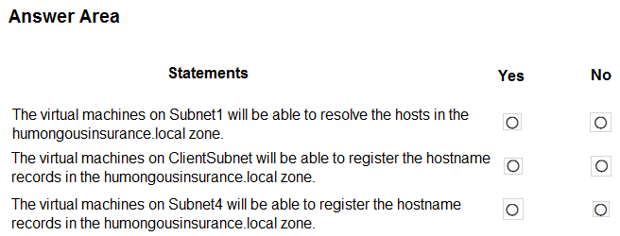

**Answer**: No, Yes, No

1. CASE STUDY:

Humongous Insurance is an insurance company that has three offices in Miami, Tokyo and Bangkok. Each office has 5,000 users.

Existing Environment:

* Active Directory Environment - Humongous Insurance has a single-domain Active Directory forest named humongousinsurance.com. The functional level of the forest is Windows Server 2012. You recently provisioned an Azure Active Directory (Azure AD) tenant.
* Network Infrastructure - Each office has a local data center that contains all the servers for that office. Each office has a dedicated connection to the Internet. Each office has several link load balancers that provide access to the servers.
* Active Directory Issue - Several users in humongousinsurance.com have UPNs that contain special characters. You suspect that some of the characters are unsupported in Azure AD.
* Licensing Issue - You attempt to assign a license in Azure to several users and receive the following error message: "Licenses not assigned. License assignment failed for one user." You verify that the Azure subscription has the available licenses.

Requirements:

* Planned Changes - Humongous Insurance plans to open a new office in Paris. The Paris office will contain 1,000 users who will be hired during the next 12 months. All the resources used by the Paris office users will be hosted in Azure.
* Planned Azure AD Infrastructure - The on-premises Active Directory domain will be synchronized to Azure AD. All client computers in the Paris office will be joined to an Azure AD domain.
* Planned Azure Networking Infrastructure - You plan to create the following networking resources in a resource group named All_Resources:
  + Default Azure system routes that will be the only routes used to route traffic
  + A virtual network named Paris-VNet that will contain two subnets named Subnet1 and Subnet2
  + A virtual network named ClientResources-VNet that will contain one subnet named ClientSubnet
  + A virtual network named AllOffices-VNet that will contain two subnets named Subnet3 and Subnet4

You plan to enable peering between Paris-VNet and AllOffices-VNet. You will enable the Use remote gateways setting for the Paris-VNet peerings.

You plan to create a private DNS zone named humongousinsurance.local and set the registration network to the ClientResources-VNet virtual network.

* Planned Azure Computer Infrastructure - Each subnet will contain several virtual machines that will run either Windows Server 2012 R2, Windows Server 2016, or Red Hat Linux.
* Department Requirements - Humongous Insurance identifies the following requirements for the company's departments: Web administrators will deploy Azure web apps for the marketing department. Each web app will be added to a separate resource group. The initial configuration of the web apps will be identical. The web administrators have permission to deploy web apps to resource groups. During the testing phase, auditors in the finance department must be able to review all Azure costs from the past week.
* Authentication Requirements - Users in the Miami office must use Azure Active Directory Seamless Single Sign-on (Azure AD Seamless SSO) when accessing resources in Azure.

Question:

You are evaluating the connectivity between the virtual machines after the planned implementation of the Azure networking infrastructure.

For each of the following statements, select Yes if the statement is true. Otherwise, select No.

Hot Area:

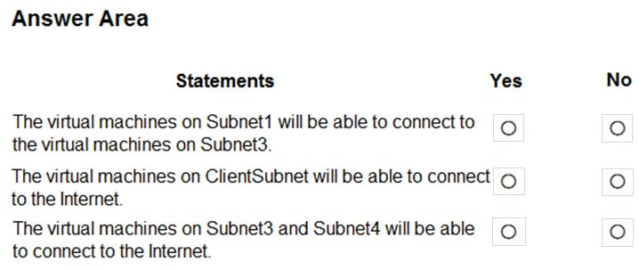

**Answer**: Yes, Yes, Yes

1. CASE STUDY:

Contoso, Ltd. is a consulting company that has a main office in Montreal and two branch offices in Seattle and New York.

The Montreal office has 2,000 employees. The Seattle office has 1,000 employees. The New York office has 200 employees.

All the resources used by Contoso are hosted on-premises.

Contoso creates a new Azure subscription. The Azure Active Directory (Azure AD) tenant uses a domain named contoso.onmicrosoft.com. The tenant uses the

P1 pricing tier.

Existing Environment -

The network contains an Active Directory forest named contoso.com. All domain controllers are configured as DNS servers and host the contoso.com DNS zone.

Contoso has finance, human resources, sales, research, and information technology departments. Each department has an organizational unit (OU) that contains all the accounts of that respective department. All the user accounts have the department attribute set to their respective department. New users are added frequently.

Contoso.com contains a user named User1.

All the offices connect by using private links.

Contoso has data centers in the Montreal and Seattle offices. Each data center has a firewall that can be configured as a VPN device.

All infrastructure servers are virtualized. The virtualization environment contains the servers in the following table.



Contoso uses two web applications named App1 and App2. Each instance on each web application requires 1GB of memory.

The Azure subscription contains the resources in the following table.



The network security team implements several network security groups (NSGs).

Planned Changes -

Contoso plans to implement the following changes:

* Deploy Azure ExpressRoute to the Montreal office.
* Migrate the virtual machines hosted on Server1 and Server2 to Azure.
* Synchronize on-premises Active Directory to Azure Active Directory (Azure AD).
* Migrate App1 and App2 to two Azure web apps named WebApp1 and WebApp2.

Technical requirements -

Contoso must meet the following technical requirements:

* Ensure that WebApp1 can adjust the number of instances automatically based on the load and can scale up to five instances.
* Ensure that VM3 can establish outbound connections over TCP port 8080 to the applications servers in the Montreal office.
* Ensure that routing information is exchanged automatically between Azure and the routers in the Montreal office.
* Ensure Azure Multi-Factor Authentication (MFA) for the users in the finance department only.
* Ensure that webapp2.azurewebsites.net can be accessed by using the name app2.contoso.com
* Connect the New York office to VNet1 over the Internet by using an encrypted connection.
* Create a workflow to send an email message when the settings of VM4 are modified.
* Create a custom Azure role named Role1 that is based on the Reader role.
* Minimize costs whenever possible.

Question:

You need to meet the connection requirements for the New York office.

What should you do? To answer, select the appropriate options in the answer area.

NOTE: Each correct selection is worth one point.

Hot Area:

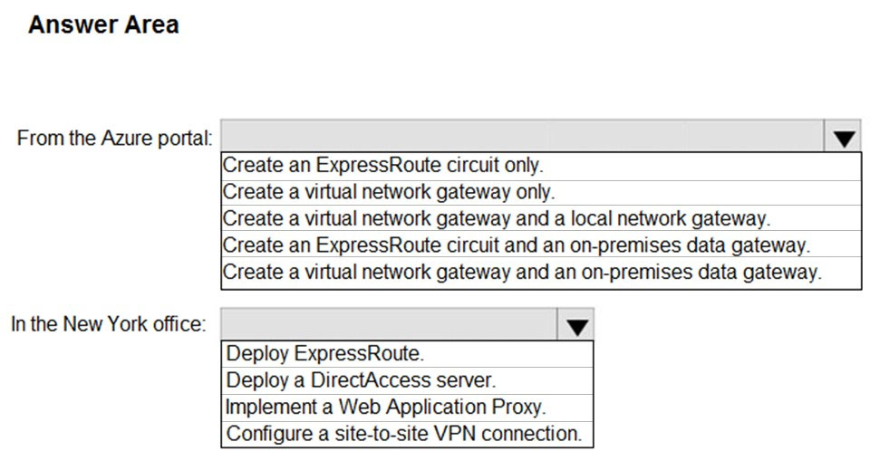

**Answer**: “Create a virtual network gateway and a local network gateway” + “Configure a site-to-site VPN connection”

1. CASE STUDY:

Contoso, Ltd. is a manufacturing company that has offices worldwide. Contoso works with partner organizations to bring products to market.

Contoso products are manufactured by using blueprint files that the company authors and maintains.

Existing Environment -

Currently, Contoso uses multiple types of servers for business operations, including the following:

* File servers
* Domain controllers
* Microsoft SQL Server servers

Your network contains an Active Directory forest named contoso.com. All servers and client computers are joined to Active Directory.

You have a public-facing application named App1. App1 is comprised of the following three tiers:

* A SQL database
* A web front end
* A processing middle tier

Each tier is comprised of five virtual machines. Users access the web front end by using HTTPS only.

Requirements -

Planned Changes -

Contoso plans to implement the following changes to the infrastructure:

* Move all the tiers of App1 to Azure.
* Move the existing product blueprint files to Azure Blob storage.
* Create a hybrid directory to support an upcoming Microsoft Office 365 migration project.

Technical Requirements -

Contoso must meet the following technical requirements:

* Move all the virtual machines for App1 to Azure.
* Minimize the number of open ports between the App1 tiers.
* Ensure that all the virtual machines for App1 are protected by backups.
* Copy the blueprint files to Azure over the Internet.
* Ensure that the blueprint files are stored in the archive storage tier.
* Ensure that partner access to the blueprint files is secured and temporary.
* Prevent user passwords or hashes of passwords from being stored in Azure.
* Use unmanaged standard storage for the hard disks of the virtual machines.
* Ensure that when users join devices to Azure Active Directory (Azure AD), the users use a mobile phone to verify their identity
* Minimize administrative effort whenever possible

User Requirements -

Contoso identifies the following requirements for users:

* Ensure that only users who are part of a group named Pilot can join devices to Azure AD.
* Designate a new user named Admin1 as the service admin for the Azure subscription.
* Admin1 must receive email alerts regarding service outages.
* Ensure that a new user named User3 can create network objects for the Azure subscription.

Question:

You are planning the move of App1 to Azure.

You create a network security group (NSG).

You need to recommend a solution to provide users with access to App1.

What should you do?

**Answer**: A. Create an incoming security rule for port 443 from the Internet. Associate the NSG to the subnet that contains the web servers.

1. CASE STUDY:

Contoso, Ltd. is a manufacturing company that has offices worldwide. Contoso works with partner organizations to bring products to market.

Contoso products are manufactured by using blueprint files that the company authors and maintains.

Existing Environment -

Currently, Contoso uses multiple types of servers for business operations, including the following:

* File servers
* Domain controllers
* Microsoft SQL Server servers

Your network contains an Active Directory forest named contoso.com. All servers and client computers are joined to Active Directory.

You have a public-facing application named App1. App1 is comprised of the following three tiers:

* A SQL database
* A web front end
* A processing middle tier

Each tier is comprised of five virtual machines. Users access the web front end by using HTTPS only.

Requirements -

Planned Changes -

Contoso plans to implement the following changes to the infrastructure:

* Move all the tiers of App1 to Azure.
* Move the existing product blueprint files to Azure Blob storage.
* Create a hybrid directory to support an upcoming Microsoft Office 365 migration project.

Technical Requirements -

Contoso must meet the following technical requirements:

* Move all the virtual machines for App1 to Azure.
* Minimize the number of open ports between the App1 tiers.
* Ensure that all the virtual machines for App1 are protected by backups.
* Copy the blueprint files to Azure over the Internet.
* Ensure that the blueprint files are stored in the archive storage tier.
* Ensure that partner access to the blueprint files is secured and temporary.
* Prevent user passwords or hashes of passwords from being stored in Azure.
* Use unmanaged standard storage for the hard disks of the virtual machines.
* Ensure that when users join devices to Azure Active Directory (Azure AD), the users use a mobile phone to verify their identity
* Minimize administrative effort whenever possible

User Requirements -

Contoso identifies the following requirements for users:

* Ensure that only users who are part of a group named Pilot can join devices to Azure AD.
* Designate a new user named Admin1 as the service admin for the Azure subscription.
* Admin1 must receive email alerts regarding service outages.
* Ensure that a new user named User3 can create network objects for the Azure subscription.

Question:

You need to recommend a solution for App1. The solution must meet the technical requirements.

What should you include in the recommendation? To answer, select the appropriate options in the answer area.

NOTE: Each correct selection is worth one point.

Hot Area:

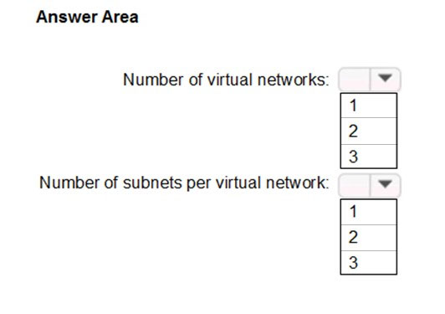

**Answer**: 1 + 3

1. CASE STUDY:

Contoso, Ltd. is a manufacturing company that has offices worldwide. Contoso works with partner organizations to bring products to market.

Contoso products are manufactured by using blueprint files that the company authors and maintains.

Existing Environment -

Currently, Contoso uses multiple types of servers for business operations, including the following:

* File servers
* Domain controllers
* Microsoft SQL Server servers

Your network contains an Active Directory forest named contoso.com. All servers and client computers are joined to Active Directory.

You have a public-facing application named App1. App1 is comprised of the following three tiers:

* A SQL database
* A web front end
* A processing middle tier

Each tier is comprised of five virtual machines. Users access the web front end by using HTTPS only.

Requirements -

Planned Changes -

Contoso plans to implement the following changes to the infrastructure:

* Move all the tiers of App1 to Azure.
* Move the existing product blueprint files to Azure Blob storage.
* Create a hybrid directory to support an upcoming Microsoft Office 365 migration project.

Technical Requirements -

Contoso must meet the following technical requirements:

* Move all the virtual machines for App1 to Azure.
* Minimize the number of open ports between the App1 tiers.
* Ensure that all the virtual machines for App1 are protected by backups.
* Copy the blueprint files to Azure over the Internet.
* Ensure that the blueprint files are stored in the archive storage tier.
* Ensure that partner access to the blueprint files is secured and temporary.
* Prevent user passwords or hashes of passwords from being stored in Azure.
* Use unmanaged standard storage for the hard disks of the virtual machines.
* Ensure that when users join devices to Azure Active Directory (Azure AD), the users use a mobile phone to verify their identity
* Minimize administrative effort whenever possible

User Requirements -

Contoso identifies the following requirements for users:

* Ensure that only users who are part of a group named Pilot can join devices to Azure AD.
* Designate a new user named Admin1 as the service admin for the Azure subscription.
* Admin1 must receive email alerts regarding service outages.
* Ensure that a new user named User3 can create network objects for the Azure subscription.

Question:

You need to configure the Device settings to meet the technical requirements and the user requirements.

Which two settings should you modify? To answer, select the appropriate settings in the answer area.

Hot Area:

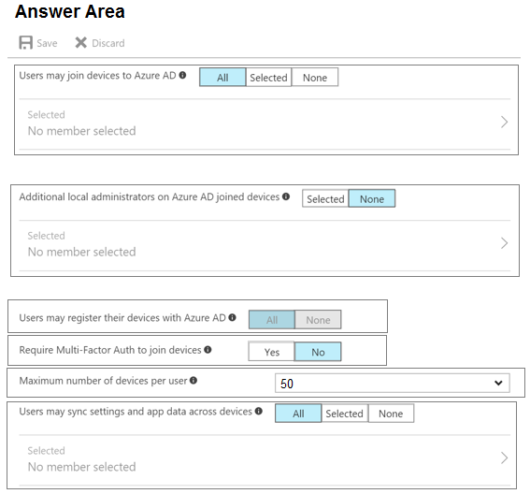

**Answer**: “Users may join devices to Azure AD – Selected” + “Require MFA to join devices – Yes”

1. CASE STUDY:

Contoso, Ltd. is a manufacturing company that has offices worldwide. Contoso works with partner organizations to bring products to market.

Contoso products are manufactured by using blueprint files that the company authors and maintains.

Existing Environment -

Currently, Contoso uses multiple types of servers for business operations, including the following:

* File servers
* Domain controllers
* Microsoft SQL Server servers

Your network contains an Active Directory forest named contoso.com. All servers and client computers are joined to Active Directory.

You have a public-facing application named App1. App1 is comprised of the following three tiers:

* A SQL database
* A web front end
* A processing middle tier

Each tier is comprised of five virtual machines. Users access the web front end by using HTTPS only.

Requirements -

Planned Changes -

Contoso plans to implement the following changes to the infrastructure:

* Move all the tiers of App1 to Azure.
* Move the existing product blueprint files to Azure Blob storage.
* Create a hybrid directory to support an upcoming Microsoft Office 365 migration project.

Technical Requirements -

Contoso must meet the following technical requirements:

* Move all the virtual machines for App1 to Azure.
* Minimize the number of open ports between the App1 tiers.
* Ensure that all the virtual machines for App1 are protected by backups.
* Copy the blueprint files to Azure over the Internet.
* Ensure that the blueprint files are stored in the archive storage tier.
* Ensure that partner access to the blueprint files is secured and temporary.
* Prevent user passwords or hashes of passwords from being stored in Azure.
* Use unmanaged standard storage for the hard disks of the virtual machines.
* Ensure that when users join devices to Azure Active Directory (Azure AD), the users use a mobile phone to verify their identity
* Minimize administrative effort whenever possible

User Requirements -

Contoso identifies the following requirements for users:

* Ensure that only users who are part of a group named Pilot can join devices to Azure AD.
* Designate a new user named Admin1 as the service admin for the Azure subscription.
* Admin1 must receive email alerts regarding service outages.
* Ensure that a new user named User3 can create network objects for the Azure subscription.

Question:

You need to recommend an identity solution that meets the technical requirements.

What should you recommend?

**Answer**: A. Pass-through Authentication and single sign-on (SSO)

1. CASE STUDY:

Contoso, Ltd. is a manufacturing company that has offices worldwide. Contoso works with partner organizations to bring products to market.

Contoso products are manufactured by using blueprint files that the company authors and maintains.

Existing Environment -

Currently, Contoso uses multiple types of servers for business operations, including the following:

* File servers
* Domain controllers
* Microsoft SQL Server servers

Your network contains an Active Directory forest named contoso.com. All servers and client computers are joined to Active Directory.

You have a public-facing application named App1. App1 is comprised of the following three tiers:

* A SQL database
* A web front end
* A processing middle tier

Each tier is comprised of five virtual machines. Users access the web front end by using HTTPS only.

Requirements -

Planned Changes -

Contoso plans to implement the following changes to the infrastructure:

* Move all the tiers of App1 to Azure.
* Move the existing product blueprint files to Azure Blob storage.
* Create a hybrid directory to support an upcoming Microsoft Office 365 migration project.

Technical Requirements -

Contoso must meet the following technical requirements:

* Move all the virtual machines for App1 to Azure.
* Minimize the number of open ports between the App1 tiers.
* Ensure that all the virtual machines for App1 are protected by backups.
* Copy the blueprint files to Azure over the Internet.
* Ensure that the blueprint files are stored in the archive storage tier.
* Ensure that partner access to the blueprint files is secured and temporary.
* Prevent user passwords or hashes of passwords from being stored in Azure.
* Use unmanaged standard storage for the hard disks of the virtual machines.
* Ensure that when users join devices to Azure Active Directory (Azure AD), the users use a mobile phone to verify their identity
* Minimize administrative effort whenever possible

User Requirements -

Contoso identifies the following requirements for users:

* Ensure that only users who are part of a group named Pilot can join devices to Azure AD.
* Designate a new user named Admin1 as the service admin for the Azure subscription.
* Admin1 must receive email alerts regarding service outages.
* Ensure that a new user named User3 can create network objects for the Azure subscription.

Question:

You need to meet the user requirement for Admin1.

What should you do?

**Answer**: B. From the Subscriptions blade, select the subscription, and then modify the Properties.

1. CASE STUDY:

Contoso, Ltd. is a consulting company that has a main office in Montreal and two branch offices in Seattle and New York.

The Montreal office has 2,000 employees. The Seattle office has 1,000 employees. The New York office has 200 employees.

All the resources used by Contoso are hosted on-premises.

Contoso creates a new Azure subscription. The Azure Active Directory (Azure AD) tenant uses a domain named contoso.onmicrosoft.com. The tenant uses the

P1 pricing tier.

Existing Environment -

The network contains an Active Directory forest named contoso.com. All domain controllers are configured as DNS servers and host the contoso.com DNS zone.

Contoso has finance, human resources, sales, research, and information technology departments. Each department has an organizational unit (OU) that contains all the accounts of that respective department. All the user accounts have the department attribute set to their respective department. New users are added frequently.

Contoso.com contains a user named User1.

All the offices connect by using private links.

Contoso has data centers in the Montreal and Seattle offices. Each data center has a firewall that can be configured as a VPN device.

All infrastructure servers are virtualized. The virtualization environment contains the servers in the following table.

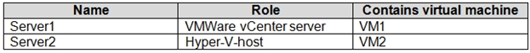

Contoso uses two web applications named App1 and App2. Each instance on each web application requires 1GB of memory.

The Azure subscription contains the resources in the following table.

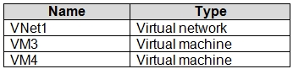

The network security team implements several network security groups (NSGs).

Planned Changes -

Contoso plans to implement the following changes:

* Deploy Azure ExpressRoute to the Montreal office.
* Migrate the virtual machines hosted on Server1 and Server2 to Azure.
* Synchronize on-premises Active Directory to Azure Active Directory (Azure AD).
* Migrate App1 and App2 to two Azure web apps named WebApp1 and WebApp2.

Technical requirements -

Contoso must meet the following technical requirements:

* Ensure that WebApp1 can adjust the number of instances automatically based on the load and can scale up to five instances.
* Ensure that VM3 can establish outbound connections over TCP port 8080 to the applications servers in the Montreal office.
* Ensure that routing information is exchanged automatically between Azure and the routers in the Montreal office.
* Ensure Azure Multi-Factor Authentication (MFA) for the users in the finance department only.
* Ensure that webapp2.azurewebsites.net can be accessed by using the name app2.contoso.com
* Connect the New York office to VNet1 over the Internet by using an encrypted connection.
* Create a workflow to send an email message when the settings of VM4 are modified.
* Create a custom Azure role named Role1 that is based on the Reader role.
* Minimize costs whenever possible.

Question:

You need to recommend a solution to automate the configuration for the finance department users. The solution must meet the technical requirements.

What should you include in the recommendation?

**Answer**: D. dynamic groups and conditional access policies

1. CASE STUDY:

Contoso, Ltd. is a consulting company that has a main office in Montreal and two branch offices in Seattle and New York.

The Montreal office has 2,000 employees. The Seattle office has 1,000 employees. The New York office has 200 employees.

All the resources used by Contoso are hosted on-premises.

Contoso creates a new Azure subscription. The Azure Active Directory (Azure AD) tenant uses a domain named contoso.onmicrosoft.com. The tenant uses the

P1 pricing tier.

Existing Environment -

The network contains an Active Directory forest named contoso.com. All domain controllers are configured as DNS servers and host the contoso.com DNS zone.

Contoso has finance, human resources, sales, research, and information technology departments. Each department has an organizational unit (OU) that contains all the accounts of that respective department. All the user accounts have the department attribute set to their respective department. New users are added frequently.

Contoso.com contains a user named User1.

All the offices connect by using private links.

Contoso has data centers in the Montreal and Seattle offices. Each data center has a firewall that can be configured as a VPN device.

All infrastructure servers are virtualized. The virtualization environment contains the servers in the following table.



Contoso uses two web applications named App1 and App2. Each instance on each web application requires 1GB of memory.

The Azure subscription contains the resources in the following table.



The network security team implements several network security groups (NSGs).

Planned Changes -

Contoso plans to implement the following changes:

* Deploy Azure ExpressRoute to the Montreal office.
* Migrate the virtual machines hosted on Server1 and Server2 to Azure.
* Synchronize on-premises Active Directory to Azure Active Directory (Azure AD).
* Migrate App1 and App2 to two Azure web apps named WebApp1 and WebApp2.

Technical requirements -

Contoso must meet the following technical requirements:

* Ensure that WebApp1 can adjust the number of instances automatically based on the load and can scale up to five instances.
* Ensure that VM3 can establish outbound connections over TCP port 8080 to the applications servers in the Montreal office.
* Ensure that routing information is exchanged automatically between Azure and the routers in the Montreal office.
* Ensure Azure Multi-Factor Authentication (MFA) for the users in the finance department only.
* Ensure that webapp2.azurewebsites.net can be accessed by using the name app2.contoso.com
* Connect the New York office to VNet1 over the Internet by using an encrypted connection.
* Create a workflow to send an email message when the settings of VM4 are modified.
* Create a custom Azure role named Role1 that is based on the Reader role.
* Minimize costs whenever possible.

Question:

You need to implement Role1.

Which command should you run before you create Role1? To answer, select the appropriate options in the answer area.

NOTE: Each correct selection is worth one point.

Hot Area:

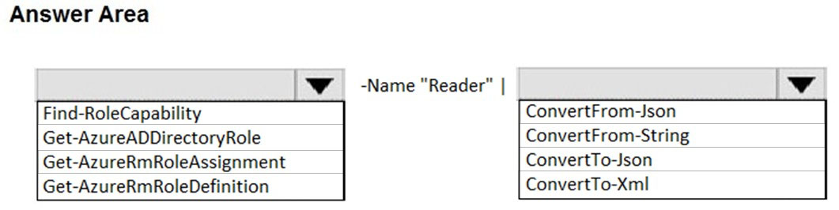

**Answer**: “Get-AzureRmRoleDefinition” + “ConvertTo-Json”

1. You have an Azure subscription named Subscription1 that contains an Azure Log Analytics workspace named Workspace1.

You need to view the error events from a table named Event.

Which query should you run in Workspace1?

**Answer**: D. search in (Event) "error"

1. You have an Azure subscription named Subscription1 and an on-premises deployment of Microsoft System Center Service Manager.

Subscription1 contains a virtual machine named VM1.

You need to ensure that an alert is set in Service Manager when the amount of available memory on VM1 is below 10 percent.

What should you do first?

**Answer**: C. Deploy the IT Service Management Connector (ITSM).

1. You have an Azure subscription that contains the following resources:

✑ 100 Azure virtual machines

✑ 20 Azure SQL databases

✑ 50 Azure file shares

You need to create a daily backup of all the resources by using Azure Backup.

What is the minimum number of backup policies that you must create?

**Answer**: 3

1. You have an azure subscription named Subscription1 that has the following providers registered:

✑ Authorization

✑ Automation

✑ Resources

✑ Compute

✑ KeyVault

✑ Network

✑ Storage

✑ Billing

✑ Web

Subscription1 contains an Azure virtual machine named VM1 that has the following configurations:

✑ Private IP address: 10.0.0.4 (dynamic)

✑ Network security group (NSG): NSG1

✑ Public IP address: None

✑ Availability set: AVSet

✑ Subnet: 10.0.0.0/24

✑ Managed disks: No

✑ Location: East US

You need to record all the successful and failed connection attempts to VM1.

Which three actions should you perform? Each correct answer presents part of the solution.

NOTE: Each correct selection is worth one point.

**Answer**: ABD (A. Create an Azure Storage account + B. Register the Microsoft.Insights resource provider + D. Enable Azure Network Watcher in the East US Azure region)

1. You have an Azure virtual machine named VM1 that runs Windows Server 2016.

You need to create an alert in Azure when more than two error events are logged to the System log on VM1 within an hour.

Solution: You create an event subscription on VM1. You create an alert in Azure Monitor and specify VM1 as the source.

Does this meet the goal?

**Answer**: No

1. You have an Azure virtual machine named VM1 that runs Windows Server 2016.

You need to create an alert in Azure when more than two error events are logged to the System log on VM1 within an hour.

Solution: You create an Azure Log Analytics workspace and configure the data settings. You install the Microsoft Monitoring Agent on VM1. You create an alert in

Azure Monitor and specify the Log Analytics workspace as the source.

Does this meet the goal?

**Answer**: Yes

1. You have an Azure subscription that contains the following resources:

✑ A virtual network that has a subnet named Subnet1

✑ Two network security groups (NSGs) named NSG-VM1 and NSG-Subnet1

✑ A virtual machine named VM1 that has the required Windows Server configurations to allow Remote Desktop connections

NSG-Subnet1 has the default inbound security rules only.

NSG-VM1 has the default inbound security rules and the following custom inbound security rule:

✑ Priority: 100

✑ Source: Any

✑ Source port range: *

✑ Destination: *

✑ Destination port range: 3389

✑ Protocol: UDP

✑ Action: Allow

VM1 connects to Subnet1. NSG1-VM1 is associated to the network interface of VM1. NSG-Subnet1 is associated to Subnet1.

You need to be able to establish Remote Desktop connections from the internet to VM1.

Solution: You modify the custom rule for NSG-VM1 to use the internet as a source and TCP as a protocol.

Does this meet the goal?

**Answer**: No

1. You have an Azure subscription that contains the following resources:

✑ A virtual network that has a subnet named Subnet1

✑ Two network security groups (NSGs) named NSG-VM1 and NSG-Subnet1

✑ A virtual machine named VM1 that has the required Windows Server configurations to allow Remote Desktop connections

NSG-Subnet1 has the default inbound security rules only.

NSG-VM1 has the default inbound security rules and the following custom inbound security rule:

✑ Priority: 100

✑ Source: Any

✑ Source port range: *

✑ Destination: *

✑ Destination port range: 3389

✑ Protocol: UDP

✑ Action: Allow

VM1 connects to Subnet1. NSG1-VM1 is associated to the network interface of VM1. NSG-Subnet1 is associated to Subnet1.

You need to be able to establish Remote Desktop connections from the internet to VM1.

Solution: You add an inbound security rule to NSG-Subnet1 that allows connections from the Any source to the * destination for port range 3389 and uses the TCP protocol. You remove NSG-VM1 from the network interface of VM1.

Does this meet the goal?

**Answer**: Yes

1. You have an Azure subscription that contains the following resources:

✑ A virtual network that has a subnet named Subnet1

✑ Two network security groups (NSGs) named NSG-VM1 and NSG-Subnet1

✑ A virtual machine named VM1 that has the required Windows Server configurations to allow Remote Desktop connections

NSG-Subnet1 has the default inbound security rules only.

NSG-VM1 has the default inbound security rules and the following custom inbound security rule:

✑ Priority: 100

✑ Source: Any

✑ Source port range: *

✑ Destination: *

✑ Destination port range: 3389

✑ Protocol: UDP

✑ Action: Allow

VM1 connects to Subnet1. NSG1-VM1 is associated to the network interface of VM1. NSG-Subnet1 is associated to Subnet1.

You need to be able to establish Remote Desktop connections from the internet to VM1.

Solution: You add an inbound security rule to NSG-Subnet1 and NSG-VM1 that allows connections from the internet source to the VirtualNetwork destination for port range 3389 and uses the TCP protocol.

Does this meet the goal?

**Answer**: Yes

1. You have an Azure subscription that contains the following resources:

✑ A virtual network that has a subnet named Subnet1

✑ Two network security groups (NSGs) named NSG-VM1 and NSG-Subnet1

✑ A virtual machine named VM1 that has the required Windows Server configurations to allow Remote Desktop connections

NSG-Subnet1 has the default inbound security rules only.

NSG-VM1 has the default inbound security rules and the following custom inbound security rule:

✑ Priority: 100

✑ Source: Any

✑ Source port range: *

✑ Destination: *

✑ Destination port range: 3389

✑ Protocol: UDP

✑ Action: Allow

VM1 connects to Subnet1. NSG1-VM1 is associated to the network interface of VM1. NSG-Subnet1 is associated to Subnet1.

You need to be able to establish Remote Desktop connections from the internet to VM1.

Solution: You add an inbound security rule to NSG-Subnet1 that allows connections from the Internet source to the VirtualNetwork destination for port range 3389 and uses the UDP protocol.

Does this meet the goal?

**Answer**: No

1. You have a Microsoft 365 tenant and an Azure Active Directory (Azure AD) tenant named contoso.com.

You plan to grant three users named User1, User2, and User3 access to a temporary Microsoft SharePoint document library named Library1.

You need to create groups for the users. The solution must ensure that the groups are deleted automatically after 180 days.

Which two groups should you create? Each correct answer presents a complete solution.

NOTE: Each correct selection is worth one point.

**Answer**: BC (B. an Office 365 group that uses the Assigned membership type + C. an Office 365 group that uses the Dynamic User membership type)

1. You have an Azure subscription.

You enable multi-factor authentication for all users.

Some users report that the email applications on their mobile device cannot connect to their Microsoft Exchange Online mailbox. The users can access Exchange

Online by using a web browser and from Microsoft Outlook 2016 on their computer.

You need to ensure that the users can use the email applications on their mobile device.

What should you instruct the users to do?

**Answer**: B. Create an app password.

1. You have an Azure Active Directory (Azure AD) tenant named contoso.com. Multi-factor authentication (MFA) is enabled for all users.

You need to provide users with the ability to bypass MFA for 10 days on devices to which they have successfully signed in by using MFA.

What should you do?

**Answer**: C. From the multi-factor authentication page, configure the service settings.

1. You have a Microsoft 365 subscription and a hybrid deployment of Azure Active Directory (Azure AD). User identities and password hashes are synced.

You have a user account named User1.

From Active Directory, you select the User must change password at next logon account option for User1.

What will occur if User1 attempts to sigh in to myapps.microsoft.com?

**Answer**: C. User1 will be prevented from signing in.

1. You have an Azure subscription. All users are enabled for multi-factor authentication (MFA).

You need to ensure that the users can lock out their own account if they receive an unsolicited MFA request from Azure.

Which MFA settings should you configure?

**Answer**: D. Fraud alert

1. You have an Azure subscription that contains an Azure Active Directory (Azure AD) tenant named adatum.com. The tenant contains 500 user accounts.

You deploy Microsoft Office 365. You configure Office 365 to use the user accounts in adatum.com.

You configure 60 users to connect to mailboxes in Microsoft Exchange Online.

You need to ensure that the 60 users use Azure Multi-Factor Authentication (MFA) to connect to the Exchange Online mailboxes. The solution must only affect connections to the Exchange Online mailboxes.

What should you do?

**Answer**: B. From Azure Active Directory admin center, create a conditional access policy.

1. You have an Azure subscription named Subscription1 that contains a virtual network named VNet1. VNet1 is in a resource group named RG1.

Subscription1 has a user named User1. User1 has the following roles:

✑ Reader

✑ Security Admin

✑ Security Reader

You need to ensure that User1 can assign the Reader role for VNet1 to other users.

What should you do?

**Answer**: B. Assign User1 the User Access Administrator role for VNet1.

1. You have an Azure virtual machine named VM1 that runs Windows Server 2019.

You save VM1 as a template named Template1 to the Azure Resource Manager library.

You plan to deploy a virtual machine named VM2 from Template1.

What can you configure during the deployment of VM2?

**Answer**: C. administrator username.

1. You have an Azure virtual network named VNet1 that contains a subnet named Subnet1. Subnet1 contains three Azure virtual machines. Each virtual machine has a public IP address.

The virtual machines host several applications that are accessible over port 443 to user on the Internet.

Your on-premises network has a site-to-site VPN connection to VNet1.

You discover that virtual machines can be accessed by using the Remote Desktop Protocol (RDP) from the Internet and from the on-premises network.

You need to prevent RDP access to the virtual machines from the Internet, unless the RDP connection is established from the on-premises network. The solution must ensure that all the applications can still be accesses by the Internet users.

What should you do?

**Answer**: A. Create a deny rule in a network security group (NSG) that is linked to Subnet1.